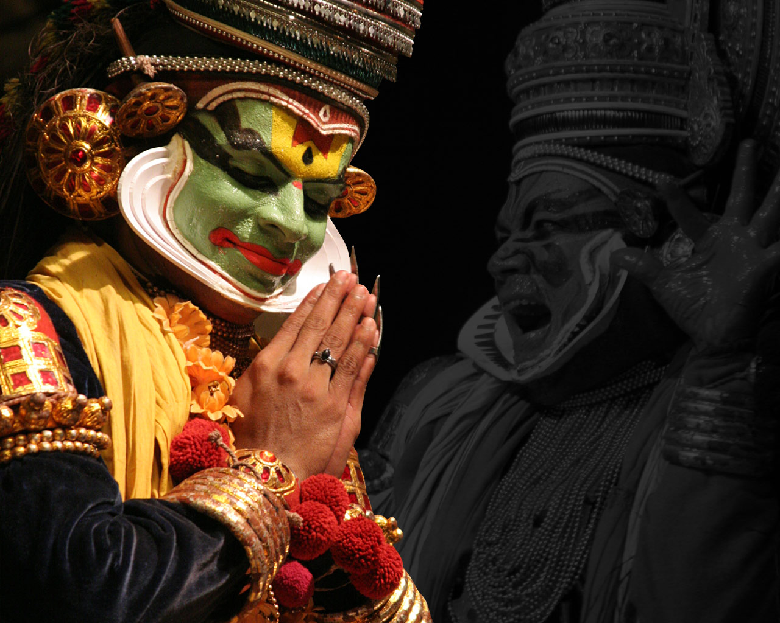**Tour Name : Essence of South India**

**Tour Code : II#03**

**Duration : 17 Nights / 18 Days**

**Places covered : Bangaluru (Bangalore) - Chikmagalur - Kabini - Mysore - Kochi - Kumarakom - Periyar - Madurai - Chennai**

**Interests : Culture, Heritage, Wildlife, Nature, Photography**

**Itinerary:**

**Day 1 - Bengaluru (Bangalore)**

Arrive in Bengaluru. Known for its wide variety of indulgences, Bengaluru offers a rich cultural heritage of historic monuments, traditional arts and crafts and exotic cuisine. Overnight at Hotel.

**Day 2 – Bengaluru**

Drive past city landmarks, including the renowned Lal Bagh botanical gardens and the legislative house of the state of Karnataka, a marvel of neo-Dravidian architecture. Overnight at Hotel.

**Day 3 – Bengaluru to Chikmagalur**

A seven hour drive through picturesque countryside laden with coffee estates and spice plantations brings you to Chikmagalur. En- route visit the intricately carved temples at Hoysala, Belur and Halebid. Overnight at Hotel.

**Day 4 – Chikmagalur to Kabini**

Proceed on a seven hour drive to Kabini and visit Nagarhole National Park, a wildlife sanctuary of gentle slopes and shallow valleys sheltering herds of Asian elephants and bison. Overnight at Hotel.

**Day 5 – Kabini**

Embark on a jeep safari into the wilderness of Nagarhole National Park. Keep an eye out for wildlife and colourful birdlife. Overnight at Hotel.

**Days 6-7 – Kabini to Mysore**

Depart for the royal city of Mysore, the political capital of a dynasty that ruled Karnataka for 150 years. Visit the Maharaja’s Palace, a treasure-trove of exquisite works of art, and the Rajendra Art Gallery. Overnight at Hotel.

**Day 8 – Mysore to Kochi via Bangalore**

Fly to Kochi. This ‘Queen of the Arabian Sea’ boasts one of the finest natural harbours in the world and is the very spirit of eclectic Kerala. Overnight at Hotel.

**Day 9: Kochi**

Visit the Portuguese Church of St. Francis and the oldest living synagogue in the world. Continue to Mattancherry Palace, built by the Portuguese for the King of Kochi. This evening, dine on authentic Kerala cuisine at the residence of a famous culinary expert. Overnight at Hotel.

**Days 10-11 – Kochi to Kumarakom**

Drive to Kumarakon then spend a day at leisure to relax in the serene environs. Explore Kerala’s backwaters in a Kettuvalam (houseboat). Enjoy the peace and tranquility on a journey through fascinating palm-fringed canals, lakes and villages.

**Day 12 – Kumarakom to Periyar**

Drive through tranquil countryside to arrive in Periyar. Set in the heart of the Cardamom Hills, Periyar Tiger Reserve is renowned for its elephant population, birdlife, wild boar, sambar, monkeys, and wildcats. Overnight at Hotel.

**Day 13 – Periyar to Madurai**

Drive to Madurai. Enjoy an evening ceremony at Meenakshi temple. Overnight at Hotel.

**Day 14 – Madurai**

Visit remarkable Sri Meenakshi temple, adorned with multi-colored images of gods, animals and mythical figures. Overnight at Hotel.

**Days 15-16 – Madurai to Chennai**

Fly to Chennai and drive to Covelong. Explore Chennai highlights, including the first British   
outpost in India, St. Mary Church, and a temple dedicated to Lord Shiva. Overnight at Hotel.

**Day 17 – Chennai**

Excursion to Kanchipuram and Mahabalipuram: Visit Kanchipuram, one of the seven sacred, ancient cities of India, and Mahabalipuram, home to brilliant rock-cut temples and monolithic chariots. Overnight at Hotel.

**Day 18 – Chennai**

Transfer to Chennai's International Airport for your onward flight.

**Tour Ends**

**Incoming India** offers you flexibility of choosing your Holidays –

We mix it; match it to suit your interest, preferences & budgets…