

ITA_User instruction manual

OpenStack-driver

*－* Version 1.3*－*

Copyright © NEC Corporation 2019. All rights reserved.

Disclaimer

All the contents of this document are protected by copyright owned by NEC Corporation.

Unauthorized reproduction or copying of all or part of the contents of this document is prohibited.

The contents of this document are subject to change without prior notice in the future.

NEC Corporation is not responsible for any technical or editorial errors or omissions in this document.

NEC Corporation do not guarantee accuracy, usability, certainty of the content in this document.

Trademark

* Linux is registered trademark or trademark of Linus Torvalds, registered in the U.S. and other countries.
* Red Hat is registered trademark or trademark of Red Hat, Inc., registered in the U.S. and other countries.
* Apache、Apache Tomcat、Tomcat are registered trademarks or trademarks of Apache Software Foundation.
* Oracle and MySQL are registered trademarks of Oracle Corporation and its subsidiaries and affiliates in the United States and other countries.
* MariaDB is a registered trademark or trademark of the MariaDB Foundation.

The names of other systems, company name and products mentioned in this document are registered trademarks or trademarks of their respective companies.

The ® mark and TM mark is not specified in this document.

※「Exastro IT Automation」is written as「ITA」in this document.

# Table of contents

Table of contents 2

Introduction 3

1 Overview of OpenStack driver 4

2 Features of OpenStack driver 4

3 Installation related 5

(1) OpenStack driver installation checkout 5

(2) Set the OpenStack interface information 5

(3) Set sudo privilege to the Apache daemon user 5

(4) Version confirmation 5

4 Function description 6

4.1 Web contents 6

4.1.1 Menu/screen list 6

4.1.2 Menu screen component description 6

4.1.3 Screen description 7

(1) Interface information 7

(2) Movement list 8

(3) Substitution value list 10

(4) Execution 12

(5) Check operation status 13

(6) Result list 14

(7) Result details 15

4.1.4 Workflow 16

4.1.5 About stack 17

5 Application operation 18

5.1 Change log level 18

5.2 About the maintenance method 19

# Introduction

This document explains the function and the operation method of ITA OpenStack driver (referred to as OpenStack driver hereafter) system.

In addition, please note that the screen examples described in this document may be different from the actual screens.

Please note that the contents of this document are subject to change without prior notice in the future.

# Overview of OpenStack driver

OpenStack driver works as the optional function of ITA system and uses OpenStack to construct the virtual machine on the construction target server device registered on ITA system.

* System configuration

OpenStack driver is divided into OpenStack ITA function and OpenStack.

The OpenStack ITA function works on the same server with ITA system

OpenStack can work on ITA system server or on a separate server.

Please refer to "System Configuration/Environment Construction Guide - OpenStack-driver" for the operating environment of this system.

# Features of OpenStack driver

The main function of OpenStack driver is separated into the following categories.

1. Web

Web content. The ITA system OpenStack driver screen provided on the browser.

1. BackYard

Resident processes that runs on a server independent from the web content.

# Installation related

Please execute the following procedure as the post-work after finishing the work in the installer.

### OpenStack driver installation checkout

The installation is successful if users can access to the ITA system main menu and can move to each screen from the links.

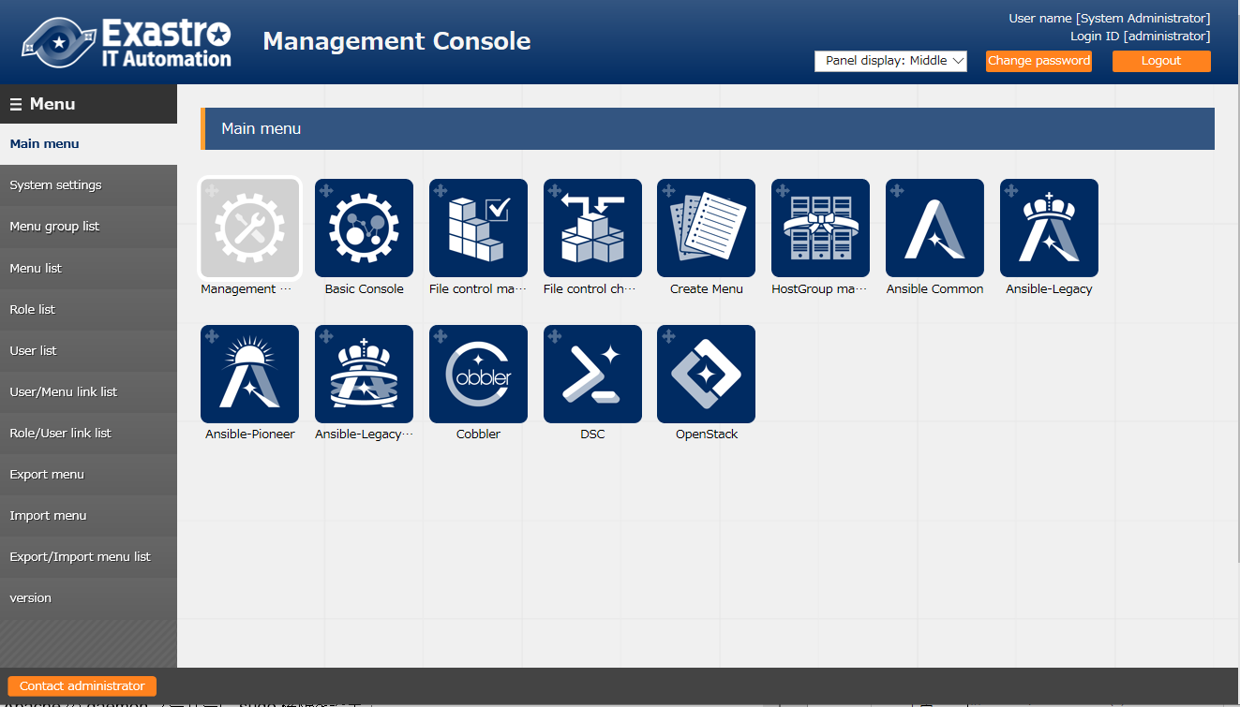

### Set the OpenStack interface information

Please set the OpenStack interface information

Please refer to "(1) Interface information" on the 8th page for details

### Set sudo privilege to the Apache daemon user

Please set sudo privilege to the Apache daemon user in the server where OpenStack is installed.

Setting file: /etc/sudoers.d

Setting content: please add the following description.

daemon ALL=(ALL) NOPASSWD:ALL

HTTPD_LANG=ja_JP.UTF-8

The configuration is required for OpenStack to execute the command that need sudo privilege

### Version confirmation

The version information of OpenStack Driver can be checked with the following procedure.

$ cat /{ installation destination directory }/ita-root/libs/release/ita _ openstack-driver  HTTPD_LANG=ja_JP.UTF-8

HTTPD_LANG=ja_JP.UTF-8

# Function description

Explaining the functions (Web) provided by OpenStack driver.

The menu screen provided by Web function includes not only the Web functions but also the screens that are related to authentication such as login.



## Web contents

### 4.1.1 Menu/screen list

The list of Web menus is as below.

Table 4.1-1 OpenStack driver menu/screen list

|  |  |  |
| --- | --- | --- |
| **No** | **Menu・Screen** | Management target |
| 1 | Interface information | The OpenStack server used in ITA system |
| 2 | Movement list | The list of work pattern used when constructing virtual machine with OpenStack |
| 3 | Substitution value list | Correspondence of operation / work pattern / project / substitution value |
| 4 | Execution | Operation plan |
| 5 | Result list | Execution status |
| 6 | Result details | Execution status of each project |

### 4.1.2 Menu screen component description

Please refer to the "First step guide".

### 4.1.3 Screen description

### Interface information

Update of the server on which OpenStack is installed.

※ Please make sure that only one server is registered.

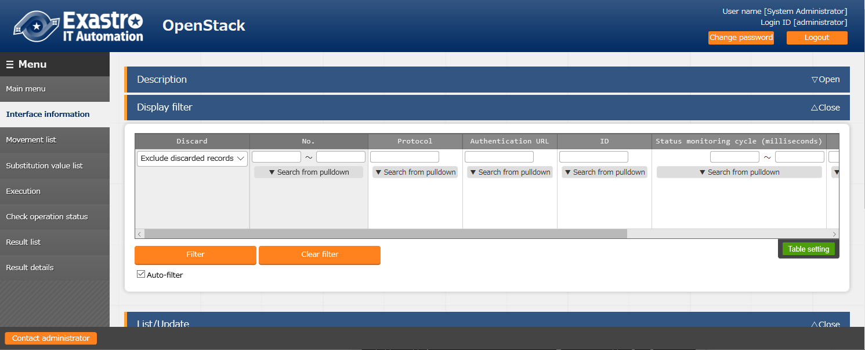

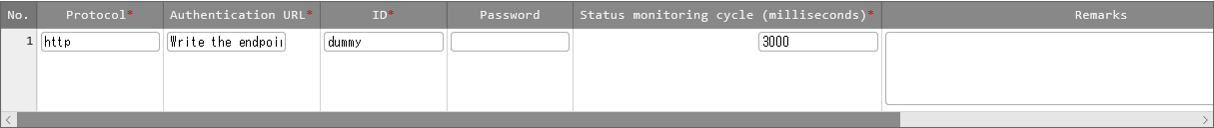

|  |  |
| --- | --- |
| Column name | Description |
| Protocol | Enter the protocol (http, etc.) of the server on which OpenStack is installed. |
| Authentication URL | Enter the URL of the server on which OpenStack is installed |
| ID | Enter the user ID used to log in to the OpenStack |
| Password | Enter the password used to log in to the OpenStack |
| Status monitoring cycle (milliseconds) | Enter the refresh interval of the log displayed in "check operation status" menu. Usually the value around 3000 milliseconds is recommended. |
| Remarks | Can used to save notes. Can also be registered when discarding/restoring records |

### Movement list

Register/Update/discard work pattern name from "Movement list".

After referencing each file, please "Upload in advance" before "Register".

For this time, upload the following "heat.tmp" for HEAT template files and "environment_setting_file.txt" to environment setting file then follow the procedure.

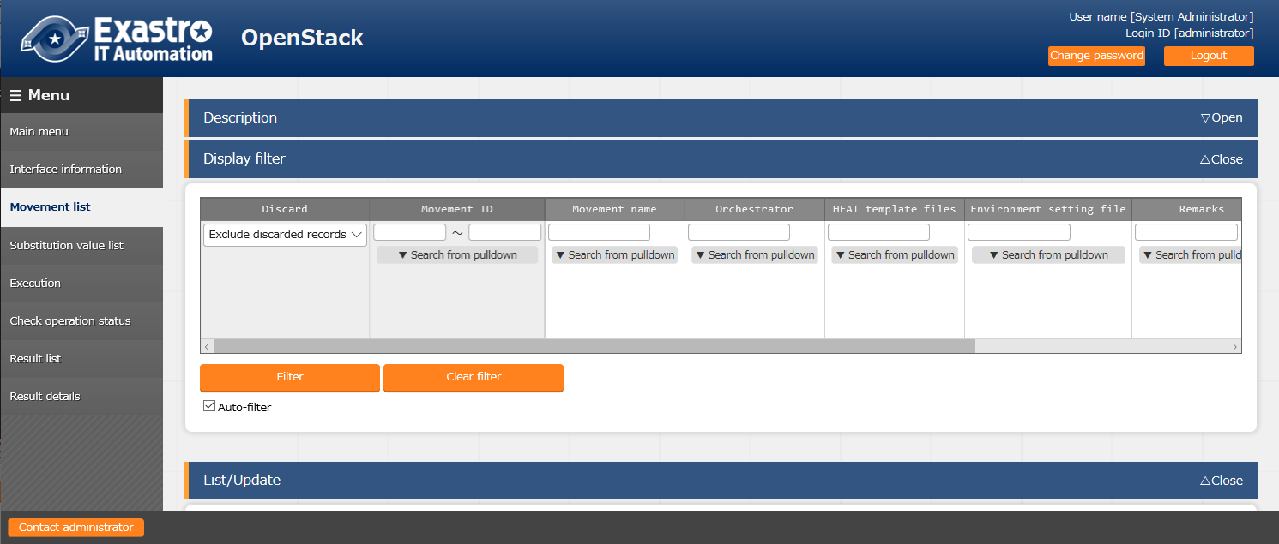

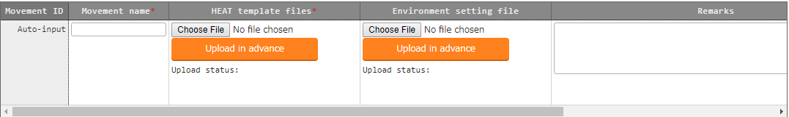

|  |  |
| --- | --- |
| Column name | Description |
| Movement name | Enter the name of work pattern. |
| HEAT template files | Upload the HEAT template file which is the basis for virtual machine construction. |
| Environment setting file | Upload the environment configuration file which describes the script executed after virtual machine construction. |
| Remarks | Can used to save notes. |

　　　　　　Heat.tmp

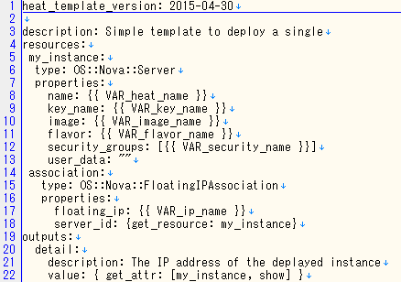

environment_setting_file.txt

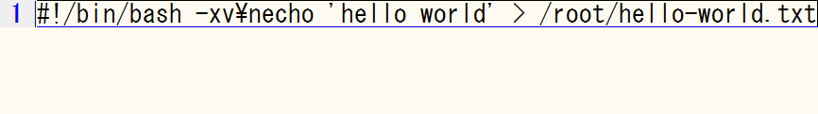

### Substitution value list

Register/Update/Discard the subsitution value of the variable from the "substitution value list" menu

Manage the variable value according to the combination of Operation, work pattern, and project.

The registered substitution value will be assigned to the variables in the HEAT template file.

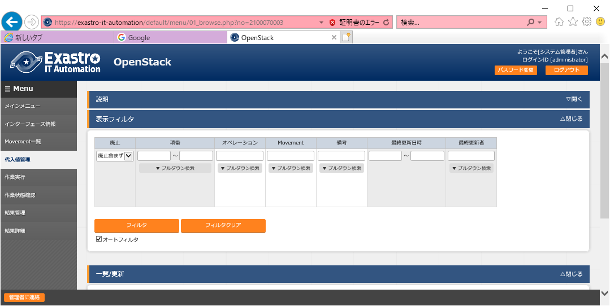

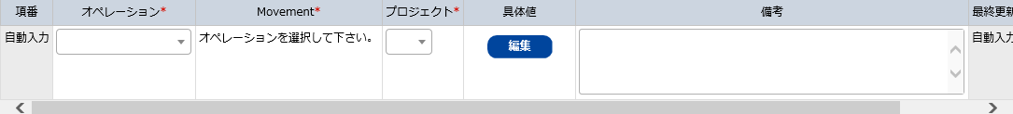

|  |  |
| --- | --- |
| Column name | Description |
| Operation | Please select the target operation name from the operation registered in ITA basic console. |
| Movement | Please select the target work pattern name. |
| Project | Please select the target OpenStack project name |
| Specific value | If the "Edit button" is clicked, the substitution value configuration dialog will display. Please configure the substitution values. |
| Remarks | Can used to save notes. Can also be registered when discarding/restoring records. |

If the "Specific value" column is clicked, a specific value registration modal window will be displayed.

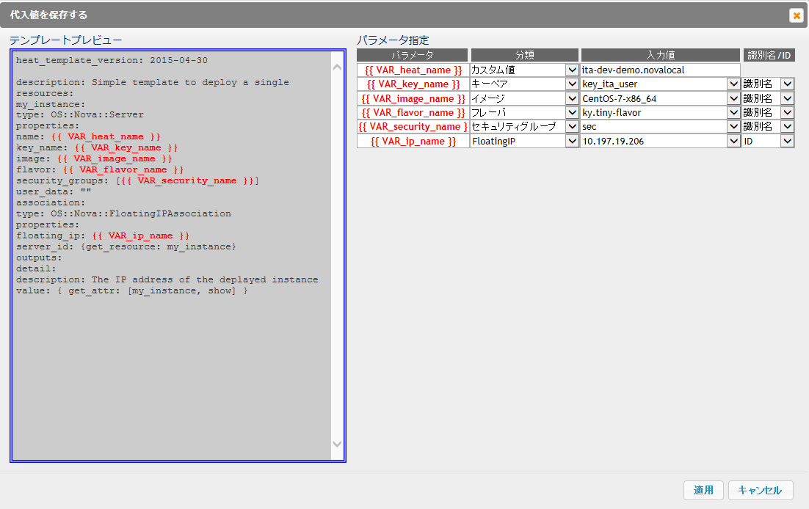

|  |  |
| --- | --- |
| Column name | Description |
| Parameter | The variable in the HEAT template file is entered automatically. |
| Classification | Select the category of the input value. The option of input value column will change according to the selected content. |
| Input value | Select the input value to be assigned to the parameter.  (FloatingIP is associated with the IP address in the device list menu of basic console. Please refer to "User instruction manual_basic console" for "Device list" menu. |
| Symbol name/ID | Select ID if the input value is literal and select symbol name to represent the variable with symbolic name (Error occurs if ID is not selected for FloatingIP) |

### Execution

Instruct Operation execution. Select the radio button from the Movement list and operation list and click the execution button, the screen will jump to "(5) Check operation status" menu and the operation will be executed.

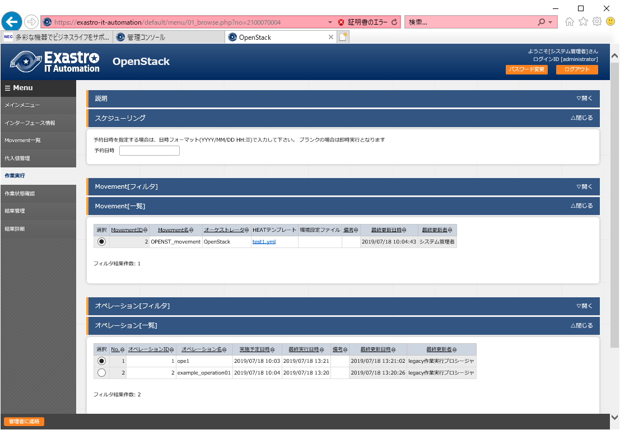

Scheduling execution is possible by entering the "scheduled date/time".

(Only future date/time can be registered for the "scheduled date/time")

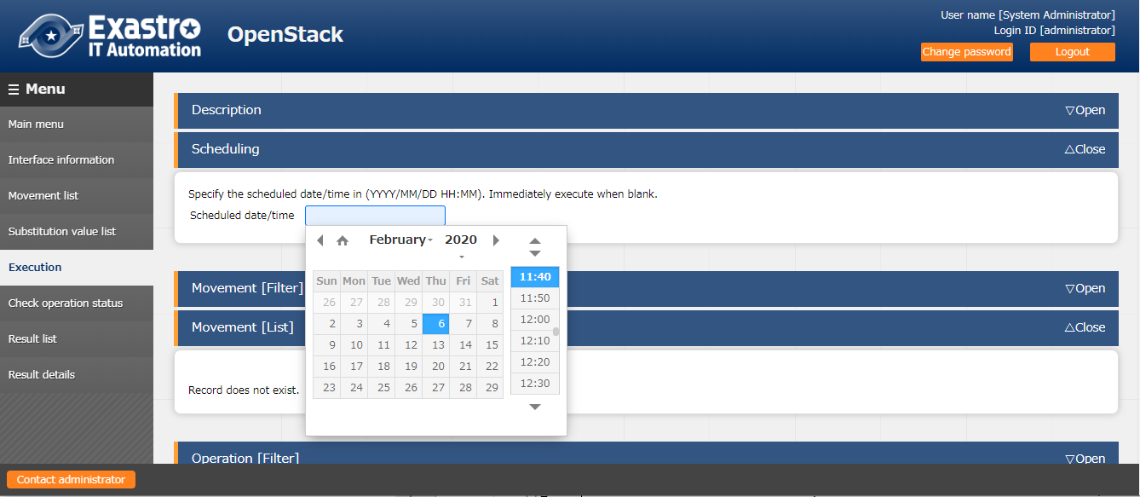

### Check operation status

Monitor the operation execution status. Emergency stop is also performed here.

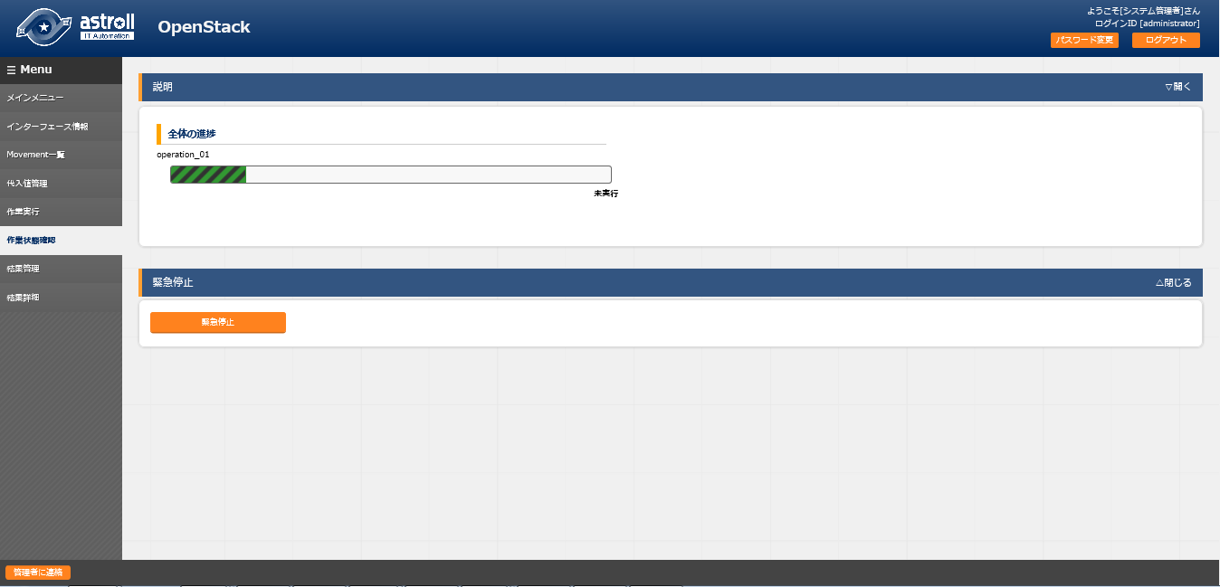

The execution can be stopped by clicking the "Emergency stop" button.

If the operation is scheduled to execute, the "schedule cancellation" button will be displayed.

Status is displayed according to the execution status.

According to the operation execution status and each detailed operation execution status, the following status is displayed.

The status display refresh interval in this menu can be specified in the "Status monitoring cycle (milliseconds)" of "Interface information" menu.

Status according to the execution status of each operation detail

|  |  |
| --- | --- |
| Status | Description |
| Unexecuted | Unexecuted. |
| Unexecuted (schedule) | Unexecuted since the time is before scheduled date/time. |
| Preparing | Preparing for execution. |
| Executing | During execution. |
| Emergency stop - processing | Performing emergency stop operation. |
| Emergency stop - completed | Emergency stop operation is done. |
| Failure | The operation execution failed. |
| Completed (partial failure) | Execution completed but some part failed. |
| Completed | Execution completed. |
| Schedule cancellation | The schedule is canceled before the scheduled execution date/time. |

Status according to the execution status of each operation detail.

|  |  |
| --- | --- |
| Status | Status |
| Cancel | Execution canceled |
| Build in progress | During construction |
| Failure (HEAT error) | Execution failed due to syntax error of HEAT template file |
| Failure (other errors) | Execution failed due to other errors |
| Completed | Execution completed |

※　About emergency stop

Emergency stop does not stop the operation immediately.

Emergency stop is performed when the process of every row to the target host is done.

### Result list

The history of operation can be viewed here.

By specifying criteria and clicking the "Filter" button, the operation list table and graph will be displayed.

By hovering the mouse cursor over each graph, the download button of the graph will be displayed.

Users can download the graphs by clicking the displayed graph download button.

Users can view the details of execution status by clicking the "Execution status check" button to jump to the "(5) Execution status check" screen.

Users can view the details of the execution status for each operation by clicking the "Result Details" button to jump to the "(7) Result details" screen.

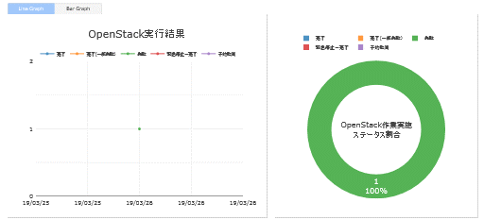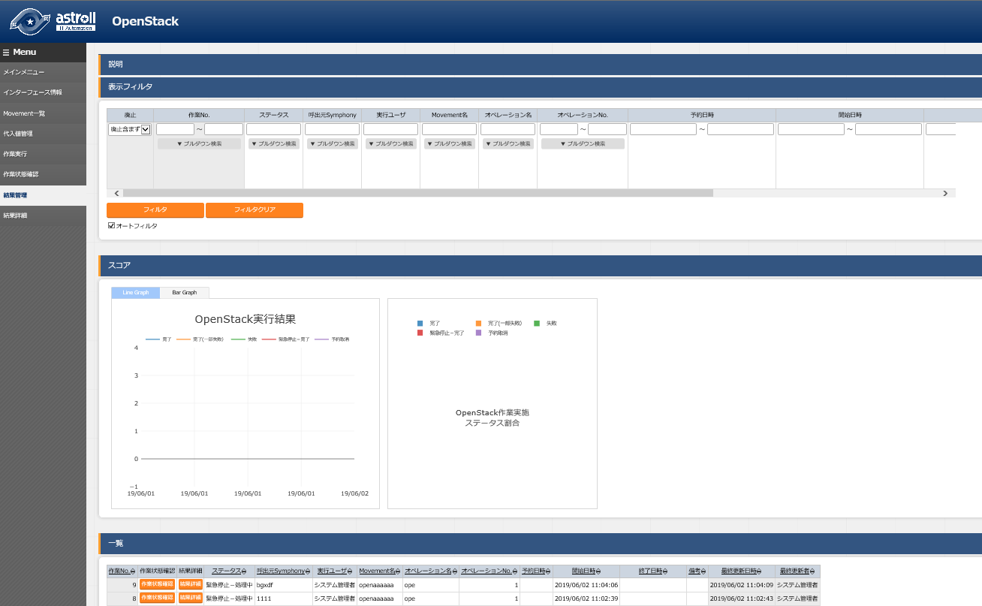

### Result details

Display details of the execution status for each operation.

Since the JSON of request and response during execution can be checked in this menu, please check here if error occurs.

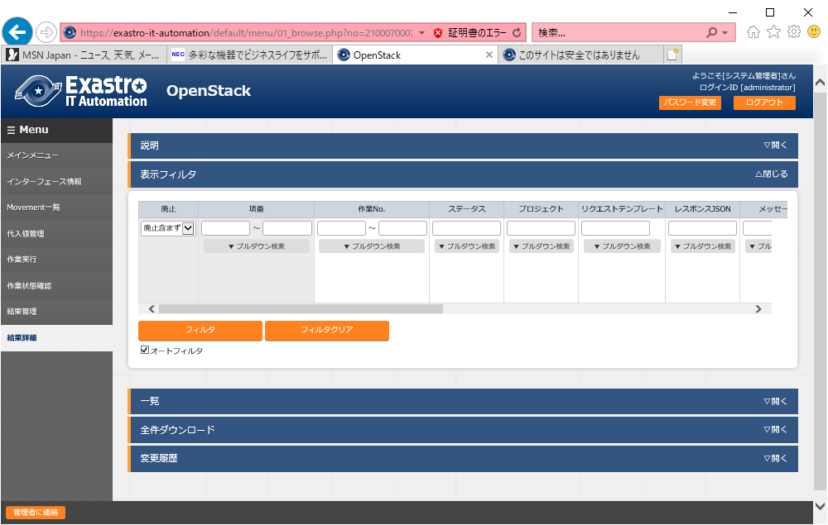

After the operation is completed, users can check if the file set in the directory specified in the environment setting file has been uploaded by logging in the created environment via terminal, etc.

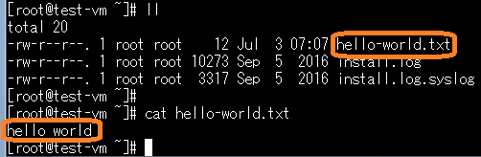

### Workflow

The following is the workflow of creating virtual machine instance using OpenStack.

**Design operation**

Design work pattern

Please register the work pattern (combination of HEAT template file and environment setting file).

(2) Movement list

②

Please register the information of OpenStack from OpenStack Web.

(1) Interface information

①

**Operation execution**

Once work pattern is set, users can start from this procedure from the next time.

Prepare for execution

Please configure the substitution value for the variable in HEAT template file according to the combination of Operation, work pattern, and project.

※Please register the details of operation even if the HEAT template file doesn't contain any variable.

(3) Substitution value list

The status of executed operation is displayed in real-time.

(5) Check operation status

③⑦

Please select the work pattern and operation then click the "Execute" button. Please click the "Execute" button after entering the scheduled date/time if you want to schedule the execution.

(4) Execution

②

**Result details**

The list of result for each operation detail is displayed.

(7) Result details

The list of executed operation is displayed.

Users can jump to the "Check operation status" screen by clicking the "Check operation status" button.

Users can jump to the "Result details" screen by clicking the "Result details" button.

(6) Result list

### About stack

Log in to OpenStack and check the created stack from the "Stack" menu in "Orchestration".

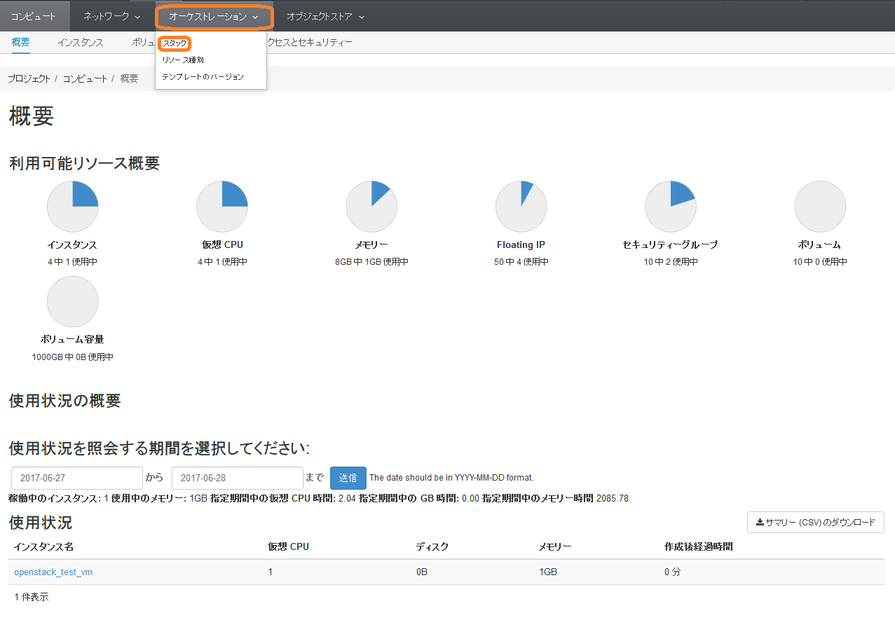

If the stack reaches 100 items, no more instance can be created and error occurs during operation execution.

Also, if the stack is deleted, the instance created according to the stack will also be deleted. It is recommended to delete unnecessary instance periodically.

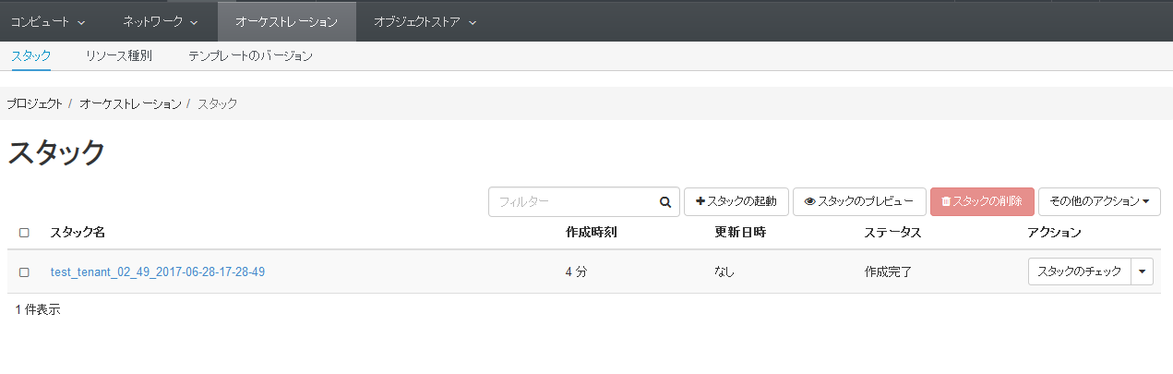

# Application operation

The operation to utilizing ITA system is not only inputs by user from the browser screen of client PC but also operations according to system operation and maintenance.

The available operation and maintenance are as follows.

* Change log level
* Maintenance



## Change log level

The method to change the log level of ITA system process is as follows.

Open the target file in target directory and modify it as below.

1. Change to NORMAL level

Rewrite the 8th line of the following file from “DEBUG” to “NORMAL”.  
Log level setting file： <insallation direcotory>/ita-root/confs/backyardconfs/ita_env

1. Change to DEBUG level  
   Rewrite the 8th line of the following file from “NORMAL” to “DEBUG”.  
   Log level setting file： <installation direcotory>/ita-root/confs/backyardconfs/ita_env

After rewriting the file, **the change takes effect after restarting the process.**

Please refer to next section " 5.2 About the maintenance method" for restart.

Log file output destinaton： <installation directory>/ita-root/logs/backyardlogs

## About the maintenance method

Start/Stop/Restart the OpenStack driver independent process.

Taking ky_openStack_masterSync-workflow for example.

* + Start process

＄/usr/bin/systemctl start ky_openStack_masterSync-workflow 

* + Stop process

＄/usr/bin/systemctl stop ky_openStack_masterSync-workflow 

* + Restart process

＄/usr/bin/systemctl restart ky_openStack_masterSync-workflow 

Similarly, substitute each target file name to start / stop / restart the process.