**GRAFANA & INFRASTRUCTURE AS CODE**

With Grafana Cloud, you can configure dashboards as code. You can manage your Grafana resources as code in a declarative manner, which enables code review, code reuse, and in general, better workflows. Grafana administrators can manage dashboards and alerts, add synthetic monitoring probes and checks, manage identity and access, and more using:

* Terraform provider for Grafana.
  + Best suited for users who are already using Terraform for non-Grafana use cases
  + To manage the entire Grafana ecosystem of resources, because it supports the most Grafana resources compared to Grafana’s other as-code solutions.
  + Managing dashboards isn’t the simplest process — you have to work with long JSON files, which can become difficult to review and update
* Ansible collection for Grafana.
  + Best suited for people already using Ansible for non-Grafana use cases.
  + The collection only works for Grafana Cloud right now, so it makes the most sense for Grafana Cloud customers who want to manage resources declaratively using Ansible.
  + Only supports eight resources: API keys, cloud stacks, plugins, dashboards, folders, data sources, alert contact points, and notification policies.
  + Building dashboards is a challenging process
* Grizzly
  + Best suited for users who are either using Jsonnet to manage Grafana resources or those who prefer a Kubernetes-style YAML definition of their Grafana resources.
  + Doesn’t support Grafana OnCall and Grafana Alerting resources.

**TERRAFORM**

**grafana_contact_point** - Manages Grafana Alerting contact points.

## **SCHEMA**

### Required:

### [name](https://registry.terraform.io/providers/grafana/grafana/latest/docs/resources/contact_point#name) (String) The name of the contact point.

Optional: alertmanager, dingding, discord, email, googlechat, kafka, opsgenie, pagerduty, pushover, sensugo, slack, teams, telegram, threema, victorops, webhook, wecom.

### **NESTED SCHEMA FOR E-MAIL**

Required:

* [addresses](https://registry.terraform.io/providers/grafana/grafana/latest/docs/resources/contact_point#addresses) (List of String) The addresses to send emails to.

### **NESTED SCHEMA FOR TEAMS**

Required:

* [url](https://registry.terraform.io/providers/grafana/grafana/latest/docs/resources/contact_point#url) (String, Sensitive) A Teams webhook URL.

**EXAMPLE CONFIG (e-mail)**

Using the Grafana Terraform provider to define a Grafana contact point resource with a name of "My Contact Point" and an email notification configuration.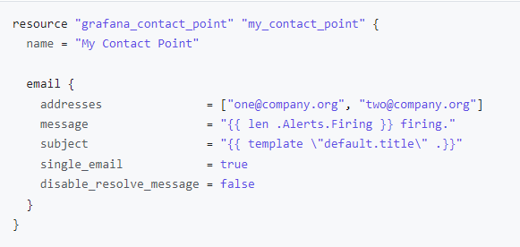

**grafana_notification_policy** - Sets the global notification policy for Grafana. Note that this resource manages the entire notification policy tree, and will overwrite any existing policies.

## **SCHEMA**

### **Required**

### [contact_point](https://registry.terraform.io/providers/grafana/grafana/latest/docs/resources/notification_policy#contact_point) (String) The default contact point to route all unmatched notifications to.

### [group_by](https://registry.terraform.io/providers/grafana/grafana/latest/docs/resources/notification_policy#group_by) (List of String) A list of alert labels to group alerts into notifications by. Use the special label ... to group alerts by all labels, effectively disabling grouping.

**EXAMPLE**

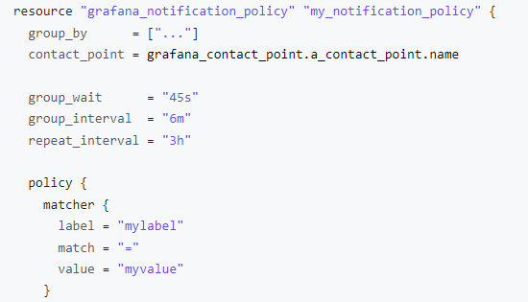

**grafana_rule_group** – Manages Grafana Alerting rule groups

## **SCHEMA**

### **Required**

### [folder_uid](https://registry.terraform.io/providers/grafana/grafana/latest/docs/resources/rule_group#folder_uid) (String) The UID of the folder that the group belongs to.

### [interval_seconds](https://registry.terraform.io/providers/grafana/grafana/latest/docs/resources/rule_group#interval_seconds) (Number) The interval, in seconds, at which all rules in the group are evaluated. If a group contains many rules, the rules are evaluated sequentially.

### [name](https://registry.terraform.io/providers/grafana/grafana/latest/docs/resources/rule_group#name) (String) The name of the rule group.

### [org_id](https://registry.terraform.io/providers/grafana/grafana/latest/docs/resources/rule_group#org_id) (String) The ID of the org to which the group belongs.

### [rule](https://registry.terraform.io/providers/grafana/grafana/latest/docs/resources/rule_group#rule) (Block List, Min: 1) The rules within the group. (see below for nested schema)

### **NESTED SCHEMA FOR 'rule’**

Required:

* [condition](https://registry.terraform.io/providers/grafana/grafana/latest/docs/resources/rule_group#condition) (String) The ref_id of the query node in the data field to use as the alert condition.
* [data](https://registry.terraform.io/providers/grafana/grafana/latest/docs/resources/rule_group#data) (Block List, Min: 1) A sequence of stages that describe the contents of the rule. (see below for nested schema)
* [name](https://registry.terraform.io/providers/grafana/grafana/latest/docs/resources/rule_group#name) (String) The name of the alert rule.

### **NESTED SCHEMA FOR ‘rule_data’**

Required:

* [datasource_uid](https://registry.terraform.io/providers/grafana/grafana/latest/docs/resources/rule_group#datasource_uid) (String) The UID of the datasource being queried, or "-100" if this stage is an expression stage.
* [model](https://registry.terraform.io/providers/grafana/grafana/latest/docs/resources/rule_group#model) (String) Custom JSON data to send to the specified datasource when querying.
* [ref_id](https://registry.terraform.io/providers/grafana/grafana/latest/docs/resources/rule_group#ref_id) (String) A unique string to identify this query stage within a rule.
* [relative_time_range](https://registry.terraform.io/providers/grafana/grafana/latest/docs/resources/rule_group#relative_time_range) (Block List, Min: 1, Max: 1) The time range, relative to when the query is executed, across which to query. (see below for nested schema)

### **NESTED SCHEMA FOR ‘rule.data.relative_time_range’**

Required:

* [from](https://registry.terraform.io/providers/grafana/grafana/latest/docs/resources/rule_group#from) (Number) The number of seconds in the past, relative to when the rule is evaluated, at which the time range begins.
* [to](https://registry.terraform.io/providers/grafana/grafana/latest/docs/resources/rule_group#to) (Number) The number of seconds in the past, relative to when the rule is evaluated, at which the time range ends.

**LINKS**

* [Terraform | Grafana Cloud documentation](https://grafana.com/docs/grafana-cloud/infrastructure-as-code/terraform/)
* [Docs overview | grafana/grafana | Terraform Registry](https://registry.terraform.io/providers/grafana/grafana/latest/docs)