Enter password: ******
Welcome to the MySQL monitor. Commands end with ; or \g.
Your MySQL connection id is 20
Server version: 8.0.45 MySQL Community Server - GPL
Copyright (c) 2000, 2026, Oracle and/or its affiliates.
Oracle is a registered trademark of Oracle Corporation and/or its
affiliates. Other names may be trademarks of their respective
owners.
Type 'help;' or '\h' for help. Type '\c' to clear the current input statement.

mysql> CREATE DATABASE college_db;
Query OK, 1 row affected (0.01 sec)
mysql> USE college_db;
Database changed

mysql> CREATE TABLE Instructor (
-> InstructorID INT PRIMARY KEY AUTO_INCREMENT,
-> Name VARCHAR(100) NOT NULL,
-> Email VARCHAR(100) UNIQUE NOT NULL,
-> Department VARCHAR(50)
-> );
Query OK, 0 rows affected (0.05 sec)
3 rows in set (0.00 sec)
mysql> CREATE TABLE Student (
-> StudentID INT PRIMARY KEY AUTO_INCREMENT,
-> Name VARCHAR(100) NOT NULL,
-> Email VARCHAR(100) UNIQUE NOT NULL,
-> Age INT,
-> Address VARCHAR(50)
-> );
Query OK, 0 rows affected (0.04 sec)
mysql> CREATE TABLE Course (
-> CourseID INT PRIMARY KEY AUTO_INCREMENT,
-> CourseName VARCHAR(100) NOT NULL,
-> Credits INT,
-> InstructorID INT,
-> FOREIGN KEY (InstructorID) REFERENCES Instructor(InstructorID)
-> );
Query OK, 0 rows affected (0.07 sec)
mysql> CREATE TABLE Enrollement (
-> EnrollmentID INT PRIMARY KEY AUTO_INCREMENT,
-> StudentID INT,
-> CourseID INT,
-> EnrollmentDate DATE,
-> FOREIGN KEY (StudentID) REFERENCES Student(StudentID),
-> FOREIGN KEY (CourseID) REFERENCES Course(CourseID)
-> );
Query OK, 0 rows affected (0.06 sec)
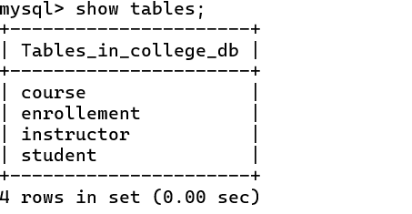

mysql> INSERT INTO Instructor (Name, Email, Department)
-> VALUES
-> ('Dr. Alan Turing', 'alan@college.edu', 'Artificial Intelligence'),
-> ('Prof. Ada Lovelace', 'ada@college.edu', 'Software Engineering'),
-> ('Sensei Tanaka', 'tanaka@college.edu', 'Foreign Languages');
Query OK, 3 rows affected (0.01 sec)
Records: 3 Duplicates: 0 Warnings: 0
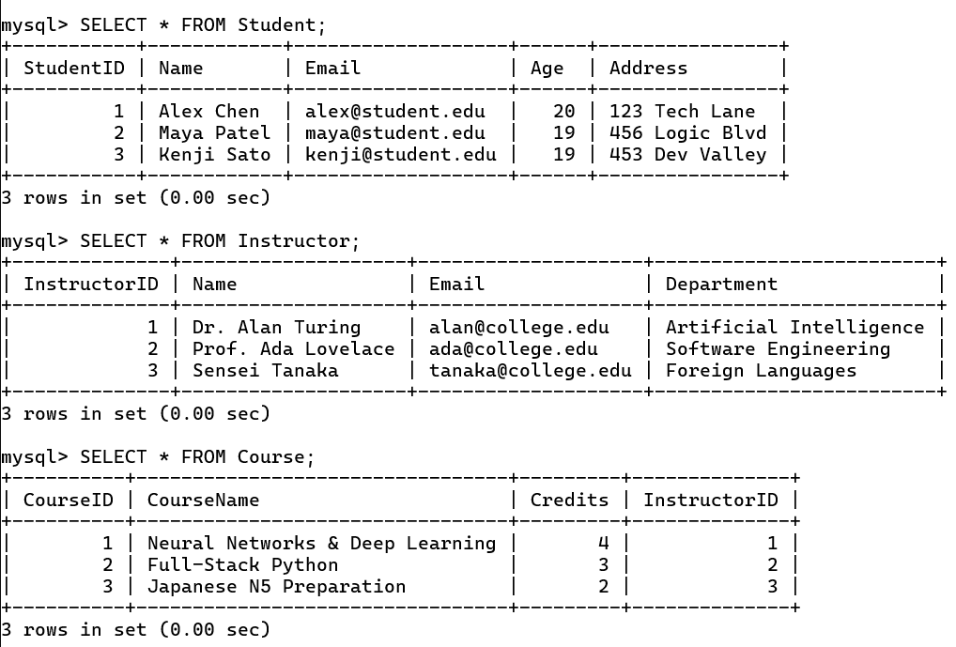

mysql> INSERT INTO Student (Name, Email, Age, Address)
-> VALUES
-> ('Alex Chen', 'alex@student.edu', 20, '123 Tech Lane'),
-> ('Maya Patel', 'maya@student.edu', 19, '456 Logic Blvd'),
-> ('Kenji Sato', 'kenji@student.edu', 19, '453 Dev Valley');
Query OK, 3 rows affected (0.01 sec)
Records: 3 Duplicates: 0 Warnings: 0


mysql> INSERT INTO Course (CourseName, Credits, InstructorID)
-> VALUES
-> ('Neural Networks & Deep Learning', 4, 1),
-> ('Full-Stack Python', 3, 2),
-> ('Japanese N5 Preparation', 2, 3);
Query OK, 3 rows affected (0.01 sec)Records: 3 Duplicates: 0 Warnings: 
mysql> INSERT INTO Enrollement (StudentID, CourseID, EnrollmentDate)
-> VALUES
-> (1, 1, '2026-08-15'),
-> (1, 2, '2026-08-15'),
-> (2, 2, '2026-08-16'),
-> (3, 1, '2026-08-17'),
-> (3, 3, '2026-08-17');
Query OK, 5 rows affected (0.01 sec)
Records: 5 Duplicates: 0 Warnings: 0
