mysql> USE college_db;
Database changed
mysql> CREATE VIEW StudentCourseReport AS
-> SELECT
-> Student.Name AS Student_Name,
-> Course.CourseName,
-> Instructor.Name AS Instructor_Name
-> FROM Enrollment
-> JOIN Student ON Enrollment.StudentID = Student.StudentID
-> JOIN Course ON Enrollment.CourseID = Course.CourseID
-> JOIN Instructor ON Course.InstructorID = Instructor.InstructorID;
Query OK, 0 rows affected (0.01 sec)

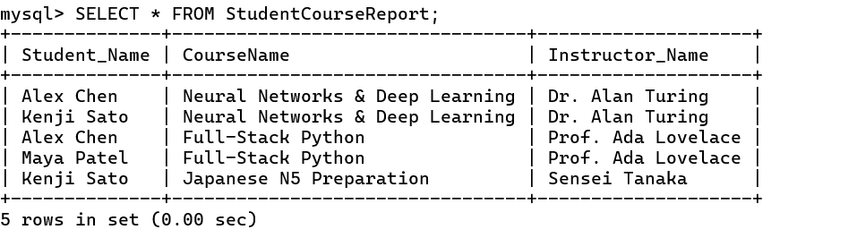

mysql> CREATE VIEW StudentDirectory
-> AS SELECT
-> StudentID, Name, Email, Age
-> FROM Student;
Query OK, 0 rows affected (0.05 sec)

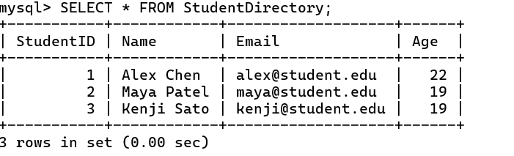

mysql> UPDATE StudentDirectory SET Age = 22 WHERE Name = 'Alex Chen';
Query OK, 1 row affected (0.01 sec)
Rows matched: 1 Changed: 1 Warnings: 0

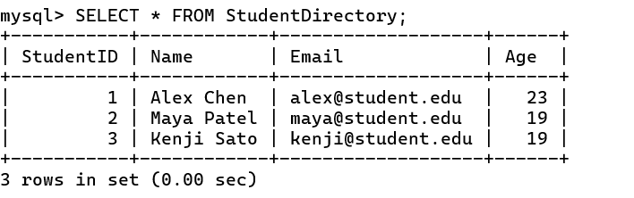

mysql> DELETE FROM StudentDirectory WHERE Name = 'John Doe';
Query OK, 0 rows affected (0.00 sec)

mysql> CREATE INDEX
-> idx_student_name ON Student(Name);
Query OK, 0 rows affected (0.05 sec)
Records: 0 Duplicates: 0 Warnings: 0
