mysql> USE college_db;
Database changed

mysql> SELECT Name, Age
-> FROM Student
-> WHERE Age > 19;


mysql> SELECT Course.CourseName, Course.Credits
-> FROM Course
-> JOIN Instructor ON Course.InstructorID = Instructor.InstructorID
-> WHERE Instructor.Name = 'Dr. Alan Turing';


mysql> SELECT Name, Email
-> FROM Student
-> ORDER BY Name ASC;


mysql> SELECT CourseName, Credits
-> FROM Course
-> ORDER BY Credits DESC;


mysql> SELECT AVG(Age) AS Average_Student_Age
-> FROM Student;
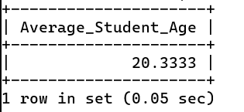

mysql> SELECT Course.CourseName, COUNT(Enrollment.StudentID) AS Total_Students
-> FROM Enrollment
-> JOIN Course ON Enrollment.CourseID = Course.CourseID
-> GROUP BY Course.CourseName;


mysql> SELECT Name, Age
-> FROM Student
-> WHERE Age > (SELECT AVG(Age) FROM Student);


