mysql> CREATE DATABASE shop_db;
Query OK, 1 row affected (0.01 sec)

mysql> USE shop_db;
Database changed

mysql> CREATE TABLE Customers (
-> CustomerID INT PRIMARY KEY,
-> CustomerName VARCHAR(100)
-> );
Query OK, 0 rows affected (0.02 sec)

mysql> CREATE TABLE Orders (
-> OrderID INT PRIMARY KEY,
-> Product VARCHAR(100),
-> CustomerID INT
-> );
Query OK, 0 rows affected (0.02 sec)

mysql> INSERT INTO Customers (CustomerID, CustomerName)
-> VALUES
-> (1, 'Alex Chen'),
-> (2, 'Maya Patel'),
-> (3, 'Kenji Sato');
Query OK, 3 rows affected (0.01 sec)
Records: 3 Duplicates: 0 Warnings: 0

mysql> INSERT INTO Orders (OrderID, Product, CustomerID)
-> VALUES
-> (101, 'Mac Book Pro', 1),
-> (102, 'Mechanical Keyboard', 1),
-> (103, 'Wireless Mouse', 2),
-> (104, '27-inch Monitor', 99);
Query OK, 4 rows affected (0.04 sec)
Records: 4 Duplicates: 0 Warnings: 0

mysql> SELECT Customers.CustomerName, Orders.OrderID, Orders.Product
-> FROM Customers
-> INNER JOIN Orders ON Customers.CustomerID = Orders.CustomerID;
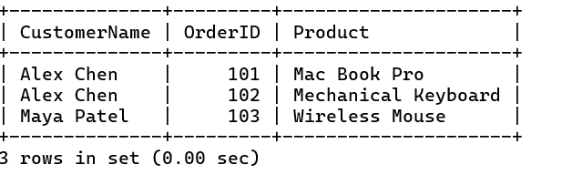

mysql> SELECT Customers.CustomerName, Orders.OrderID, Orders.Product
-> FROM Customers
-> LEFT JOIN Orders ON Customers.CustomerID = Orders.CustomerID;
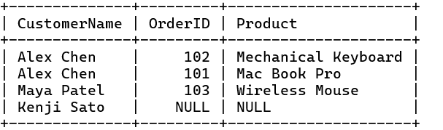

mysql> SELECT Customers.CustomerName, Orders.OrderID, Orders.Product
-> FROM Customers
-> RIGHT JOIN Orders ON Customers.CustomerID = Orders.CustomerID;
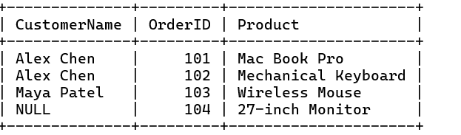

mysql> SELECT Customers.CustomerName, Orders.OrderID, Orders.Product
-> FROM Customers
-> LEFT JOIN Orders ON Customers.CustomerID = Orders.CustomerID
-> UNION
-> SELECT Customers.CustomerName, Orders.OrderID, Orders.Product
-> FROM Customers
-> RIGHT JOIN Orders ON Customers.CustomerID = Orders.CustomerID;
