mysql> CREATE DATABASE Sales_db;
Query OK, 1 row affected (0.01 sec)

mysql> USE Sales_db;
Database changed

mysql> CREATE TABLE Sales (
-> SaleID INT PRIMARY KEY AUTO_INCREMENT,
-> ItemName VARCHAR(100),
-> Quantity INT,
-> PricePerUnit DECIMAL(10, 2)
-> );
Query OK, 0 rows affected (0.03 sec)

mysql> DELIMITER //
mysql> CREATE PROCEDURE AddNewSale(
-> IN p_ItemName VARCHAR(100),
-> IN p_Quantity INT,
-> IN p_Price DECIMAL(10,2)
-> )
-> BEGIN
-> -- Here you could add IF statements to validate data before inserting
-> INSERT INTO Sales (ItemName, Quantity, PricePerUnit)
-> VALUES (p_ItemName, p_Quantity, p_Price);
-> END //
Query OK, 0 rows affected (0.01 sec)
mysql> DELIMITER ;

mysql> CALL AddNewSale('Ergonomic Chair', 2, 150.00);
Query OK, 1 row affected (0.02 sec)

mysql> CALL AddNewSale('Standing Desk', 1, 300.00);
Query OK, 1 row affected (0.01 sec)

mysql> DELIMITER //
mysql> CREATE FUNCTION CalculateTotalSales()
-> RETURNS DECIMAL(10,2)
-> READS SQL DATA
-> BEGIN
-> DECLARE total DECIMAL(10,2);
->
-> -- Calculate Quantity * Price for all rows and store it in our 'total' variable
-> SELECT SUM(Quantity * PricePerUnit) INTO total FROM Sales;
->
-> -- IFNULL ensures that if the table is empty, we return 0.00 instead of a NULL error
-> RETURN IFNULL(total, 0.00);
-> END //
Query OK, 0 rows affected (0.01 sec)
mysql> DELIMITER ;

mysql> SELECT * FROM Sales;
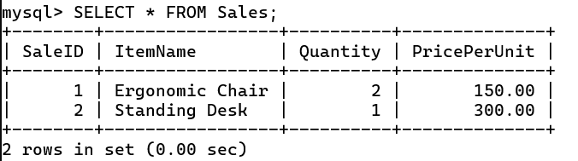
mysql> SELECT CalculateTotalSales() AS Total_System_Revenue;
