mysql> CREATE DATABASE employee_db;
Query OK, 1 row affected (0.01 sec)

mysql> USE employee_db;
Database changed

mysql> CREATE TABLE Employees (
-> EmpID INT PRIMARY KEY AUTO_INCREMENT,
-> Name VARCHAR(100),
-> Department VARCHAR(50),
-> Salary DECIMAL(10,2)
-> );
Query OK, 0 rows affected (0.04 sec)

mysql> CREATE TABLE Employee_Audit (
-> AuditID INT PRIMARY KEY AUTO_INCREMENT,
-> EmpID INT,
-> ActionType VARCHAR(50),
-> OldSalary DECIMAL(10,2),
-> NewSalary DECIMAL(10,2),
-> ChangeDate TIMESTAMP DEFAULT CURRENT_TIMESTAMP
-> );
Query OK, 0 rows affected (0.02 sec)

mysql> INSERT INTO Employees (Name, Department, Salary) VALUES
-> ('Alice Smith', 'IT', 60000.00),
-> ('Bob Jones', 'HR', 45000.00),
-> ('Charlie Brown', 'IT', 55000.00);
Query OK, 3 rows affected (0.00 sec)
Records: 3 Duplicates: 0 Warnings: 0

mysql> DELIMITER //
mysql> CREATE TRIGGER AfterSalaryUpdate
-> AFTER UPDATE ON Employees
-> FOR EACH ROW
-> BEGIN
-> -- Check if the salary actually changed
-> IF OLD.Salary <> NEW.Salary THEN
-> -- Insert a log record using the special OLD and NEW keywords
-> INSERT INTO Employee_Audit (EmpID, ActionType, OldSalary, NewSalary)
-> VALUES (OLD.EmpID, 'SALARY_UPDATE', OLD.Salary, NEW.Salary);
-> END IF;
-> END //
Query OK, 0 rows affected (0.03 sec)
mysql> DELIMITER ;

mysql> DELIMITER //
mysql> CREATE PROCEDURE UpdateITSalaries()
-> BEGIN
-> -- 1. Declare variables to hold the data we pull from each row
-> DECLARE v_EmpID INT;
-> DECLARE v_CurrentSalary DECIMAL(10,2);
-> -- 2. Declare a flag to tell us when we run out of rows
-> DECLARE done INT DEFAULT FALSE;
-> -- 3. DECLARE THE CURSOR (The query we want to loop through)
-> DECLARE emp_cursor CURSOR FOR
-> SELECT EmpID, Salary FROM Employees WHERE Department = 'IT';
-> -- 4. Tell MySQL what to do when there are no more rows left
-> DECLARE CONTINUE HANDLER FOR NOT FOUND SET done = TRUE;
-> -- 5. Open the cursor and start the engine
-> OPEN emp_cursor;
-> -- 6. Start the loop
-> read_loop: LOOP
-> -- Grab the next row and dump the data into our variables
-> FETCH emp_cursor INTO v_EmpID, v_CurrentSalary;
-> -- If we hit the end of the list, break out of the loop
-> IF done THEN
-> LEAVE read_loop;
-> END IF;
-> -- 7. Apply the 10% raise to this specific row
-> UPDATE Employees
-> SET Salary = v_CurrentSalary * 1.10
-> WHERE EmpID = v_EmpID;
-> END LOOP;
-> -- 8. Clean up and close the cursor
-> CLOSE emp_cursor;
-> END //
Query OK, 0 rows affected (0.01 sec)
mysql> DELIMITER ;

mysql> CALL UpdateITSalaries();
Query OK, 0 rows affected (0.03 sec)

mysql> SELECT * FROM Employee_Audit;
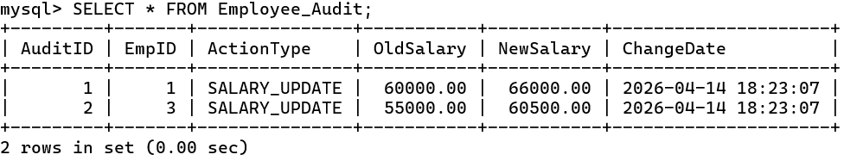

mysql> CALL UpdateITSalaries();
Query OK, 0 rows affected (0.01 sec)

mysql> SELECT * FROM Employee_Audit;
