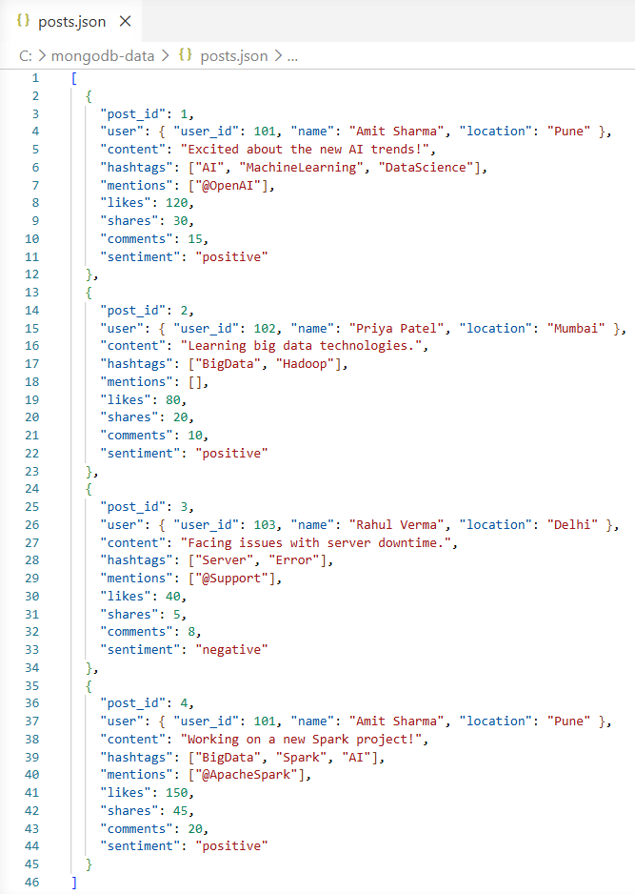
Microsoft Windows [Version 10.0.26200.8246]
(c) Microsoft Corporation. All rights reserved.

C:\Users\Lenovo>mongoimport --db social_media_db --collection posts --file "C:\mongodb-data\posts.json" --jsonArray
2026-04-21T23:11:29.237+0530 connected to: mongodb://localhost/
2026-04-21T23:11:29.287+0530 4 document(s) imported successfully. 0 document(s) failed to import.

Microsoft Windows [Version 10.0.26200.8246]
(c) Microsoft Corporation. All rights reserved.

C:\Users\Lenovo>mongosh
Current Mongosh Log ID: 69e7b6ea3362ac640c3682d0
Connecting to: mongodb://127.0.0.1:27017/?directConnection=true&serverSelectionTimeoutMS=2000&appName=mongosh+2.8.2
Using MongoDB: 8.2.6
Using Mongosh: 2.8.2

test> use social_media_db
switched to db social_media_db

social_media_db> db.posts.find().pretty()
[
{
_id: ObjectId('69e0fbc35bfc68fbb91e1f51'),
post_id: 2,
user: { user_id: 102, name: 'Priya Patel', location: 'Mumbai' },
content: 'Learning big data technologies.',
hashtags: [ 'BigData', 'Hadoop' ],
mentions: [],
likes: 80,
shares: 20,
comments: 10,
sentiment: 'positive'
},
{
_id: ObjectId('69e0fbc35bfc68fbb91e1f52'),
post_id: 3,
user: { user_id: 103, name: 'Rahul Verma', location: 'Delhi' },
content: 'Facing issues with server downtime.',
hashtags: [ 'Server', 'Error' ],
mentions: [ '@Support' ],
likes: 40,
shares: 5,
comments: 8,
sentiment: 'negative'
},
{
_id: ObjectId('69e0fbc35bfc68fbb91e1f53'),
post_id: 1,
user: { user_id: 101, name: 'Amit Sharma', location: 'Pune' },
content: 'Excited about the new AI trends!',
hashtags: [ 'AI', 'MachineLearning', 'DataScience' ],
mentions: [ '@OpenAI' ],
likes: 120,
shares: 30,
comments: 15,
sentiment: 'positive'
},
{
_id: ObjectId('69e0fbc35bfc68fbb91e1f54'),
post_id: 4,
user: { user_id: 101, name: 'Amit Sharma', location: 'Pune' },
content: 'Working on a new Spark project!',
hashtags: [ 'BigData', 'Spark', 'AI' ],
mentions: [ '@ApacheSpark' ],
likes: 150,
shares: 45,
comments: 20,
sentiment: 'positive'
}
]

social_media_db> db.posts.find({ hashtags: "AI" })
[
{
_id: ObjectId('69e0fbc35bfc68fbb91e1f53'),
post_id: 1,
user: { user_id: 101, name: 'Amit Sharma', location: 'Pune' },
content: 'Excited about the new AI trends!',
hashtags: [ 'AI', 'MachineLearning', 'DataScience' ],
mentions: [ '@OpenAI' ],
likes: 120,
shares: 30,
comments: 15,
sentiment: 'positive'
},
{
_id: ObjectId('69e0fbc35bfc68fbb91e1f54'),
post_id: 4,
user: { user_id: 101, name: 'Amit Sharma', location: 'Pune' },
content: 'Working on a new Spark project!',
hashtags: [ 'BigData', 'Spark', 'AI' ],
mentions: [ '@ApacheSpark' ],
likes: 150,
shares: 45,
comments: 20,
sentiment: 'positive'
}
]

social_media_db> db.posts.find({ "user.location": "Pune" })
[
{
_id: ObjectId('69e0fbc35bfc68fbb91e1f53'),
post_id: 1,
user: { user_id: 101, name: 'Amit Sharma', location: 'Pune' },
content: 'Excited about the new AI trends!',
hashtags: [ 'AI', 'MachineLearning', 'DataScience' ],
mentions: [ '@OpenAI' ],
likes: 120,
shares: 30,
comments: 15,
sentiment: 'positive'
},
{
_id: ObjectId('69e0fbc35bfc68fbb91e1f54'),
post_id: 4,
user: { user_id: 101, name: 'Amit Sharma', location: 'Pune' },
content: 'Working on a new Spark project!',
hashtags: [ 'BigData', 'Spark', 'AI' ],
mentions: [ '@ApacheSpark' ],
likes: 150,
shares: 45,
comments: 20,
sentiment: 'positive'
}
]

social_media_db> db.posts.find({ likes: { $gt: 100 } })
[
{
_id: ObjectId('69e0fbc35bfc68fbb91e1f53'),
post_id: 1,
user: { user_id: 101, name: 'Amit Sharma', location: 'Pune' },
content: 'Excited about the new AI trends!',
hashtags: [ 'AI', 'MachineLearning', 'DataScience' ],
mentions: [ '@OpenAI' ],
likes: 120,
shares: 30,
comments: 15,
sentiment: 'positive'
},
{
_id: ObjectId('69e0fbc35bfc68fbb91e1f54'),
post_id: 4,
user: { user_id: 101, name: 'Amit Sharma', location: 'Pune' },
content: 'Working on a new Spark project!',
hashtags: [ 'BigData', 'Spark', 'AI' ],
mentions: [ '@ApacheSpark' ],
likes: 150,
shares: 45,
comments: 20,
sentiment: 'positive'
}
]

social_media_db> db.posts.countDocuments()
4

social_media_db> db.posts.aggregate([
| { $unwind: "$hashtags" },
| { $group: { _id: "$hashtags", count: { $sum: 1 } } },
| { $sort: { count: -1 } },
| { $limit: 5 }
| ])
[
{ _id: 'BigData', count: 2 },
{ _id: 'AI', count: 2 },
{ _id: 'DataScience', count: 1 },
{ _id: 'Server', count: 1 },
{ _id: 'Hadoop', count: 1 }
]

social_media_db> db.posts.aggregate([
| { $unwind: "$hashtags" },
| { $group: { _id: "$hashtags", avgLikes: { $avg: "$likes" } } },
| { $sort: { avgLikes: -1 } }
| ])
[
{ _id: 'Spark', avgLikes: 150 },
{ _id: 'AI', avgLikes: 135 },
{ _id: 'MachineLearning', avgLikes: 120 },
{ _id: 'DataScience', avgLikes: 120 },
{ _id: 'BigData', avgLikes: 115 },
{ _id: 'Hadoop', avgLikes: 80 },
{ _id: 'Error', avgLikes: 40 },
{ _id: 'Server', avgLikes: 40 }
]

social_media_db> db.posts.aggregate([
| { $group: { _id: "$sentiment", totalPosts: { $sum: 1 } } }
| ])
[
{ _id: 'negative', totalPosts: 1 },
{ _id: 'positive', totalPosts: 3 }
]

social_media_db> db.posts.aggregate([
| { $group: { _id: "$user.name", totalPosts: { $sum: 1 } } },
| { $sort: { totalPosts: -1 } }
| ])
[
{ _id: 'Amit Sharma', totalPosts: 2 },
{ _id: 'Rahul Verma', totalPosts: 1 },
{ _id: 'Priya Patel', totalPosts: 1 }
]

social_media_db> db.posts.aggregate([
| { $project: { content: 1, engagement: { $add: ["$likes", "$shares", "$comments"] } } },
| { $sort: { engagement: -1 } },
| { $limit: 5 }
| ])
[
{
_id: ObjectId('69e0fbc35bfc68fbb91e1f54'),
content: 'Working on a new Spark project!',
engagement: 215
},
{
_id: ObjectId('69e0fbc35bfc68fbb91e1f53'),
content: 'Excited about the new AI trends!',
engagement: 165
},
{
_id: ObjectId('69e0fbc35bfc68fbb91e1f51'),
content: 'Learning big data technologies.',
engagement: 110
},
{
_id: ObjectId('69e0fbc35bfc68fbb91e1f52'),
content: 'Facing issues with server downtime.',
engagement: 53
}
]

