**ABSTRACT:** *Developing countries focus on so many other issues of the country due to among the primary issues is disregarded. Day to day road accidents due to rash driving or over speeding that can be averted are becoming the prime reason for deaths in road accidents. Current solutions to overcome these challenges are either by using speed cameras or using the RFID technology but these technologies have proved inefficient with multiple vehicles.*

**Smart challan system**

**Tarun Chaudhary₁, Parveen₂, Ankur₃, Tarun Kumar₄**

**Mentor: Mr. Manoj Kumar Yadav, Assistant Professor, Dronacharya Group of Institutions Greater Noida**

₁, ₂, ₃, ₄ Bachelor of technology, computer science and engineering, Dronacharya Group of Institutions Greater Noida

*Our solution to the problem is a system installed within the vehicle that would check the speed limit of the zone the vehicle is with the help of google maps and send a message using GSM, if that speed limit is not maintained.*

**Key Words:** GSM, RFID

**1.Introduction**

*India has been growing rapidly and by growth we do not mean only development. The population of India has continued to increase from the past many years and to order and discipline such a large population becomes quite difficult. Think about our traffic police officers where they need to stand on the road for the complete day to avoid chaos on road. It becomes difficult for them to fine the culprits, and the indiscipline on the roads carry on, so to avoid such problems, we have come up with the solution, where the system would be embedded in the vehicle that would help the authorities to maintain discipline on the roads by monitoring the speed of the vehicles and even helping them to fine the culprits.*

**2.Existing System**

*There exist two solutions currently, one, using the speed camera, that captures the number plate of the vehicle, which are quite costly, second, the one using the RFID technology[1] where each car is equipped with a fast tag that makes it easier for the camera to scan, but both these solutions shows inefficiency when multiple vehicles cross at the same time, moreover, every nook and corner cannot have a camera and a scanner, this acts as a loop hole for these solutions.*

**3.Proposed system**

*For our system we would be using the google maps along with the GSM and speed sensors. With the help of google maps we can come to know about the speed limit of the zone, where the vehicle currently is, with the help of the speed sensors we can calculate the speed of the vehicle and if the vehicle crosses the specified speed limit, he/she would first be given an alert and if the driver continues to do so, a message would be sent to the authorities with the vehicle number and the user’s registered mobile number.*

**3.1 Implementation**

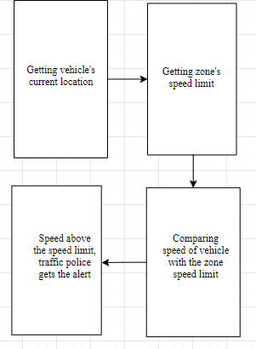

**Fig1 – Block diagram of smart challan system**

**3.2 Arduino**

*A microcontroller board, Arduino Uno is based on ATmega328P. It has 14 input/output pins out of which 6 can be used as PWM outputs, 6 analog inputs. It also has a 16 MHz quartz crystal, a USB connection, a power jack, an ICSP header and a reset button.*

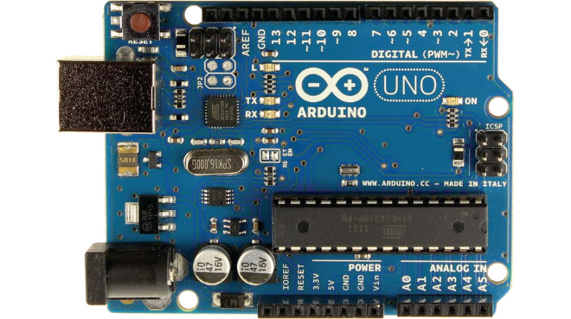

**Fig2 – Arduino UNO**

**3.3 GSM**

*An open and digital cellular technology, GSM is utilized for transporting voice over cellular and data related services which operate at the frequencies of 850MHz, 900MHz, 1800MHz, and 1900MHz bands. This technology was developed as a digital system using the time division multiple access (TDMA) technique for communication purposes.*

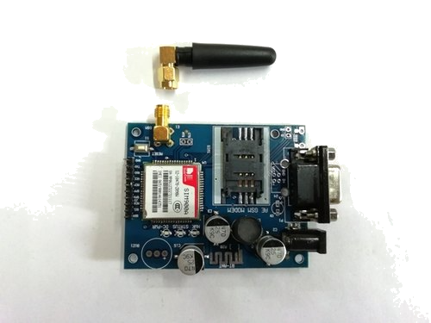

**Fig3 – GSM SIM900A**

**3.4 Tachometer**

*The IR sensor[2] module consists mainly of the IR Transmitter and Receiver, Op amp, Variable Resistor (Trimmer pot), output LED in brief. IR LED Transmitter. IR LED emits light, in the range of Infrared frequency. IR light is invisible to us as its wavelength (700nm – 1mm) is much higher than the visible light range*

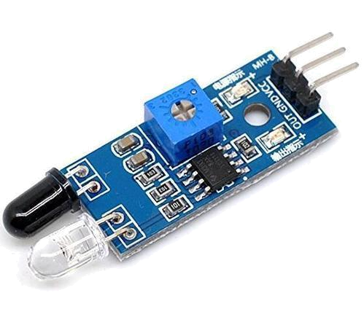

**Fig4 – Infrared Sensor/Tachometer**

**3.5 Connecting wires**

*The connecting wires consist of pins at both the ends that are used to connect different modules together*

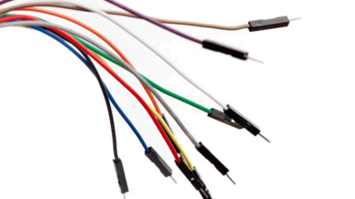

**Fig5 – connecting wires**

**4. Literature survey**

**4.1 E-Challan system**

*Authors – Allokik Pranshu, Sanjay Kumar Ijju, Swarnalatha P.*

*This paper mainly deals with the creation of an online platform for the challan system that would make it convenient for the vehicle owners as well as the traffic police and RTO authorities [3].*

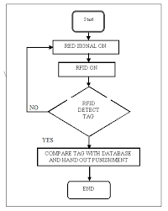

**Fig6 – E-Challan block diagram [4]**

**4.2 RFID technology and its application**

*Authors – Davinder Parkash, Twinkle Kundu, Preet Kaur.*

*This paper reviews the use of RFID technology using a fast tag, that would be put on the vehicle and when the vehicle breaks any traffic rule then the scanner would scan the tag and would get the vehicle number [5].*

*The limitations for this solution are that sometimes the photos are not effective and it is not effective during night.*

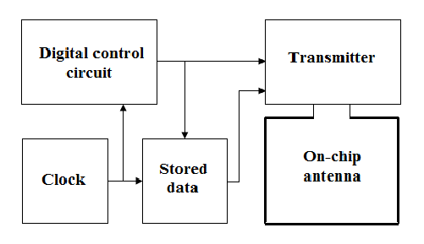

**Fig7 – RFID block diagram [6]**

**5. Applications**

*• This project can be used to prevent rash driving by keeping a track of the speed*

*• This project can be used to make people obey traffic signals at every nook and corner*

**6. Results and discussion**

*The project was successfully designed and tested. The project works as helping hand for the law protectors, for law protectors cannot be present everywhere, so our project sends the message with the help of GSM and then the traffic police can fine the vehicle for breaking the law.*

*The result will be displayed as:*

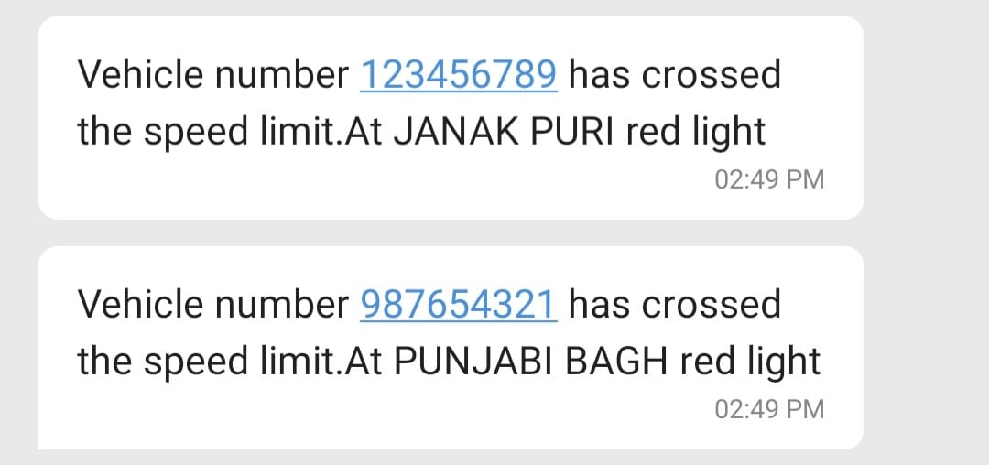

**7. Conclusion**

*In this paper our proposed idea is to control chaos and indiscipline on roads and providing the law breaker with an automated challan that would save time his/her time and makes it easy for the traffic police to fine the culprits.*

*We also hope that the project proves useful and helps the law protectors in maintaining discipline and avoiding accidents on roads.*

**References**

*[1] International Research Journal of Engineering and Technology [IRJET] e-ISSN: 2395-0056; p-ISSN: 2395-0072; Volume: 07 Issue: 03|Mar 2020 available at* [*www.irjet.net*](http://www.irjet.net)

*[2] https://www.google.com/search?q=ir+sensor+module&oq=Ir+se&aqs=chrome.1.69i57j69i59l2j0l7.1827j0j7&sourceid=chrome&ie=UTF-8*

*[3] International Journal of Computer Applications ISSN: 0975-8887; Volume: 176 -No.37 Issue: July 2020*

*[4] International Journal of Advanced Engineering and Research Development [IJAERD] e-ISSN: 2348-4470; p-ISSN: 2348-6406; Volume: 4 Issue: 08|Aug 2017 available at www.ijaerd.com*

*[5] International Journal of Electronics,* *Communication & Instrumentation Engineering Research and Development (IJECIERD) ISSN: 2249-684X Vol.2 Issue: 03|Sept 2012*

*[6] https://www.google.com/search?q=rfid+tag+working+block+diagram&sxsrf=ALeKk024TCzZ8CwhdiBFg1bu_3V_F-4oVQ:1624628357793&tbm=isch&source=iu&ictx=1&fir=8gdOGi9hzX*