Dreameweaver CS5 Project I
Grading Rubric

Student Name (s): Trevor Bright
You may type on or print this paper (to turn it in). Save it in the documents folder of your site (if electronic).

Finished projects should be placed in the DREAMWEAVER_PROJECT folder (lastname_firstname or lastname_lastname).

Technical
CSS Document | All pages are laid out with ONE EXTERNAL CSS document (you can have more than one) | 5
Organization | Inside of one root folder is an images and a pages folder. Index is in the Site/Root folder (put css in root folder or its own). Assets inside of each:  index.html in the root folder,  all secondary pages in the pages folder.  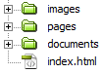 | 5
Pages | A minimum of four pages, including index | 5
Pseudoclasses | Pseudoclasses are used to style links | 5
Pre-Design | A wireframe that includes the elements of the pages. This includes colors, fonts, graphics, layout, etc. | 20
Design
Usability | Usable - Logical, intuitive sequence of information. Menus and paths to all information are clear and direct. Users can progress intuitively through screens in a logical path to find information. | 10
Accessibility | Accessibility techniques are used where applicable | 10
Subject Knowledge | All information is clear, appropriate, and correct. | 10
Creativity & Effort | Evident that time, effort, and care was put into the assignment | 10
Graphic Design | The combination of elements fonts, colors, words, graphics, content, layout - communicates and persuades to an intended audience. | 10
Use of Graphics/Pictures | Appropriate amounts of enhancements are used effectively to entice users to learn and to enrich the experience. | 10

Wireframe/Planning Sheet

Site Title | Counter Strike Global Offensive
Purpose | Teach people about Counter Strike Global Offensive
Audience | People that want to play the game
Font(s) & Rationale | Courier New, Courier, monospace
Colors (All) & Rationale | Black background  Grey body  Black text in the body  #D9C27F for nav and footer  #a8a8a8 for the sidebar
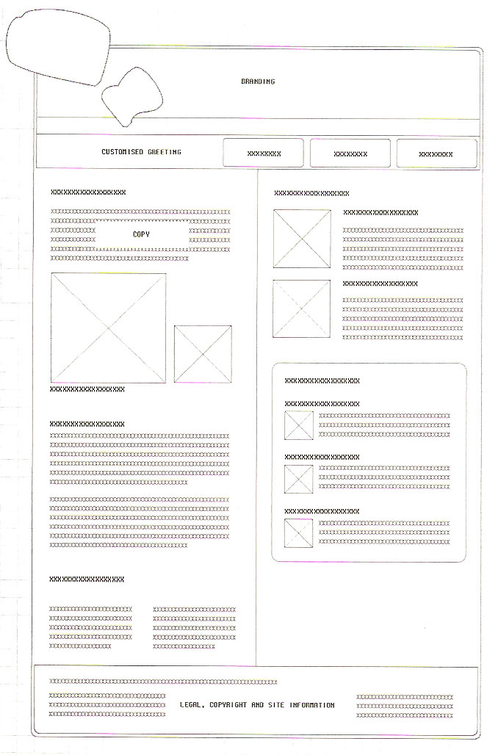
Wireframe (draw/sketch primary page and secondary page - if needed):
Home
Banner

Home | Quick overview about the game  xxxxxxxxxxxxxxxxxxxxx xxxxxxxxxxxxxxxxxxxxx xxxxxxxxxxxxxxxxxxxxx xxxxxxxxxxxxxxxxxxxxx xxxxxxxxxxxxxxxxxxxxx xxxxxxxxxxxxxxxxxxxxx  xxxxxxxxxxxxxxxxxxxxx xxxxxxxxxxxxxxxxxxxxx xxxxxxxxxxxxxxxxxxxxx  xxxxxxxxxxxxxxxxxxxxx xxxxxxxxxxxxxxxxxxxxx xxxxxxxxxxxxxxxxxxxxx  xxxxxxxxxxxxxxxxxxxxx xxxxxxxxxxxxxxxxxxxxx xxxxxxxxxxxxxxxxxxxxx xxxxxxxxxxxxxxxxxxxxx xxxxxxxxxxxxxxxxxxxxx xxxxxxxxxxxxxxxxxxxxx xxxxxxxxxxxxxxxxxxxxx xxxxxxxxxxxxxxxxxxxxx xxxxxxxxxxxxxxxxxxxxx
About
How to play
How to purchase
This site was made by Trevor Bright
This site was made by Trevor Bright | Picture
Footer with links
About
Banner

Home | About information  xxxxxxxxxxxxxxxxxxxxx xxxxxxxxxxxxxxxxxxxxx xxxxxxxxxxxxxxxxxxxxx xxxxxxxxxxxxxxxxxxxxx xxxxxxxxxxxxxxxxxxxxx xxxxxxxxxxxxxxxxxxxxx  xxxxxxxxxxxxxxxxxxxxx xxxxxxxxxxxxxxxxxxxxx xxxxxxxxxxxxxxxxxxxxx  xxxxxxxxxxxxxxxxxxxxx xxxxxxxxxxxxxxxxxxxxx xxxxxxxxxxxxxxxxxxxxx  xxxxxxxxxxxxxxxxxxxxx xxxxxxxxxxxxxxxxxxxxx xxxxxxxxxxxxxxxxxxxxx xxxxxxxxxxxxxxxxxxxxx xxxxxxxxxxxxxxxxxxxxx xxxxxxxxxxxxxxxxxxxxx xxxxxxxxxxxxxxxxxxxxx xxxxxxxxxxxxxxxxxxxxx xxxxxxxxxxxxxxxxxxxxx xxxxxxxxxxxxxxxxxxxxx xxxxxxxxxxxxxxxxxxxxx xxxxxxxxxxxxxxxxxxxxx xxxxxxxxxxxxxxxxxxxxx xxxxxxxxxxxxxxxxxxxxx xxxxxxxxxxxxxxxxxxxxx
About
How to play
How to purchase
This site was made by Trevor Bright
This site was made by Trevor Bright | Picture | Picture
Footer with links

