Approval
This document has been agreed to proceed for UAT process:
Name | Organization | Signature | Date

CSC_TRANSACTION
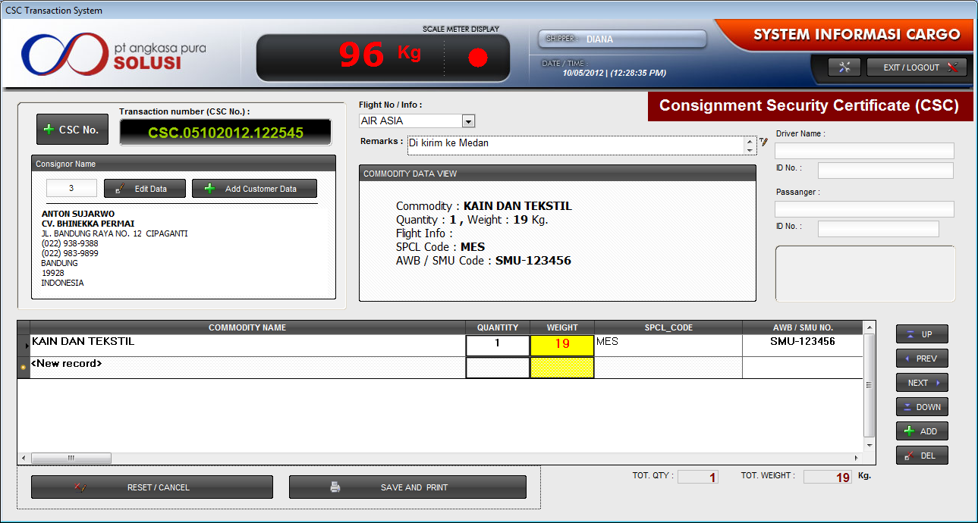

CASHIER_INVOICE
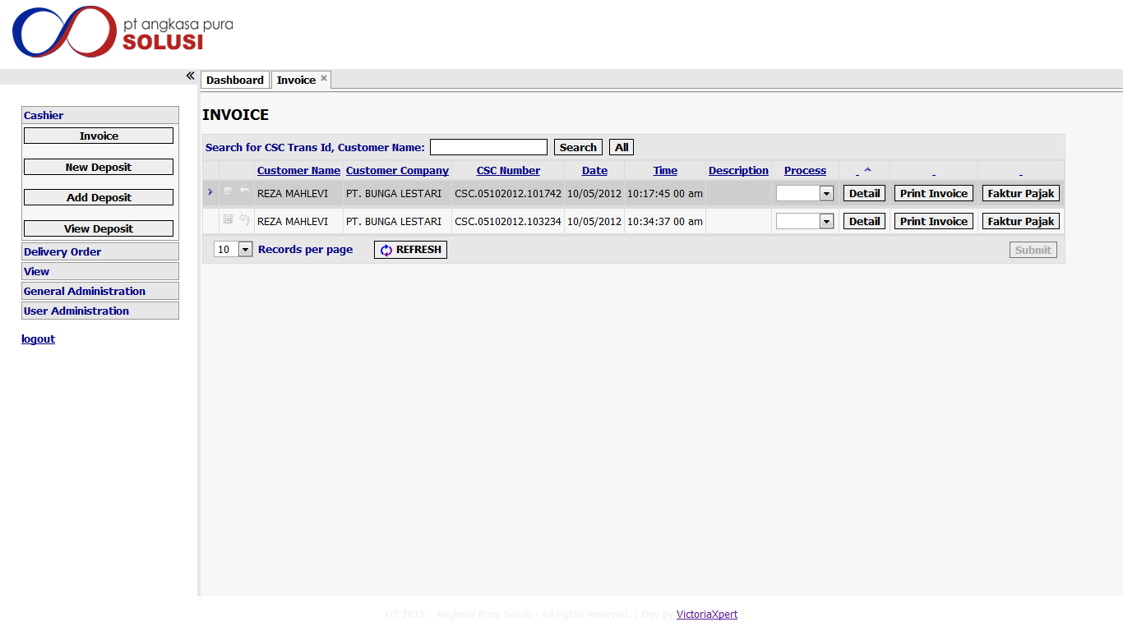

CASHIER_INVOICE_DETAIL
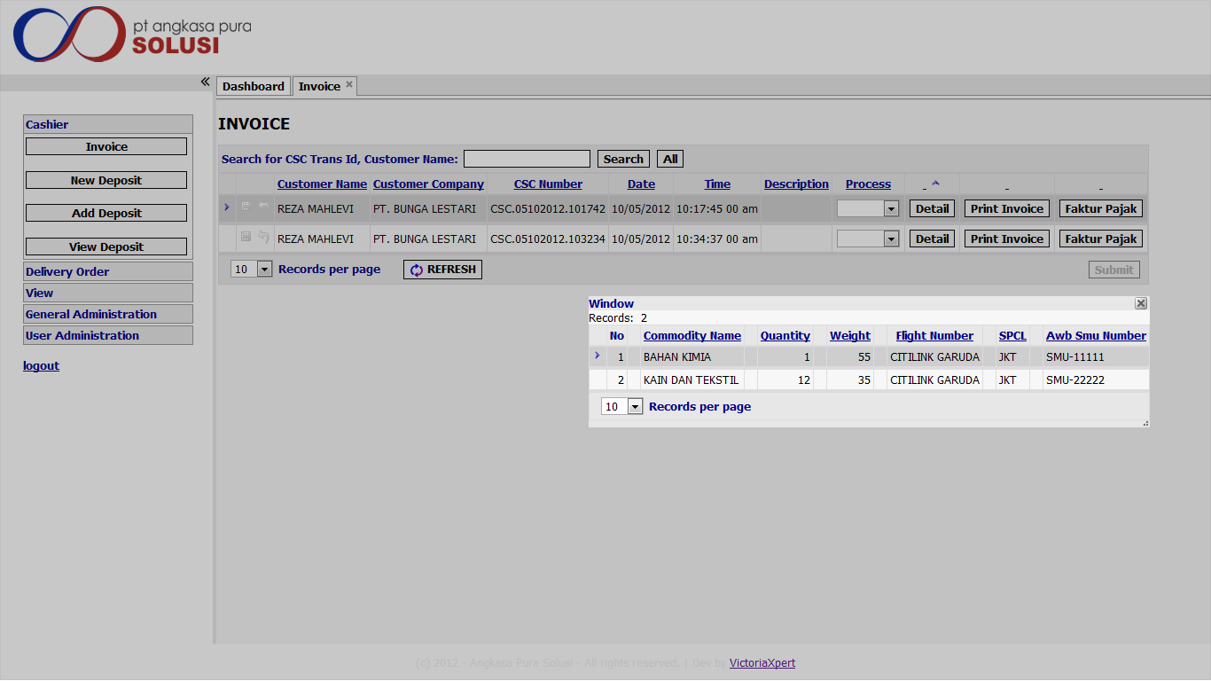

CASHIER_INVOICE_PRINT_INVOICE
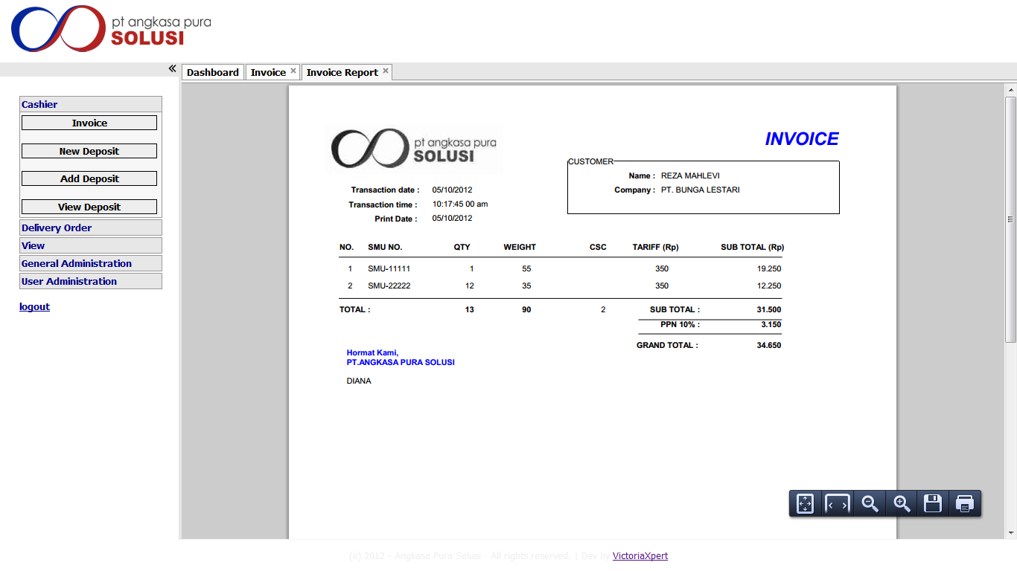

CASHIER_INVOICE_PRINT_FAKTUR_PAJAK
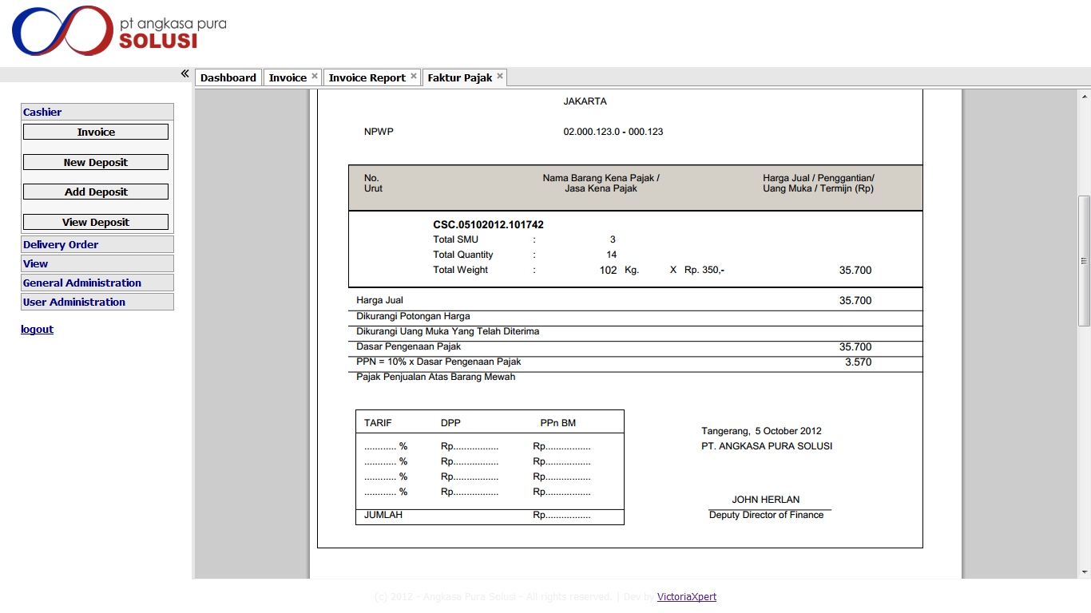

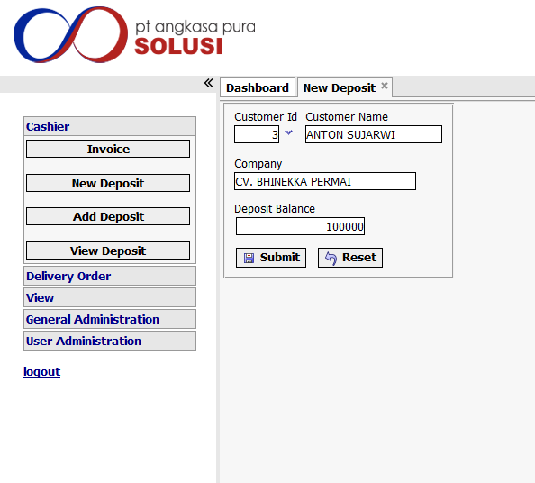
CASHIER_NEW_DEPOSIT

CASHIER_ADD_DEPOSIT

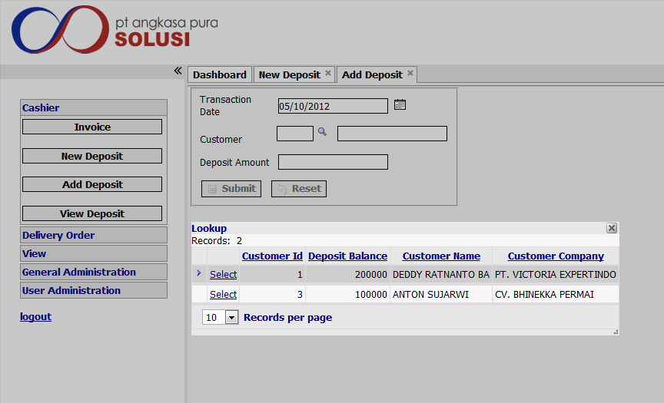

8. CASHIER_VIEW_DEPOSIT
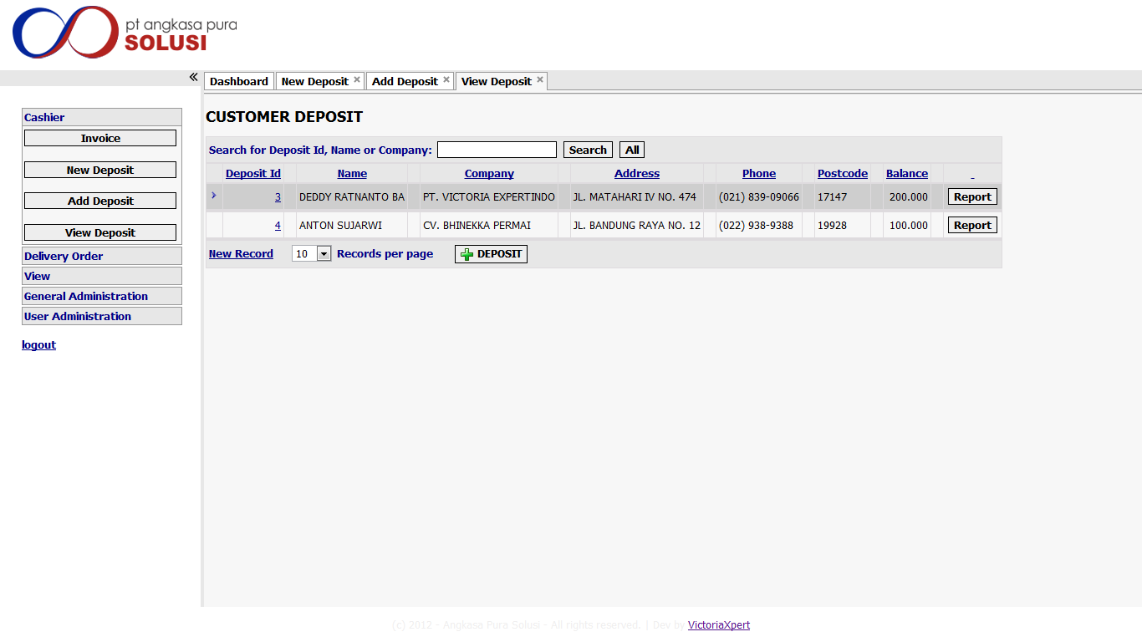

DELIVERY_ORDER_PROCESS_DO
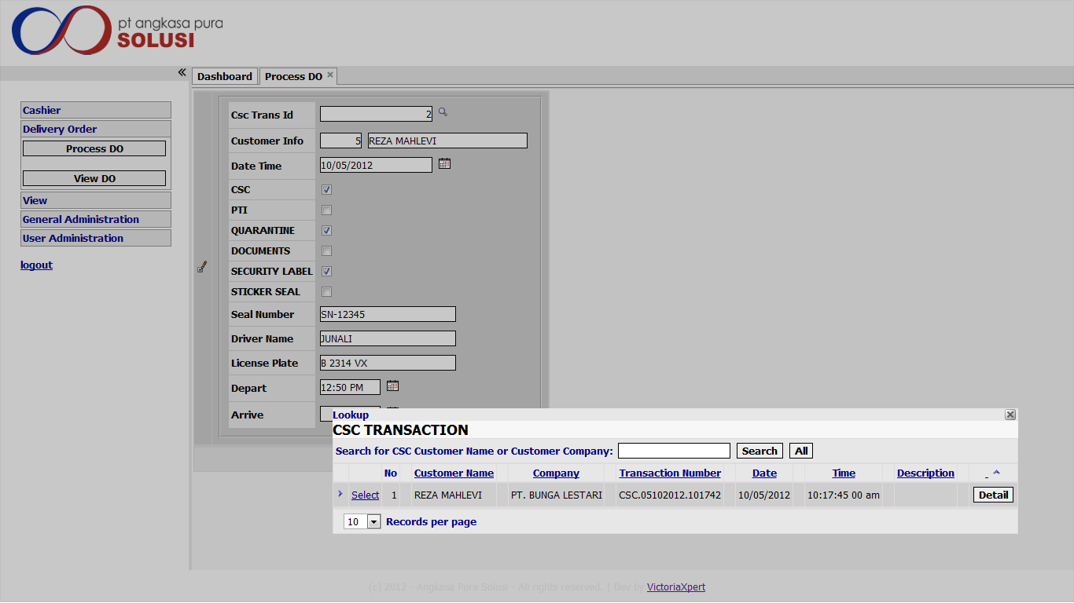

DELIVERY_ORDER_VIEW_DO
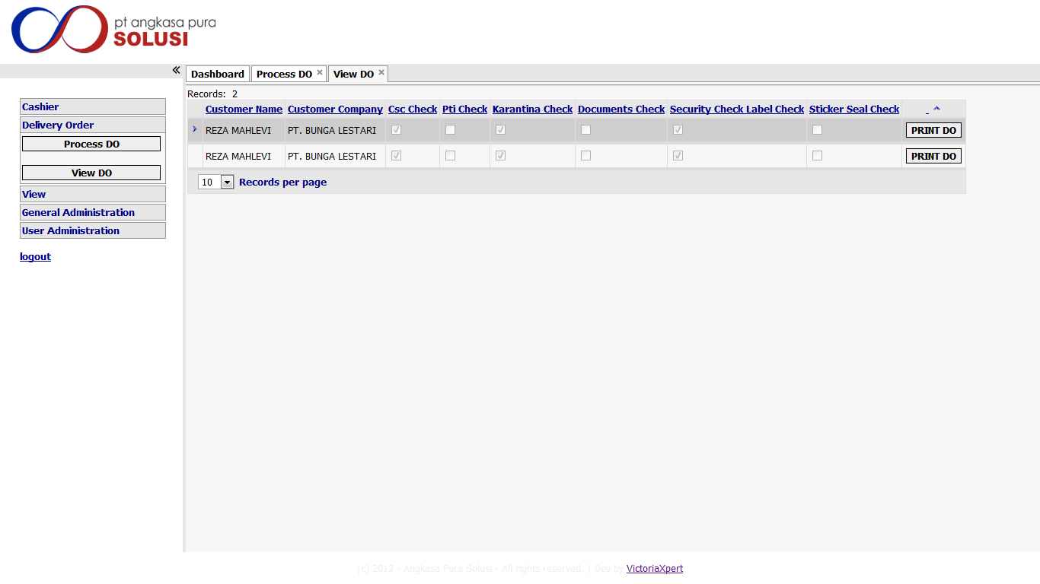

VIEW_CUSTOMER_INFO
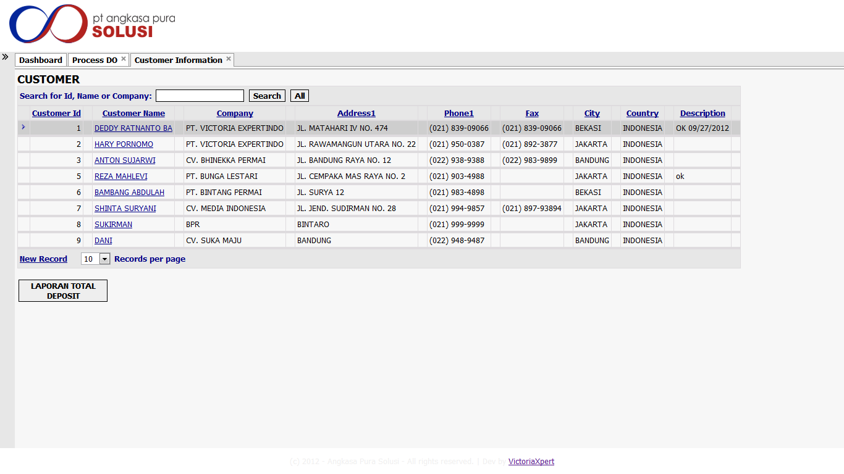

GENERAL_ADM_COMMODITY
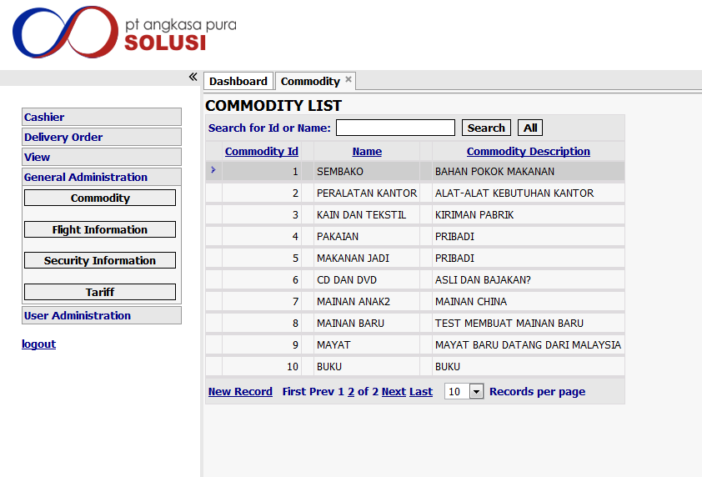

GENERAL_ADM_FLIGHT_INFO

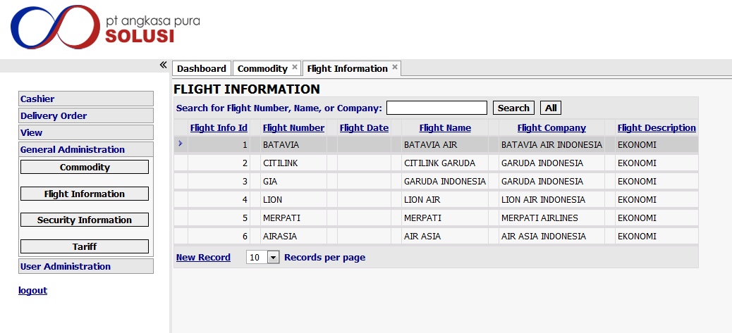

GENERAL_ADM_TARIFF
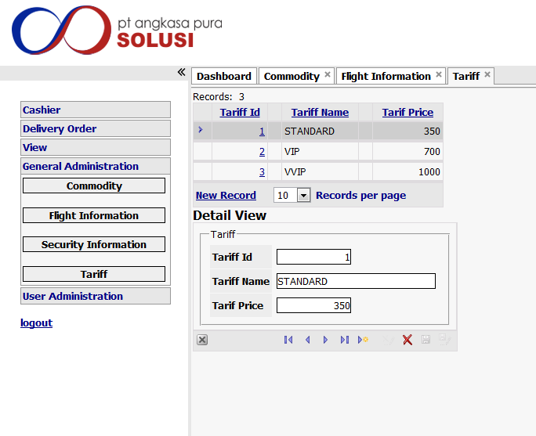

USER_ADM_USER

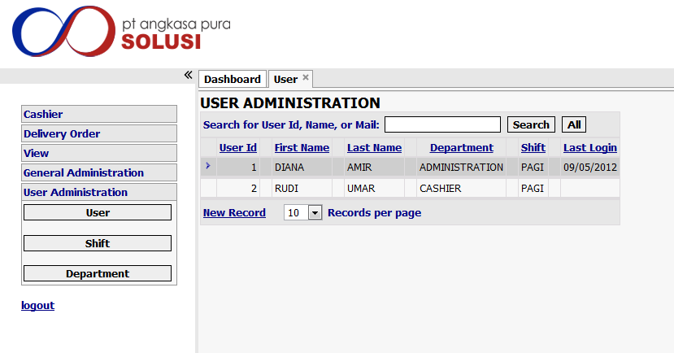

USER_ADM_SHIFT
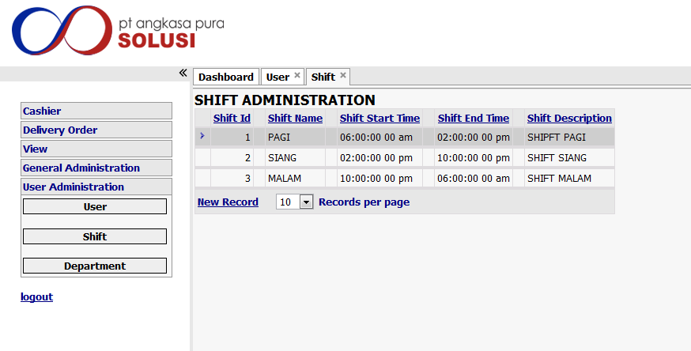

USER_ADM_DEPARTEMEN
