**“Glen’s Parallax Perspectives”** is a series of TV programs offering **fresh ways for people to see issues** such as foreign policy, social and economic justice, the environment, governmental functioning, and so forth. We provide **voices and viewpoints that are rarely heard in mainstream media**.

**Mainstream media, politicians, and culture see the world in conventional ways. Therefore, in order to solve problems, we need to see things in fresh ways.** Glen Anderson created this TV series to help people see things differently so we can solve problems at all levels from the local to the global.

This series title refers to “***parallax***,” which is the view you get by looking from a different perspective. For example, put one finger in front of your nose and another finger farther away. Close one eye. Then open that eye and close the other. Your fingers will seem to move. This is called a “parallax” view. **This TV series invites you to look at issues from fresh perspectives.**

Each program airs three times a week (currently every Monday at 1:30 pm, every Wednesday at 5:00 pm, and every Thursday at 9:00 pm) for the entire month on Thurston Community Television (TCTV), channel 22 for cable TV subscribers in Thurston County, Washington. TCTV is part of Thurston County Media. You can see their schedule at [**www.tcmedia.org**](http://www.tcmedia.org)

**You can also watch the program summarized below through your computer** at [**www.parallaxperspectives.org**](http://www.parallaxperspectives.org). All episodes of “Glen’s Parallax Perspectives” are posted on this blog’s “TV Programs” part and also in one or more of the categories listed in the right side of the blog home page. Also, see information about various issues at the category headings at [**www.parallaxperspectives.org**](http://www.parallaxperspectives.org).

Glen Anderson (360) 491-9093 [**glenanderson@integra.net**](mailto:glenanderson@integra.net)

**🡪 I saved this document in Word format with live links.** If this document does not load or print properly for you, please e-mail me at [**glenanderson@integra.net**](mailto:glenanderson@integra.net) and I’ll promptly send you the links you request.

**🡪 The following summary of what we said during the TV interview also includes a few additional bits of information and links to more resources about this topic.**

**🡪 Please invite other people to watch this video and/or read this thorough summary through these parts of my blog,** [**www.parallaxperspectives.org**](http://www.parallaxperspectives.org)**, including the categories for “TV Programs” and “Peace” and “International” and “Judicial.”**

**“International Courts and War Crimes”**

Glen’s Parallax Perspectives TV Series

April 2023

Glen Anderson (360) 491-9093 [**glenanderson@integra.net**](mailto:glenanderson@integra.net)

**Glen welcomed viewers. He introduced this month’s topic and Joanne Dufour:**

This month’s interview on “Glen’s Parallax Perspectives” provides information that very few people know about. We clearly explain international courts that support fairness and uphold international law. We also help you understand what “war crimes” are and how they can be dealt with through international law.

Glen welcomed our well-informed guest, Joanne Dufour. Joanne has an extensive background with the United Nations, the International Red Cross, and International Humanitarian Law. He said they have enjoyed working together on several issues.

A few years ago Glen took Joanne’s course on International Humanitarian Law and they produced a TV program on this. You can watch the video or read what we said here: [**https://parallaxperspectives.org/international-humanitarian-law-watch-interview-and-or-read-information**](https://parallaxperspectives.org/international-humanitarian-law-watch-interview-and-or-read-information)

Joanne is exceptionally skilled in explaining big issues in ways that ordinary people can easily understand. Joanne prepared a series of images that we showed on the screen during this hour. Joanne clearly explained these images that illustrate various aspects of International Courts and War Crimes. You will enjoy learning about these important realities.

**Definition of an international court:**

We showed this image on the screen. Joanne explained the concept of international courts and what they do.

She said international law is created by international bodies that have the authority to create it.

Examples include treaties and resolutions by the United Nations, some of the UN’s agencies, and international courts that hear cases about international law. One party in a case might be a nation (referred to as a “state”) or an international organization.

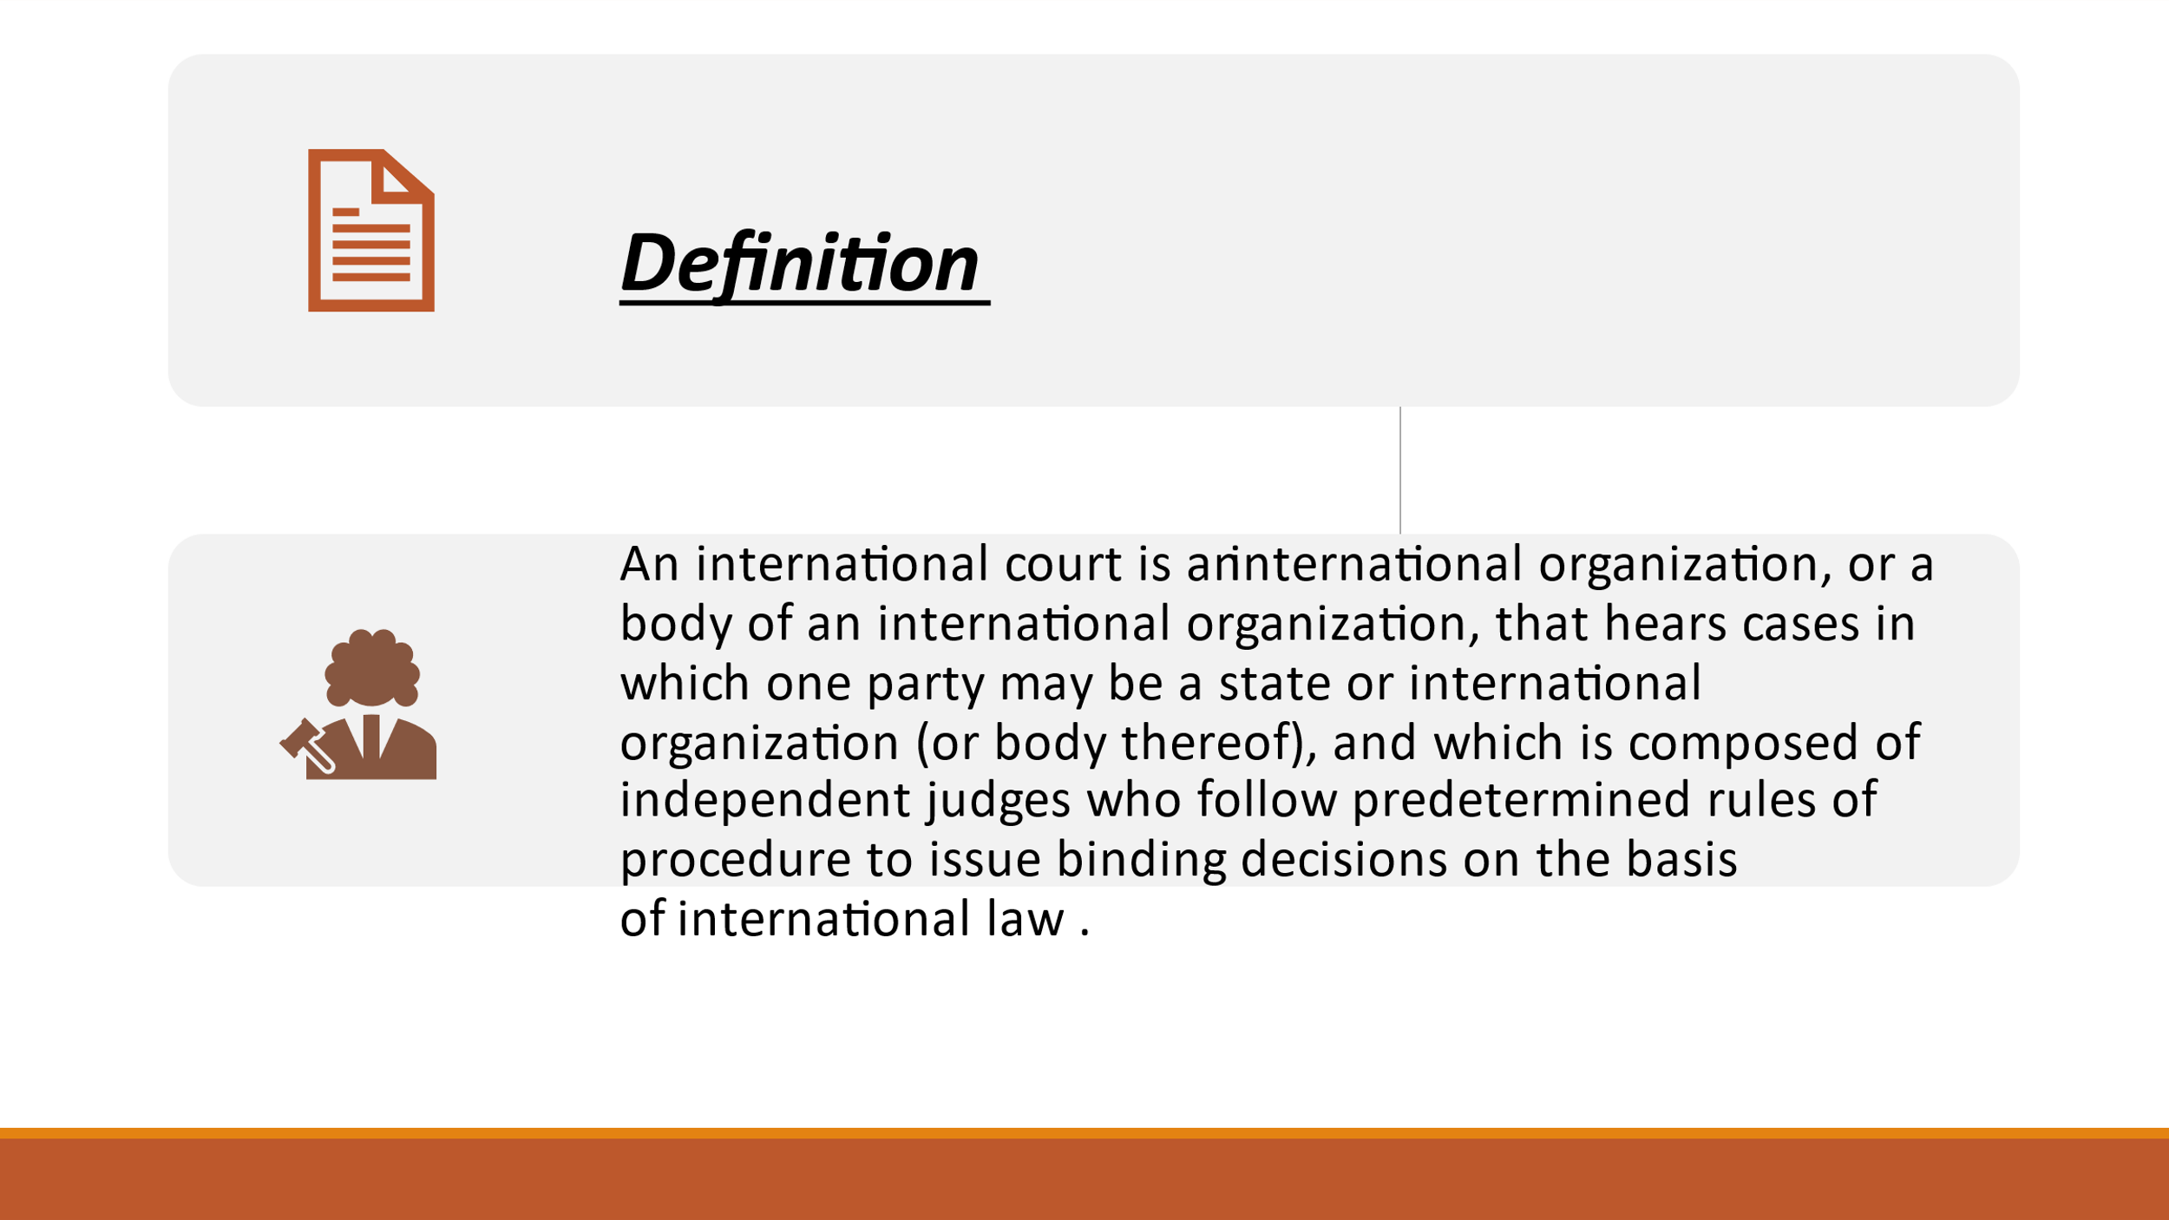

**A brief history of International Courts:**

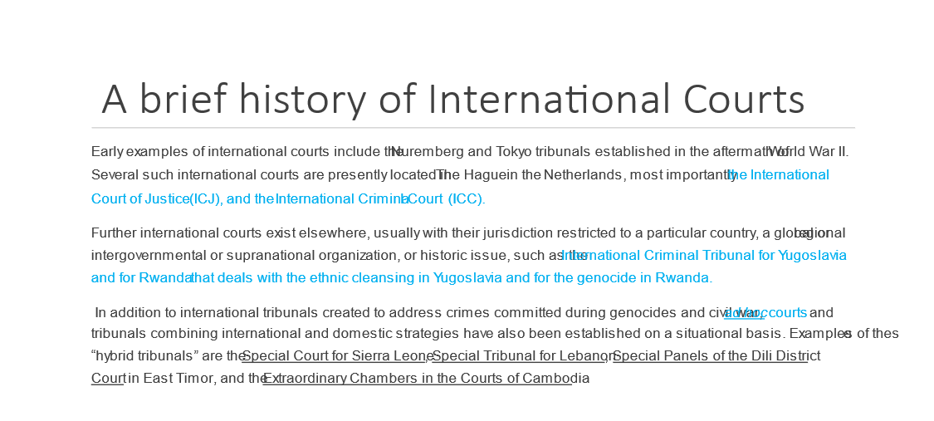

Glen said that a few years ago he took a course that Joanne taught about International Humanitarian Law. He said he enjoyed hearing her summarize the interesting history of international courts. Now Joanne showed this image on the screen and summarized the history of international courts.

Joanne said international law has a very long history that most people do not know about or appreciate. She said nowadays people are paying attention to the courts that were created after World War II. These include the courts at Nuremberg and Tokyo that prosecuted war criminals.

Two especially important courts are located at The Hague in The Netherlands: the International Court of Justice (which began in the late 1800s) and the International Criminal Court (which is much more recent). She said that besides these two, special courts have been created to deal with war crimes committed in certain countries (*see examples in the screen image above*). Some of those courts held their proceedings in places outside of The Hague where those crimes took place. The special courts dealing with ethnic cleansing in the former Yugoslavia and the genocide in Rwanda did their work at The Hague, but some other special courts did their work in the respective locations where those crimes took place. (East Timor is part of Indonesia.)

**Photo of the building in The Hague:**

Glen said the city of The Hague in The Netherlands is known as “the International City of Peace and Justice.”

We showed on the screen this photo of the big, beautiful building in The Hague where the International Court of Justice is housed.

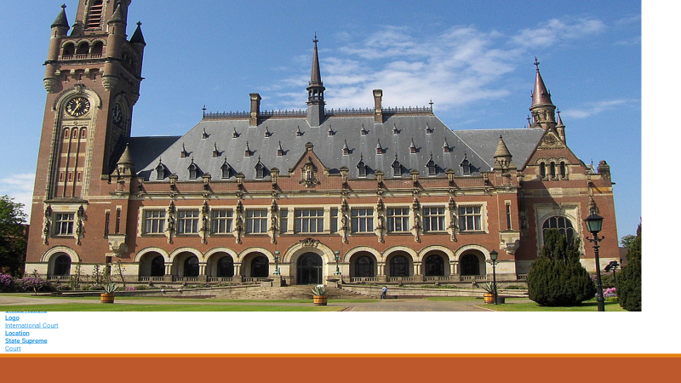

**The International Court of Justice:**

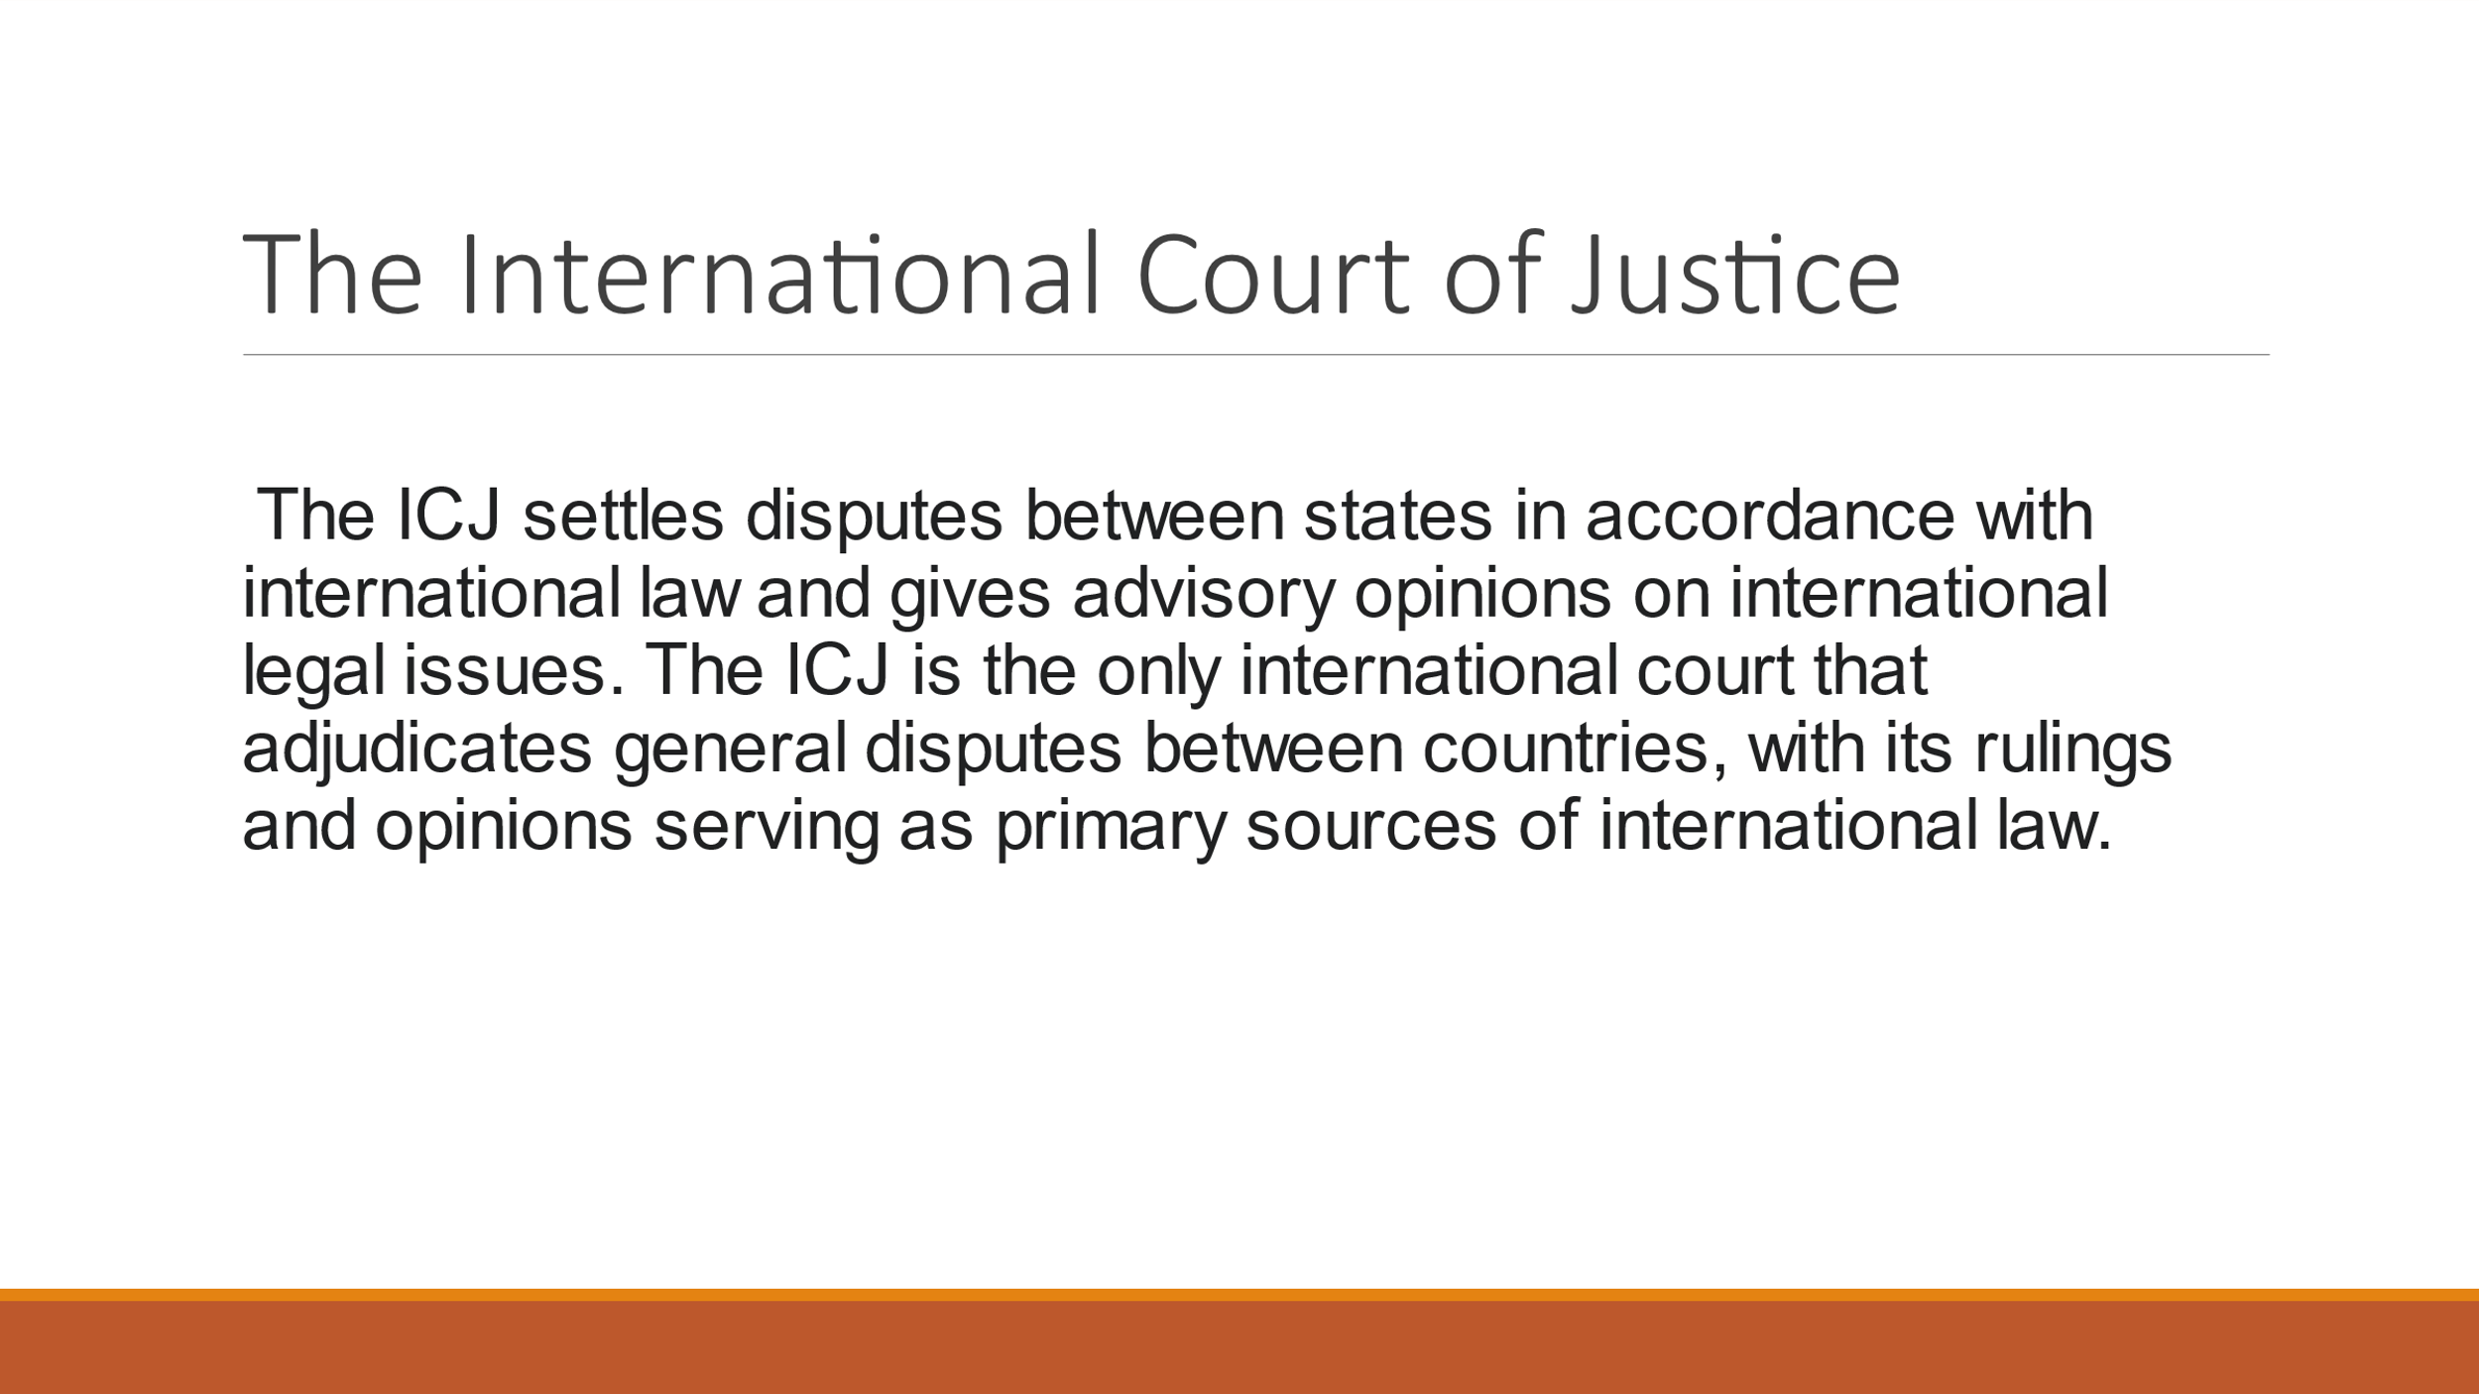

Joanne told us about the International Court of Justice. She said creating the International Court of Justice (ICJ) was the idea of Queen Juliana of The Netherlands in the late 1800s. Joanne said this building had been built by 1913 and has been housing the International Court of Justice for more than a century.

The ICJ was created so nations (“states”) that have disagreements could settle them in a court of law instead of going to war. Joanne said the ICJ is the only worldwide court that adjudicates and settles disputes between countries. She said settling the dispute in this way is a smart, effective alternative to war.

The ICJ has 15 justices who are experts in international law, which is a specialty in the field of law, so they expertly settle disputes involving nations (“states”).

Joanne said these 15 judges offer opinions or rulings that serve as another basis for international law. (*See an example at the top of the next page*.)

**ICJ’s 1996 Advisory Opinion about nuclear weapons:**

Glen said he remembers when in 1996 the International Court of Justice issued an advisory opinion AGAINST using nuclear weapons. The ICJ’s advisory opinion stated that it’s illegal to USE nuclear weapons, but it did not rule against HAVING them. The ICJ ruled that – although nuclear weapons are not inherently illegal under international law, they can be used only if they can be used consistently with International Humanitarian Law. Of course, IHL prohibits war activities that do not distinguish between combatants and civilians (*see several references to this on later pages*), so IHL actually DOES prohibit using nuclear weapons. Here is more information: [**1996 International Court of Justice Advisory Opinion on the Legality of the Threat or Use of Nuclear Weapons**](https://unfoldzero.us12.list-manage.com/track/click?u=b24250dac623a8bc5da1b0664&id=e1faa59eb4&e=49c7bef5c9)

Glen said that in 1996 the peace movement thought the ICJ’s decision would make a real difference, but the established powers pooh-poohed it, so after one day in the news this breakthrough faded away from public awareness.

He asked Joanne to help us understand the International Court of Justice’s 1996 advisory opinion about nuclear weapons. She said that from 1946 to 1968 the U.S. tested 68 nuclear weapons in the Marshall Islands, which are located in the Pacific Ocean near the intersection of the Equator and the International Date Line. The U.S.’s nuclear weapons testing caused horrible damage to their environment and public health. That damage persists to this day. Glen’s August 2021 TV program provided much information about this. You can watch the video and/or read what my Marshallese guests said at this link: [**https://parallaxperspectives.org/marshall-islanders-still-suffer-from-u-s-nuclear-weapons-testing-1946-1958**](https://parallaxperspectives.org/marshall-islanders-still-suffer-from-u-s-nuclear-weapons-testing-1946-1958)

Joanne said a judge who now lives in New York represented the Republic of the Marshall Islands in a case at the ICJ seeking to protect all nations from the kinds of abuses the U.S. had inflicted upon them. That nation wanted the ICJ to make nuclear weapons illegal. The ICJ did not make the sweeping decision that had been requested, but the ICJ did prohibit making civilians the object of attack by nuclear weapons. This specifically applies the Geneva Conventions to nuclear weapons. Already the Geneva Conventions had established that international law prohibits war-making activities that fail to distinguish between combatants and civilians. The ICJ reinforced that and declared that no nation is allowed to use nuclear weapons because they do not distinguish. This principle already existed, but now the ICJ made it explicit again in 1996.

Joanne explained what’s shown in the red font in the visual image immediately below. The ICJ is currently investigating Russia’s violations of international law in Ukraine, because Russia is directly targeting and killing civilians. Ukraine’s president Zelensky asked the ICJ to do this. (*See the right column on page 10*.)

When Glen mentioned the 1996 news (*see the first paragraph in this section*), Joanne said the U.S. has not been a real supporter of international law. Glen said the U.S. has been opposing international law (and the international Criminal Court) because the U.S. feels entitled to commit any crimes it wants to commit in other countries without being held accountable. He said Trump was very explicit about refusing to let the international community have any authority over the U.S., but really this has been long-standing bi-partisan U.S. policy for many decades. He said Trump did not invent the concept of telling the rest of the world to go to hell because the U.S. is going to do whatever we damn well please.

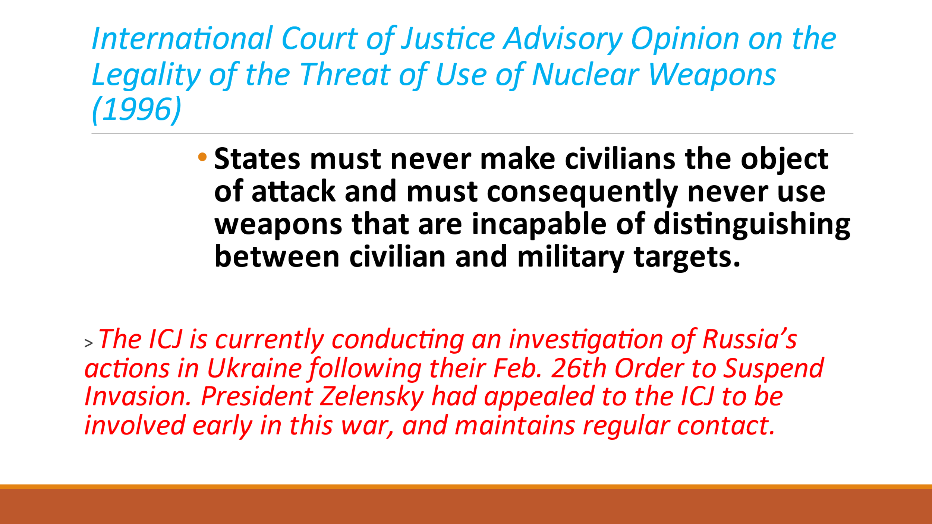

**The Nuremberg Trials their results:**

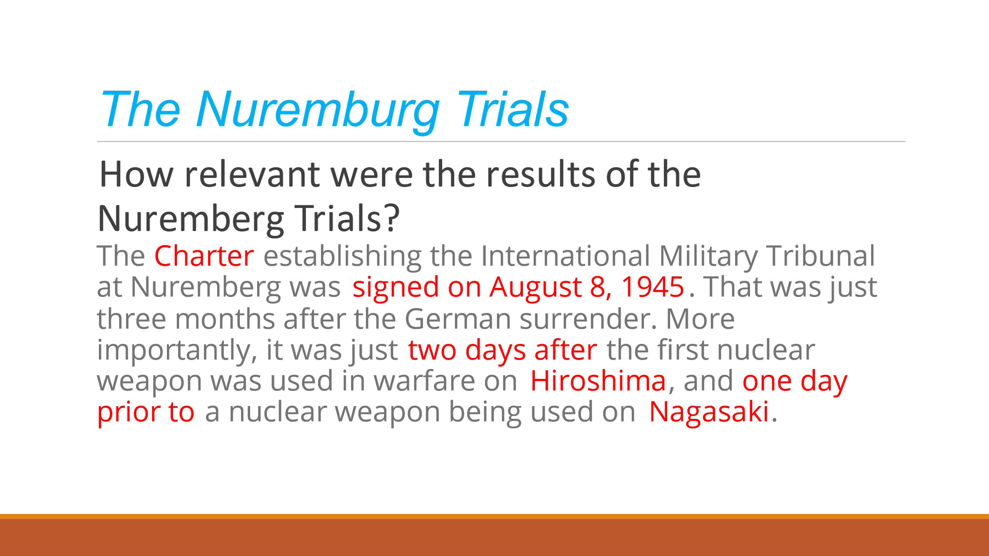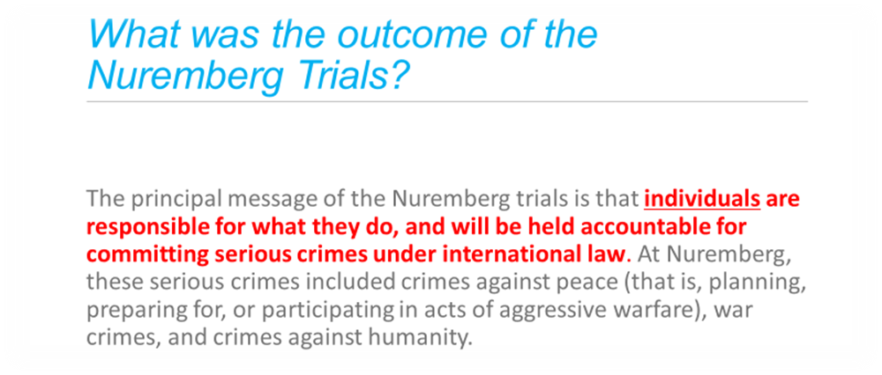

Glen said many people have heard the name “the Nuremberg Trials,” but probably most people do not know much about them. He invited Joanne to tell us about the Nuremberg Trials.

Joanne said they occurred at a time when the U.S. did show positive leadership in international affairs. After World War II, many nations in the world wanted to protect human rights so the genocide that was committed against Jews and some other kinds of people would never occur again. Three months after the Germans surrendered and the war in Europe ended, a charter was signed on August 8, 1945, for trials to be held at Nuremberg, Germany, to hold accountable the most powerful Germans who had committed war crimes. This was two days after the U.S. dropped an atomic bomb on Hiroshima, Japan, and one day before the U.S. dropped another bomb on Nagasaki. The trials in Nuremberg occurred, and – later, after the Japanese government surrendered – trials were held in Tokyo about the war crimes committed by powerful Japanese leaders.

The Nuremberg Trials decided that international law provides that individuals – including soldiers – could be held legally responsible for committing serious crimes during wars. The decision specifically said no one could escape legal accountability by saying they were merely following orders. The decision requires that soldiers disobey orders that are illegal under international law. This was a new requirement under international law. Before this, soldiers could avoid accountability for serious crimes by saying they were just following orders.

The image Joanne showed on the screen (*shown on the next page*) lists the verbs for which a person could be held accountable (“planning, preparing for, or participating in” these war crimes). These concepts of “war crimes” and “crimes against humanity” became more prominent in the Nuremberg Trials.

Glen added that because this pertains to individual soldiers, this has become part of the actual training that people in the U.S. military receive nowadays. He said that despite this, the U.S. government has been committing many “war crimes” and “crimes against humanity” in our stupid wars for the past several decades. He said the Nuremberg principles should be applied to national leaders and high-ranking military leaders who have issued those orders for these past decades. He said just like Russia has bombed Ukraine’s hospitals, so also the U.S. has bombed hospitals in Iraq and elsewhere. He said we need to vigorously uphold international law and make sure it applies to everyone, including the U.S. and our powerful people, including national leaders in addition to individual soldiers.

Joanne said that all of the defendants at Nuremberg were generals. They were following the orders issued by their national government. She said what was emerging was the concept of holding individuals legally accountable. She said this blossomed in what was called “the Rome Statute.” The International Criminal Court was created so individuals – in addition to nations – could be held legally accountable for their wartime crimes under international law.

A few minutes ago Joanne told us about the International Court of Justice. Next she explained a different court, the **International Criminal Court**.

She said the International Criminal Court was created in 2002, and the building (*shown on the next page*) was completed in 2014.

**Photo of the building that houses the International Criminal Court:**

Joanne told us about the **International Criminal Court**. The photo below shows the building that was completed in 2014. It is in The Hague, The Netherlands.

Expert architects created a building that she said is beautiful and inspires people.

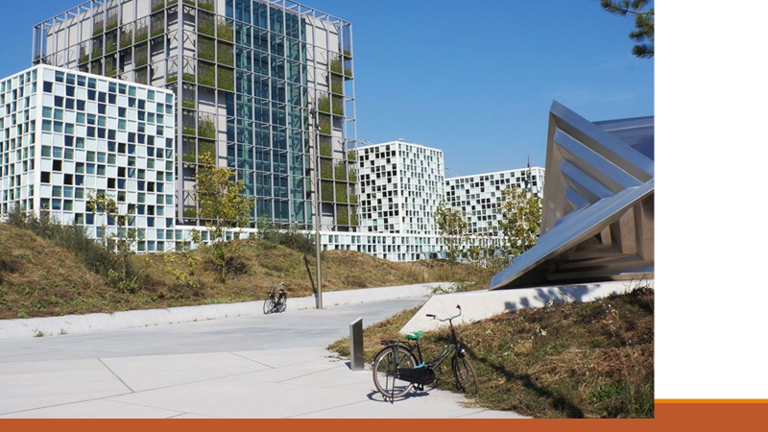

Joanne explained how the International Criminal Court works. (*See the next page*.)

**How the International Criminal Court works:**

Joanne said the 1998 Rome Statute gives the ICC jurisdiction over four main crimes. (*They are listed in the image below, which we showed on the TV screen.*) She said the ICC will accept a case only if it fits into one of these four categories.

We showed the first kind of crime– “**genocide**” – on the screen. Then she showed a second image listing the other three kinds of crimes: “**crimes against humanity**” and “**grave breaches of the Geneva Conventions**” in armed conflict and the “**crime of aggression**.” The screen images (*below*) summarize brief definitions, so I’m not repeating here what Joanne said during our interview.

She did explain that “crimes against humanity” can occur in settings other than during wars.

She also clarified that human rights treaties govern behaviors outside of wars and the Geneva Conventions deal with behaviors during wars and other armed conflicts, so those violations qualify as “war crimes.”

She said the writing and agreeing upon the text related to the “crime of aggression” took a very long time: eight years.

She said we would talk about Russia’s war in Ukraine later in the interview (*see page 10*), but for now she said some people think Russia’s crimes are “crimes against humanity,” and other people think they fit better as a “crime of aggression.” The International Criminal Court is figuring out which category best describes Russia’s violations of international law.

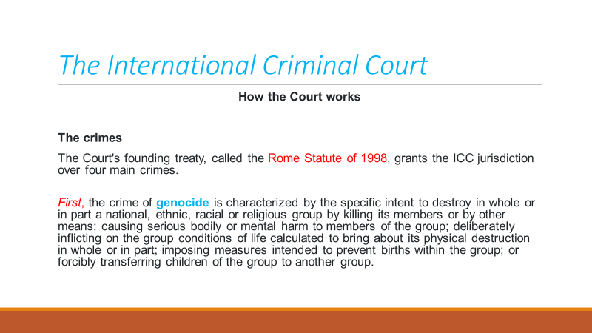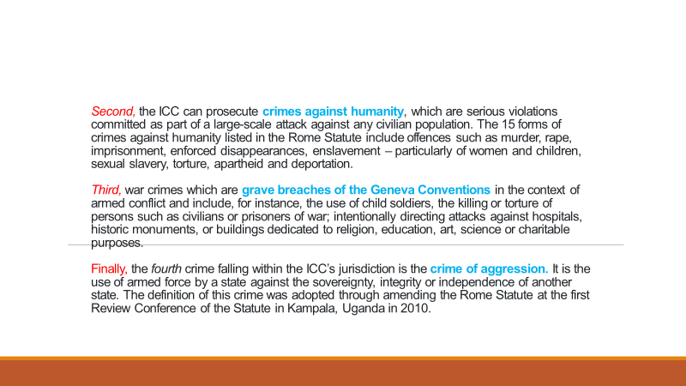

**123 countries are members of the ICC:**

The vast majority of the world’s nations (referred to as “states”) are members of the International Criminal Court. The U.S. is not. She said President Clinton signed on (with reservations) during his last day in office, and George W. Bush unsigned on his first day of office. She said the U.S. does not want to be in the ICC because the U.S. does not want its soldiers or leaders to be accused of committing war crimes. (They do commit them.)

To become a member of the ICC requires signing a treaty. Joanne said 123 countries are members of the International Court. The image she showed on the screen (*below*) also listed 12 nations that have signed (showing interest) but have either not ratified or have withdrawn from their commitment, and 10 other nations that have not even signed at all, so they also are not parties to the ICC.

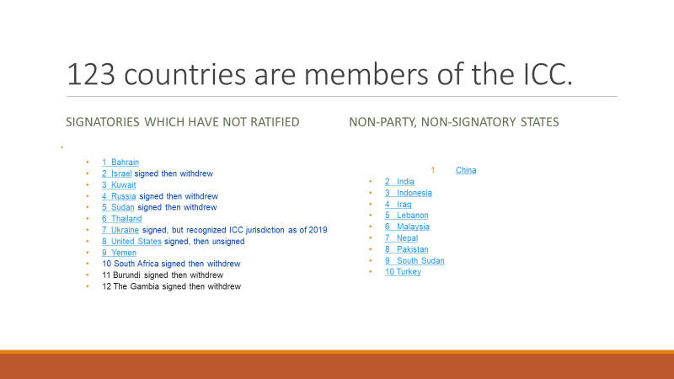

**What is a war crime?**

Next Joanne showed the image below and explained what war crimes are.

She said seriously violating International Humanitarian Law (the Geneva Conventions) – especially against civilians and even against property (reservoirs, monuments, electrical plants, etc.) –can be a war crime. She said international law allows combatants to kill other combatants, but civilians must be protected. She specified “willful killing” apart from the actual battle (*e.g*., after a battle or elsewhere). Next on the list below is “torture or inhuman treatment.”

She said the next item on the list (“willfully causing great suffering”) pertains to using mustard gas, which was outlawed after World War I and using land mines, which were outlawed in 1997. Glen said that in Vietnam the U.S. used napalm, which is like jellied gasoline. It is extremely painful and destructive to human bodies. He said the U.S. also used white phosphorous, which burns human flesh and cannot be washed off. In fact, water makes it burn even worse. Joanne said napalm is legal to exist because it is used as a defoliant, but the U.S. used it as a weapon at its strongest level.

Joanne said the next item on the list includes examples such as religious sites. She listed the final three items and said the Geneva Conventions very explicitly specify how to treat prisoners of war. She said the U.S. violated these parts of international law by torturing prisoners at Guantanamo. She explained that the final item on this list says you can’t seize someone from the other nation and force them to serve in your own military. She said all of the items in this screen image (*below*) are examples of war crimes.

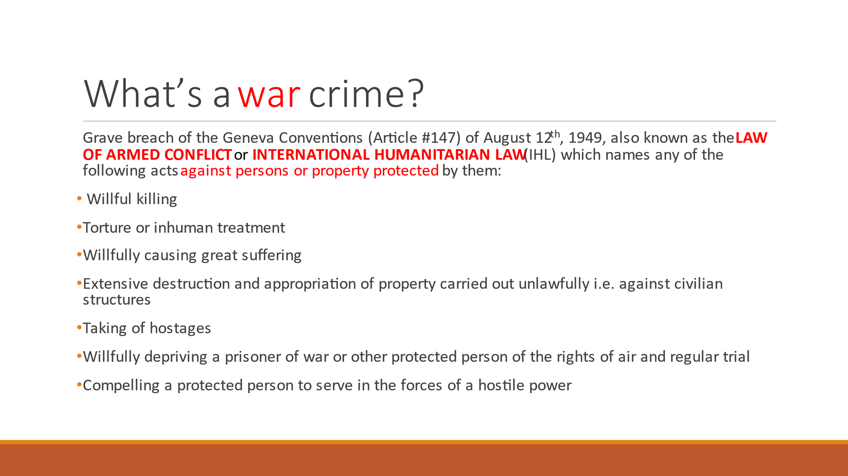

**International Humanitarian Law: What are the fundamental principles?**

Glen said that a few years ago he took a course that Joanne taught about International Humanitarian Law (IHL). He enjoyed it and learned a lot. He said very few people understand what International Humanitarian Law is.

Joanne showed a 4-item list (*see image below*) and explained IHL (the Geneva Conventions) and how these powerful principles came about. She said the U.S. calls these “the law of armed conflict.” She said all nations in the world have signed on to these.

They pertain to fighting wars, so the first item on this list – “**Military Necessity**” – protects a nation’s right to take the basic actions necessary to fight wars. International law allows combatants to kill other combatants. She said this principle of “Military Necessity” spells out what armed forces and their combatants are allowed to do to conduct their war.

But, she said, International Humanitarian Law prohibits them from simply doing whatever they want. She said the International Red Cross and the Geneva Conventions require that they distinguish between soldiers and civilians. This is the “**Distinction**” principle shown second on this list. It is illegal to deliberately target civilians. Because civilians are not actively participating in the war, they are protected by the Geneva Conventions.

Glen added that this principle of “Distinction” actually means that it is illegal to use nuclear weapons in a war. (*See page 4*) Nuclear weapons cannot distinguish between soldiers and civilians. Instead of killing only the other nation’s combatants, they kill entire populations of large geographical regions. Joanne said that immediately after the U.S. dropped an atomic bomb on Hiroshima, Japan, the International Red Cross explicitly denounced the bomb for that specific reason. The U.S. had targeted a civilian city and deliberately killed many thousands of innocent civilians.

Joanne said the third item on the list below – “**Proportionality**” – specifies that retaliating against an attack must be limited to what is proportional to match the original attack, not to escalate.

Glen added another aspect of the “Proportionality” issue. He said when a new U.S. President takes office, they spend a year or so figuring out what their new policies will be regarding nuclear weapons. They produce a “Nuclear Posture Review” that spells out the reasons for using nuclear weapons. He said when Trump took office, his “Nuclear Posture Review” violated the principle of “Proportionality” by saying he would launch nuclear weapons in response to several kinds of non-nuclear provocations, such as attacks on our infrastructure.

Glen added that when Biden took office, Biden continued some of Trump’s policies, including willingness to launch nuclear weapons violations in response to some non-nuclear attacks, in violation of the “Proportionality” principle.

Glen said ordinary people need to pay attention to these kinds of things. Joanne said President Obama also had created policies that violated the “Proportionality” principle. Glen said in the U.S. BOTH political parties are hell-bent to use nuclear weapons any time they feel like it. He said the problem is “not a partisan thing,” but rather is powered by institutional momentum within the entire Military-Industrial Complex that is always willing to escalate. Both political parties are complicit in this.

Joanne said the final item – “**Limiting Unnecessary Suffering**” – was a basic reason that led to outlawing land mines in 1997. After a war ends, the land mines typically remain buried and injure and kill innocent people long into the future, causing “unnecessary suffering.”

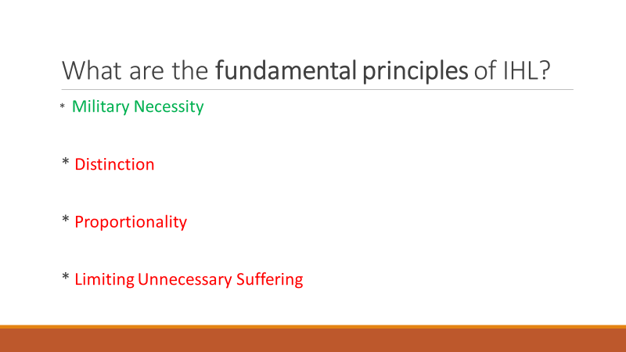

Joanne added more information about violating the “law of armed conflict,” based on the Geneva Conventions. She said in the U.S. when someone violates it, their military branch is responsible for court-martialing the offender.

She said, for example, that some of the U.S. military people who tortured prisoners at Abu Ghraib in Iraq were court-martialed and imprisoned. But, she pointed out, the higher-ranking people who had ordered or allowed it to occur were not held accountable in any way.

She questioned whether the U.S. is really following the Geneva Conventions.

**International Criminal Court Statute: Article 8 – AND -- Examples of War Crimes:**

Earlier in this interview, Joanne told us about the International Criminal Court (ICC). Now we explored the ICC a bit further. Joanne showed on the screen the image below, which refers to Article 8 of the law about the International Criminal Court. This gives an example of a war crime.

Joanne explained these concepts. The ICC holds individuals accountable. She showed this image that includes wording about how the ICC understands a “war crime.”

She said the U.S. has been using drones to attack people – including people at wedding parties in Afghanistan. She said these drone attacks are war crimes because wedding parties include civilians and are not legitimate targets.

She read the information shown in the red font at the bottom of this image, regarding the ICC’s investigations of war crimes in Ukraine. She said the ICC went to Ukraine and started investigating when the war had been going on for only about a month, right after the ICJ went there.

When she created the image below, she reported (*in the red font*) that more than 30,000 documented cases of war crimes had occurred in Ukraine since February 2022, and just recently before we produced this TV interview she has heard that the number of war crimes reached about 50,000.

She read examples from a report on what some of those war crimes have been, including massacres, murders of soldiers and civilians, deliberate indiscriminate attacks on densely populated civilian areas, attacks on critical civilian infrastructure (schools, hospitals, electric infrastructure, environmental areas, etc.), torture, rape, sexual enslavement of women and children, and children being stolen.

In March 2023 the ICC issued an arrest warrant for Vladimir Putin. [**https://www.huffpost.com/entry/icc-arrest-warrant-putin-ukraine_n_641486ede4b01ea5cd8dcf61**](https://www.huffpost.com/entry/icc-arrest-warrant-putin-ukraine_n_641486ede4b01ea5cd8dcf61) The U.S. government cheered this news, but the U.S. refuses to be a member of the ICC and does not recognize its authority: [**https://www.truthdig.com/articles/whos-afraid-of-the-international-criminal-court/**](https://www.truthdig.com/articles/whos-afraid-of-the-international-criminal-court/) Also see this: [**https://www.alternet.org/exceptions-to-american-exceptionalism-2023/?utm_source=123456&utm_medium=email&utm_campaign=12658&recip_id=22838&list_id=2**](https://www.alternet.org/exceptions-to-american-exceptionalism-2023/?utm_source=123456&utm_medium=email&utm_campaign=12658&recip_id=22838&list_id=2)

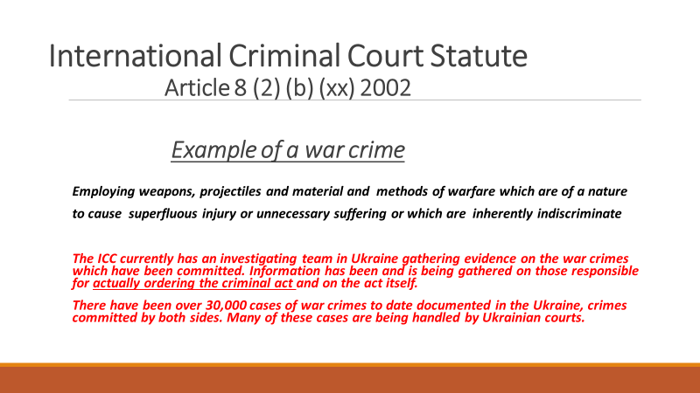

**What kinds of people do the Geneva Conventions protect?**

Joanne said that every nation – including the U.S., Russia, and China – has signed on to the Geneva Conventions.

She said the Geneva Conventions precisely state the kinds of people they protect. They are listed in what Joanne showed on the TV screen (*and at the top of the next page*.) These kinds of people include civilians, combatants who are wounded or sick, so – although when they were healthy troops they could be attacked, the Geneva Conventions protect combatants as soon as they become wounded or sick. Likewise, when someone becomes a prisoner of war, the Geneva Conventions protect them too.

Joanne said that the persons who accompany the armed forces but are not actual members of the military are protected. The image she showed (*below*) provides examples. She said an American journalist covering the Ukraine war was killed there, so the U.S. has a right to find out who was responsible for killing him and bring the offender to justice.

Also, medical persons (Red Cross workers and others) and religious chaplains – even if they are in the military – are protected.

Joanne pointed out again that people fighting in the military are not protected. They are allowed to kill other combatants, and they are eligible to be killed in the war. When you enlist, you put your life in danger.

But the Geneva Conventions prohibit you from acting cruelly or irrationally against the people who are protected.

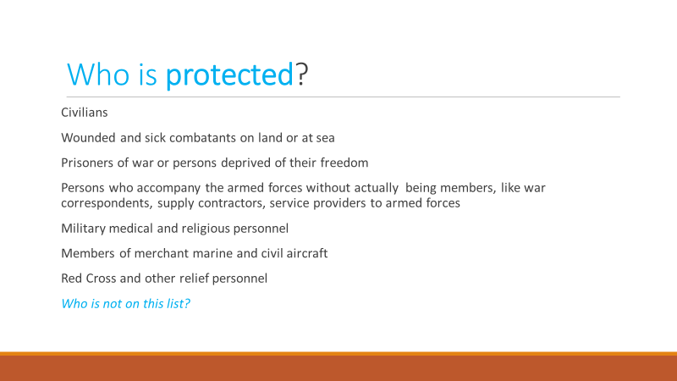

**What kinds of things do the Geneva Conventions protect?**

Joanne showed the next screen, which lists the kinds of things that are protected under international law, according to the Geneva Conventions and the International Court of Justice.

She mentioned the things on this list. Civilian homes and belongings must not be targeted. Nor can any medical facilities (military as well as civilian), and the other things listed in the image below. She said the next-to-last item about “dangerous forces” would include Ukraine’s nuclear power plants.

She said Russia clearly has been targeting the kinds of things on this list. That’s why we have 50,000 documented cases of war crimes there.

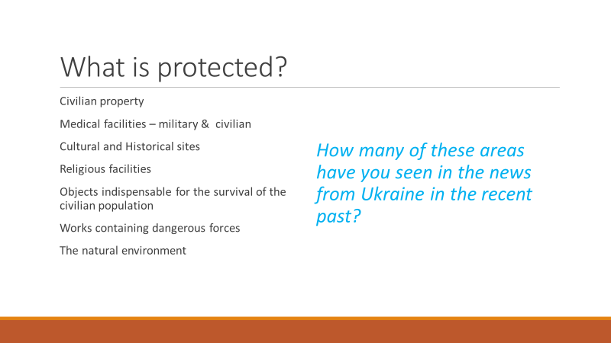

**How else can war crimes be adjudicated?**

Joanne said the International Criminal Court would be overwhelmed if it tried to handle all 50,000 documented cases of war crimes in Ukraine and all of the other war crimes occurring around the world. She showed on the screen an image about other ways of adjudicating war crimes. (*See the image below*.)

She said **District Courts** in Ukraine and some other countries are working on this. She mentioned the Joint Investigation Team, which consists of seven European nations collaborating with the ICC to deal with these war crimes. They are figuring out which cases they can deal with in their own district courts. She said some cases are being tried in Ukraine, the UK, and some other European countries.

She said they can do this because national courts have some kinds of relevant jurisdiction (A) if the case occurred in that court, and (B) if someone from that country committed a crime in another country. She said nations have another power (“passive personality”) that can be used to extradite people who have committed crimes elsewhere.

She said the most interesting way to prosecute war criminals is through what’s called “**Universal Jurisdiction**.” The image below provides some information about this. She said ¾ of the world’s nations have given their judges the power to use “Universal Jurisdiction.” Someone who has committed one of these horrible crimes (*e.g*., conducting mass killings or organizing a torture camp) and visits another country can legally be held in the country they are visiting and be prosecuted in that country’s court for their horrible crime.

She gave the example of Chile’s dictator General Pinochet, who had committed many extremely horrible crimes in Chile during his violent reign (1973-1990) and visited Europe in 1998. A judge in Spain filed “crimes against humanity” charges against him while he was in the UK. Here is information about this: [**https://en.wikipedia.org/wiki/Indictment_and_arrest_of_Augusto_Pinochet**](https://en.wikipedia.org/wiki/Indictment_and_arrest_of_Augusto_Pinochet)

She said some Americans have committed war crimes, and George W. Bush knows that if he were to visit British Columbia, Canada, a judge there has stated that he would arrest Bush because of “Universal Jurisdiction.”

She said “Universal Jurisdiction” is fascinating and powerful. It has been used dozens of times. She recently heard that it has been used 80 times.

She repeated that the U.S. and Russia have avoided being members of the International Criminal Court. She said some European nations want to charge Russia with crimes of aggression against Ukraine, but the U.S. does not want to say that because the U.S. also has committed crimes of aggression and does not want to be held accountable in the ICC.

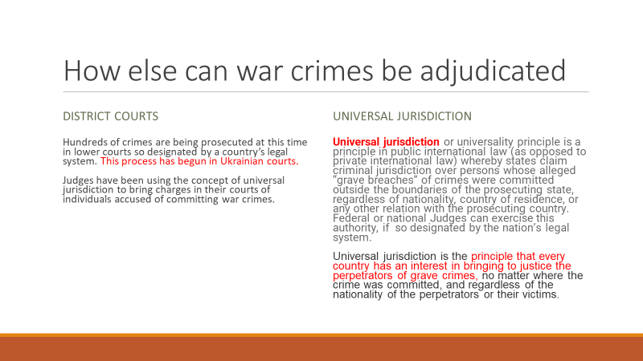

**More information about international courts:**

Joanne showed an image (*see top of next page*) saying that other places in the world – besides Ukraine –are experiencing war crimes.

Joanne said the U.S. Attorney General went to Ukraine and offered help. Other countries have done this too. But, she said, it is extremely expensive to process a case through the International Criminal Court. Gathering the evidence necessary to win a case at the ICC – or in a District Court, as she said earlier – is very expensive.

Joanne said the International Court of Justice has fifteen judges. The ICJ’s current president is an American woman who is about half way through her nine-year term. The person next in line (the first vice president) is a Russian man.

Joanne said the person elected to be president of the International Criminal Court is a Polish person. Those judges have three-year terms.

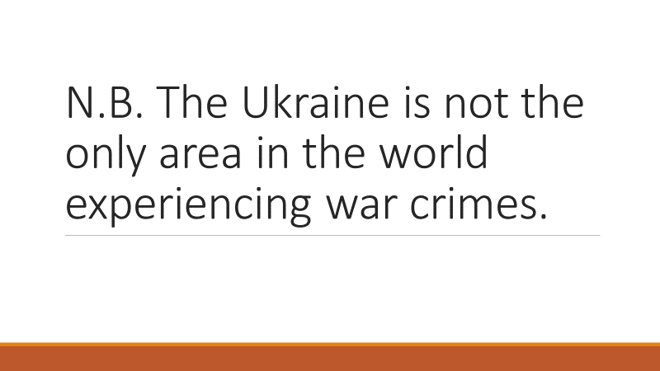

**Sources of more information:**

Glen thanked Joanne for providing fascinating information. He said he had learned a lot from her before about these topics, and he appreciates the new information she provided now during this TV interview.

He said every episode of his TV series provides a lot of substantive information. He always encourages people to learn more about the topics we discuss. He mentioned just a few now on TV, and he said he will provide much more information on his blog (in the document you are reading now that thoroughly summarizes what we said during the TV interview). The blog’s **“TV Programs”** category includes links so people can watch this TV interview and others anytime from anywhere.

His blog is [**www.parallaxperspectives.org**](http://www.parallaxperspectives.org). He invited people to visit his blog, click the link for **“TV Programs,”** and click the link for this episode, titled, **“International Courts and War Crimes.”** He said he is posting it also to his blog’s categories for **“International”** and **“Judicial”** and **“Peace.”**

Glen said he has produced and hosted more than 400 one-hour TV interview programs since February 1987. The episodes starting in January 2018 are posted to the blog’s “TV Programs” category in addition to their respective issue categories of the blog. Some of the TV episodes before 2018 are posted only to their respective issue categories.

Joanne was the guest for his March 2020 TV program about International Humanitarian Law. You can watch the video and/or read the thorough summary Glen typed up about what we said at this link to Glen’s blog: [**https://parallaxperspectives.org/international-humanitarian-law-watch-interview-and-or-read-information**](https://parallaxperspectives.org/international-humanitarian-law-watch-interview-and-or-read-information)

Joanne also has been a guest on several of Glen’s TV programs about nuclear weapons. He invited people to watch those at the blog’s **“Nuclear Weapons”** category as well as the **“TV Programs”** category.

Here is a link for information about the International Criminal Court -- and “American Exceptionalism”: [**https://www.alternet.org/exceptions-to-american-exceptionalism-2023/?utm_source=123456&utm_medium=email&utm_campaign=12658&recip_id=22838&list_id=2**](https://www.alternet.org/exceptions-to-american-exceptionalism-2023/?utm_source=123456&utm_medium=email&utm_campaign=12658&recip_id=22838&list_id=2)

You can see much information about International Humanitarian Law and related topics at the International Red Cross’s website, [**www.icrc.org**](http://www.icrc.org)

Also, see [**www.redcross.org/humanityinwar.html**](http://www.redcross.org/humanityinwar.html) for more information, including a video about “Rules of War in a Nutshell.”

You can learn about the Geneva Conventions by visiting [**www.icrc.org/en/document/geneva-conventions-1949-additional-protocols**](http://www.icrc.org/en/document/geneva-conventions-1949-additional-protocols)

Also, you search the internet for “International Criminal Court” and “truth and reconciliation commissions” and visit [**www.youtube.com**](http://www.youtube.com) and search for “International Humanitarian Law” to see informative videos.

Go on to the final page.

**Glen’s closing encouragement:**

Glen thanked Joanne Dufour for sharing her knowledge and insights. He also thanked the people who have been watching.

Glen said that at the weekly peace vigils he organizes in downtown Olympia, he often holds signs that say: “We all share one earth” and “Human rights are for everyone” and “All people are one human family.” Those signs affirm the principles that Joanne has been telling us about during this hour. These positive, inclusive messages can welcome the general public into joining our efforts for peace, human rights, and positive international relationships, such as those we’ve been discussing during this TV interview.

He said we need to practice these globally and also within our own nation and in our local communities. Let’s practice these and include people who have religions or sexual orientations that some other people don’t like. We really need to affirm that we’re all in this together, so we can create a positive, inclusive world that is fair for everyone and protects everyone’s human rights.

Both Joanne and Glen affirm that people who want peace need to also support human rights everywhere – and international law – and international courts.

He said the U.S. government often has a mixed record on this. While paying lip service to these values, sometimes the U.S. government fails to “walk the talk,” and sometimes it actually does things that are contrary to the positive values it says it supports.

Joanne said her research showed that the International Court of Justice has two cases against the U.S. – one filed by Palestinians and one filed by Iran.

She and Glen said the U.S.’s mainstream media do not adequately report on such things. Glen said mainstream media are very much subservient to the U.S. government’s interests, so they do not inform the American people adequately about things that would embarrass the government. He said the mainstream media do not even talk about the Treaty on the Prohibition of Nuclear Weapons, which is a powerful historical accomplishment, because the U.S. government opposes the Treaty and wants to keep its nuclear weapons instead of allowing the world community to abolish all of them worldwide. He said we need to get our news from sources better than the mainstream media.

Glen invited people to te;; their friends about this TV program and encourage them to watch it on TV during April 2023 in Thurston County, Washington. It airs on Thurston Community Media cable channel 22 three times a week for the full month: every Monday at 1:30 pm, every Wednesday at 5:00 pm, and every Thursday at 9:00 pm.

Also, your friends can watch it on Glen’s blog from anywhere at any time, as he said a moment ago. Visit [**www.parallaxperspectives.org**](http://www.parallaxperspectives.org). Click the link for **“TV Programs,”** and click the link for this episode, titled, **“International Courts and War Crimes.”** People can watch this TV interview and/or read the thorough summary of what we said (the document you are reading now).

You can get information about a wide variety of issues related to peace, social justice and nonviolence through my blog, [**www.parallaxperspectives.org**](http://www.parallaxperspectives.org)or by phoning me at   
(360) 491-9093 or e-mailing me at [**glenanderson@integra.net**](mailto:glenanderson@integra.net)

I end each TV program with this invitation to help make progress:

**We're all one human family, and we all share one planet.**

**We can create a better world, but we all have to work at it.**

**The world needs whatever you can do to help!**