**287. Find the Duplicate Number**

Medium

2924338FavoriteShare

Given an array *nums* containing *n* + 1 integers where each integer is between 1 and *n* (inclusive), prove that at least one duplicate number must exist. Assume that there is only one duplicate number, find the duplicate one.

**Example 1:**

**Input:** [1,3,4,2,2]

**Output:** 2

**Example 2:**

**Input:** [3,1,3,4,2]

**Output:** 3

**Note:**

1. You **must not** modify the array (assume the array is read only).
2. You must use only constant, *O*(1) extra space.
3. Your runtime complexity should be less than *O*(*n*2).
4. There is only one duplicate number in the array, but it could be repeated more than once.
5. Counter

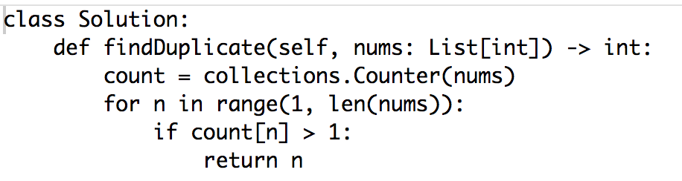

1. Fast, slow

