**322. Coin Change**

Medium

188477FavoriteShare

You are given coins of different denominations and a total amount of money *amount*. Write a function to compute the fewest number of coins that you need to make up that amount. If that amount of money cannot be made up by any combination of the coins, return -1.

**Example 1:**

**Input:** coins = [1, 2, 5], amount = 11

**Output:** 3

**Explanation:** 11 = 5 + 5 + 1

**Example 2:**

**Input:** coins = [2], amount = 3

**Output:** -1

**Note**:  
You may assume that you have an infinite number of each kind of coin.

而且 coins和amount都必须是整数，题目没写但我试过了。

类似题目参考阅读 T39，T416

1. Recursion

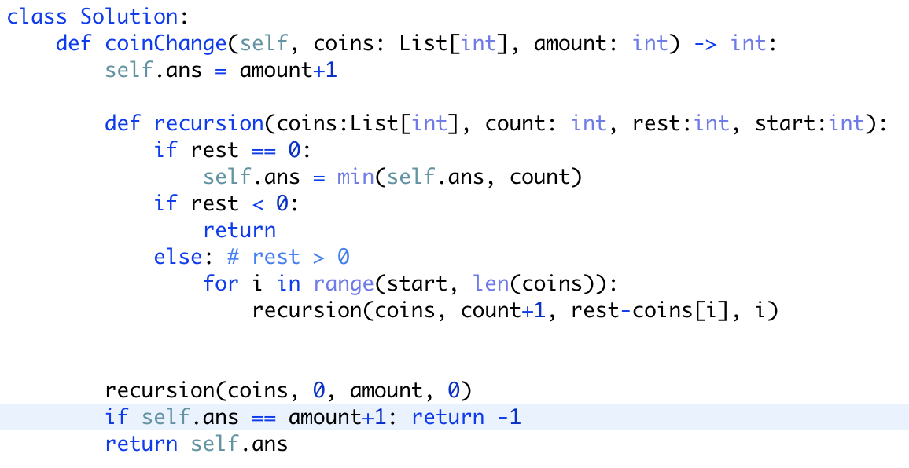

会超时，但可以用T416的方法做优化。或者用memorialize。

1. Dynamic programing

动态规划，思考后一个答案是怎么构成的，

注意如何初始化dp数组。除了dp[0] 其他都要填充一个较大的数字。因为后面有min这个处理步骤。

