**102. Binary Tree Level Order Traversal**

Medium

173044FavoriteShare

Given a binary tree, return the *level order* traversal of its nodes' values. (ie, from left to right, level by level).

For example:  
Given binary tree [3,9,20,null,null,15,7],

3

/ \

9 20

/ \

15 7

return its level order traversal as:

[

[3],

[9,20],

[15,7]

]

1. DFS

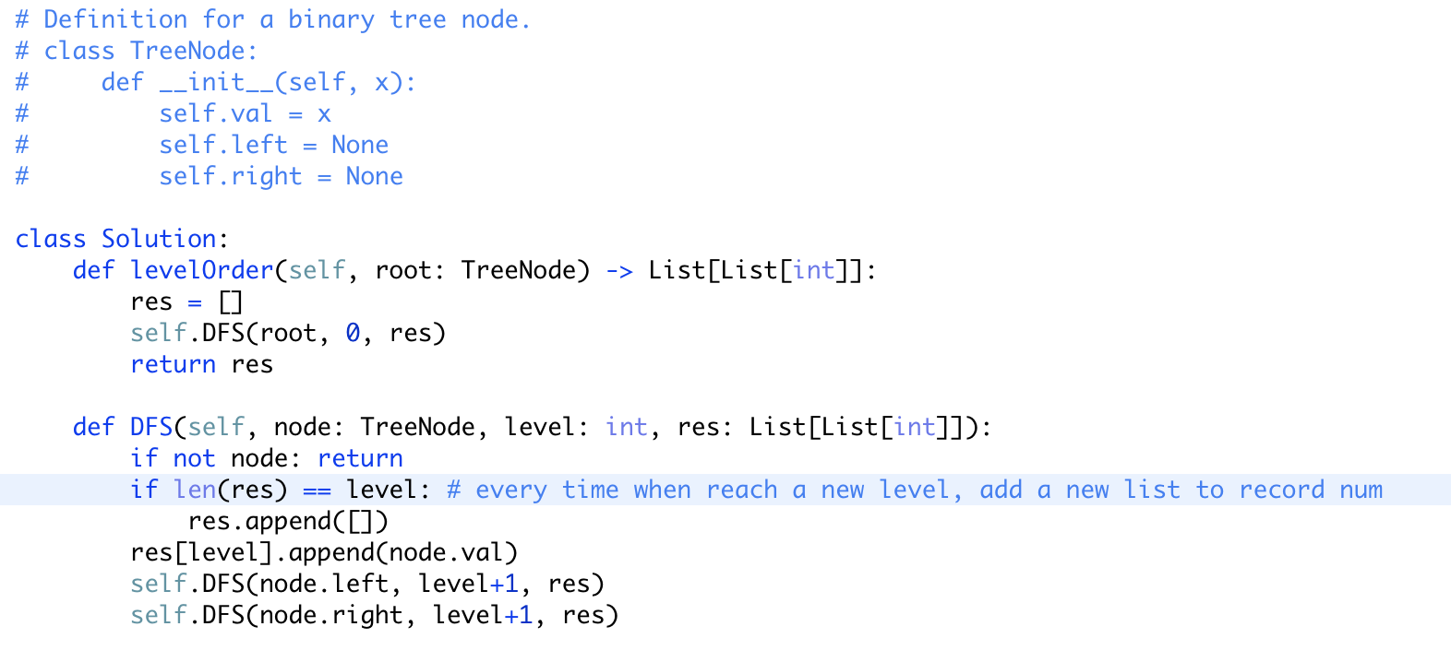

1. BFS

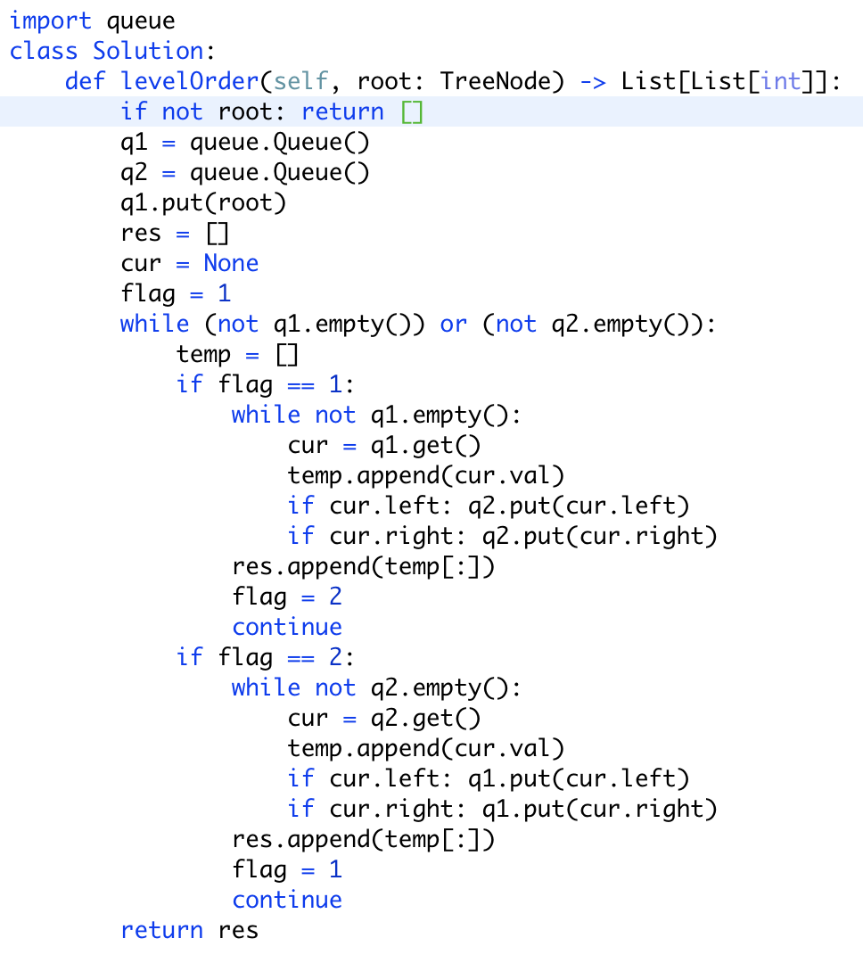

使用两个queue交替存储val，来解决分层问题

改良版：

只需要使用L来记录队列中原本元素个数，然后就可以解决分层问题

