**112. Path Sum**

Easy

1081356FavoriteShare

Given a binary tree and a sum, determine if the tree has a root-to-leaf path such that adding up all the values along the path equals the given sum.

**Note:** A leaf is a node with no children.

**Example:**

Given the below binary tree and sum = 22,

**5**

**/** \

**4** 8

**/** / \

**11** 13 4

/ **\** \

7 **2** 1

return true, as there exist a root-to-leaf path 5->4->11->2 which sum is 22.

1.dfs

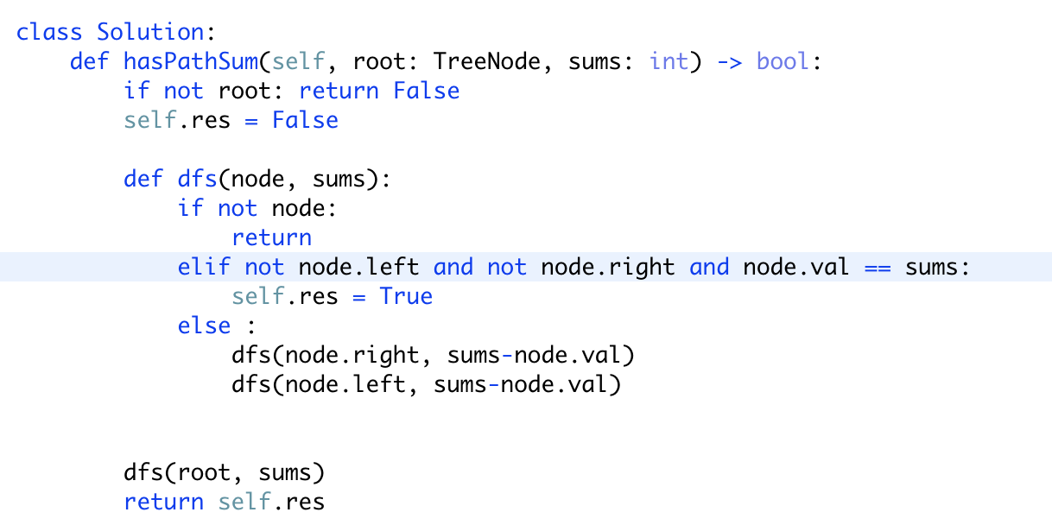

注意题目要求从root 到leaf的路径，但是单个root节点不算一条路径（[1,2] 1）

所以之前用来判断是否到达叶子结点的方法就不能用了（if not cur_node: last_node is leaf node）应该改为（if not cur_node.left and not cur_node.right: cur_node is leaf node）

改良版：

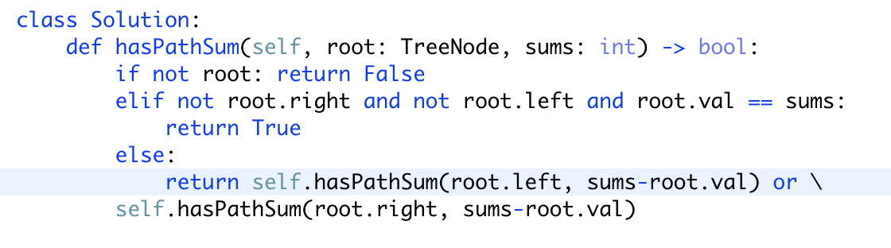

就不需要使用res来记录结果