**13. Roman to Integer**

Easy

13062719FavoriteShare

Roman numerals are represented by seven different symbols: I, V, X, L, C, D and M.

**Symbol** **Value**

I 1

V 5

X 10

L 50

C 100

D 500

M 1000

For example, two is written as II in Roman numeral, just two one's added together. Twelve is written as, XII, which is simply X + II. The number twenty seven is written as XXVII, which is XX + V+ II.

Roman numerals are usually written largest to smallest from left to right. However, the numeral for four is not IIII. Instead, the number four is written as IV. Because the one is before the five we subtract it making four. The same principle applies to the number nine, which is written as IX. There are six instances where subtraction is used:

* I can be placed before V (5) and X (10) to make 4 and 9.
* X can be placed before L (50) and C (100) to make 40 and 90.
* C can be placed before D (500) and M (1000) to make 400 and 900.

Given a roman numeral, convert it to an integer. Input is guaranteed to be within the range from 1 to 3999.

**Example 1:**

**Input:** "III"

**Output:** 3

**Example 2:**

**Input:** "IV"

**Output:** 4

**Example 3:**

**Input:** "IX"

**Output:** 9

**Example 4:**

**Input:** "LVIII"

**Output:** 58

**Explanation:** L = 50, V= 5, III = 3.

**Example 5:**

**Input:** "MCMXCIV"

**Output:** 1994

**Explanation:** M = 1000, CM = 900, XC = 90 and IV = 4.

难点： 如何解决subtraction的情况

思路：

首先为了快速访问，所以肯定要使用字典存转换值。然后为了解决难点，我们通过观察可以发现，当前面一个数小于后面一个数时，那前面那个数就是需要减去的，比如"IV"=4，那么有人肯定会问：不对啊"I"只能后面跟"V"或"X"才代表4或9啊，万一"I"后面出现了"L"怎么办？会被当成49吗？这种情况肯定不会出现，因为根据罗马数字规则，Roman numerals are usually written largest to smallest from left to right，大的数字肯定会出现在左边，只有当subtraction情况出现时才会在小的数右边，且只会跟可以减它的数一起出现。

理清这些关系，代码就很简单。

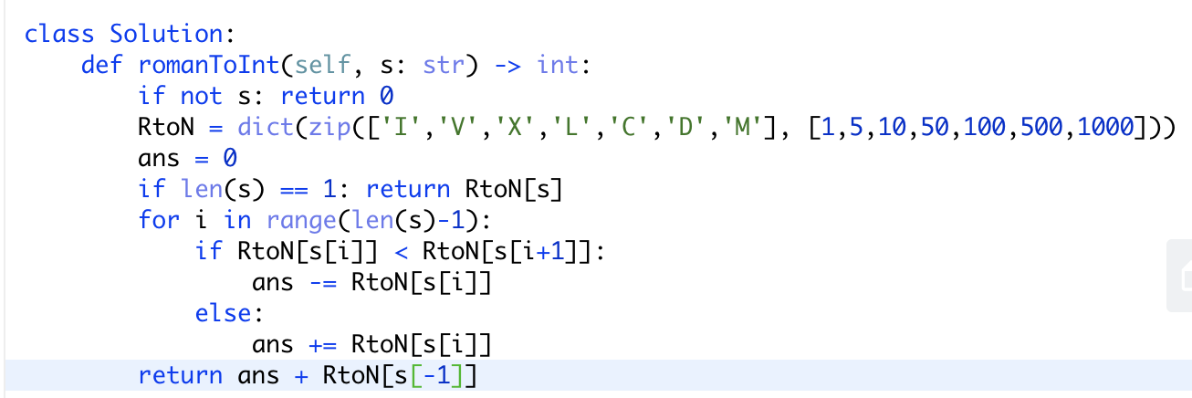

时间复杂度：O（1）。

空间复杂度：O（1）。