**134. Gas Station**

Medium

814298FavoriteShare

There are *N* gas stations along a circular route, where the amount of gas at station *i* is gas[i].

You have a car with an unlimited gas tank and it costs cost[i] of gas to travel from station *i* to its next station (*i*+1). You begin the journey with an empty tank at one of the gas stations.

Return the starting gas station's index if you can travel around the circuit once in the clockwise direction, otherwise return -1.

**Note:**

* If there exists a solution, it is guaranteed to be unique.
* Both input arrays are non-empty and have the same length.
* Each element in the input arrays is a non-negative integer.

**Example 1:**

**Input:**

gas = [1,2,3,4,5]

cost = [3,4,5,1,2]

**Output:** 3

**Explanation:**

Start at station 3 (index 3) and fill up with 4 unit of gas. Your tank = 0 + 4 = 4

Travel to station 4. Your tank = 4 - 1 + 5 = 8

Travel to station 0. Your tank = 8 - 2 + 1 = 7

Travel to station 1. Your tank = 7 - 3 + 2 = 6

Travel to station 2. Your tank = 6 - 4 + 3 = 5

Travel to station 3. The cost is 5. Your gas is just enough to travel back to station 3.

Therefore, return 3 as the starting index.

1. Two for loop:

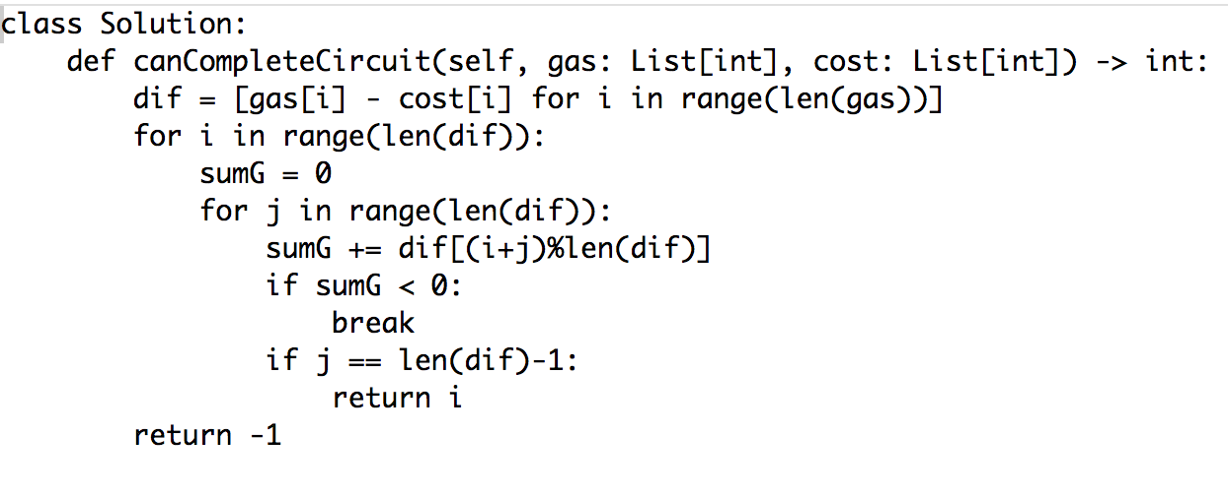

思路简单，但是超时

1. Two for loop + memory

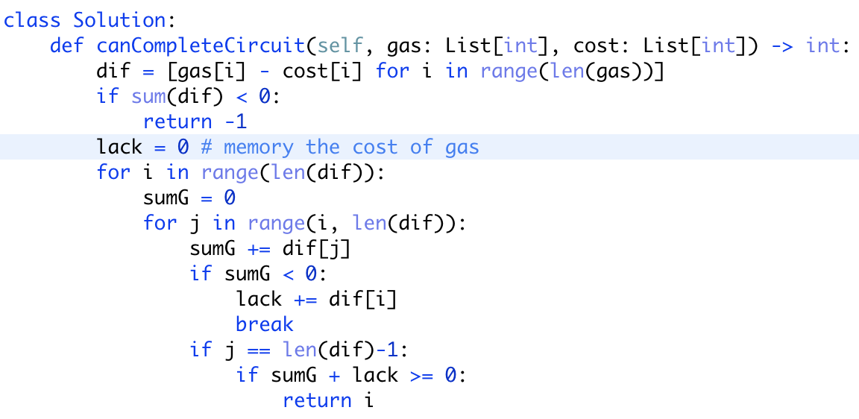

改良版，不超时了

1. While

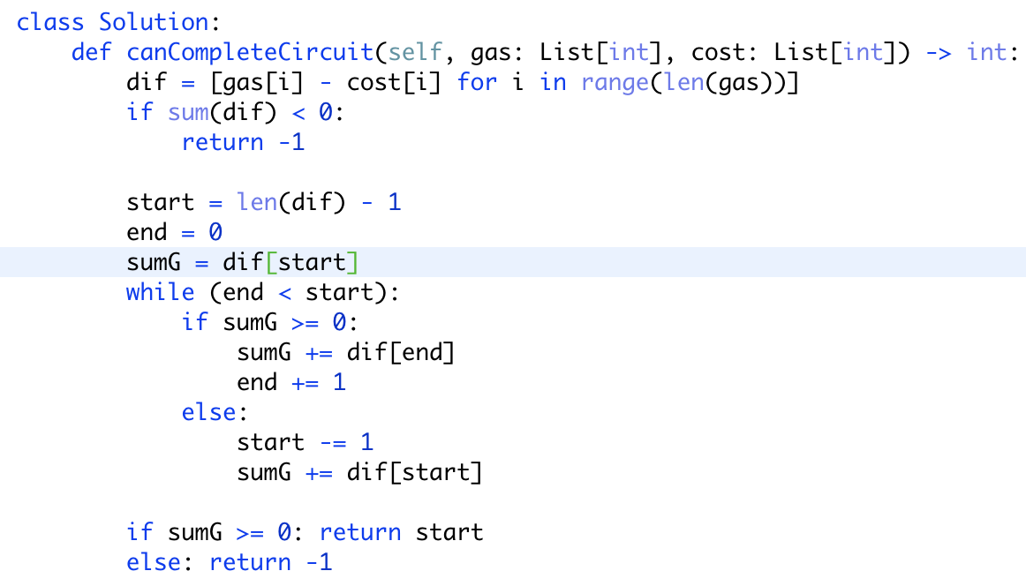

The basic idea is every time we start from a station, we go as far as possible by increasing end until remaining gas is less than 0. If 'end' finally hits start we know we can travel around from 'start'. If we haven't traveled around, we know we cannot start from this station. Then we check the station before our start station if we can start from this station. Repeat until we have checked all stations.

Note there is a little trick that every time we try to find the next start station, we always to back to extend the distance from start to end so that we can check all stations on the circuit. Otherwise, if we move start forward to decrease the distance from start to end, we are likely to end up with only checking part of the circuit. Another trick is we start from the end of the array so as to avoid some corner cases.