**139. Word Break**

Medium

2658141FavoriteShare

Given a **non-empty** string *s* and a dictionary *wordDict* containing a list of **non-empty** words, determine if *s* can be segmented into a space-separated sequence of one or more dictionary words.

**Note:**

* The same word in the dictionary may be reused multiple times in the segmentation.
* You may assume the dictionary does not contain duplicate words.

**Example 1:**

**Input:** s = "leetcode", wordDict = ["leet", "code"]

**Output:** true

**Explanation:** Return true because "leetcode" can be segmented as "leet code".

**Example 2:**

**Input:** s = "applepenapple", wordDict = ["apple", "pen"]。

**Output:** true

**Explanation:** Return true because "applepenapple" can be segmented as "apple pen apple".

  Note that you are allowed to reuse a dictionary word.

**Example 3:**

**Input:** s = "catsandog", wordDict = ["cats", "dog", "sand", "and", "cat"]

**Output:** false

1. Recursion

逻辑没问题，但超时了

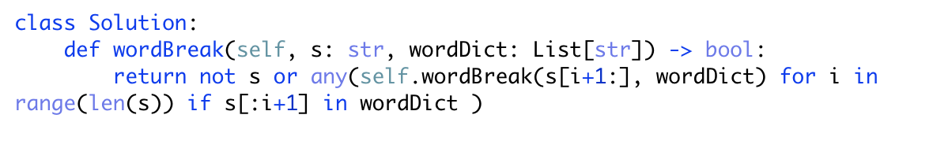

Any的用法<http://www.runoob.com/python/python-func-any.html>

用于判断给定的可迭代参数 iterable 是否全部为 False，则返回 False，如果有一个为 True，则返回 True。

1. DP

