**14. Longest Common Prefix**

Easy

14931400FavoriteShare

Write a function to find the longest common prefix string amongst an array of strings.

If there is no common prefix, return an empty string "".

**Example 1:**

**Input:** ["flower","flow","flight"]

**Output:** "fl"

**Example 2:**

**Input:** ["dog","racecar","car"]

**Output:** ""

**Explanation:** There is no common prefix among the input strings.

**Note:**

All given inputs are in lowercase letters a-z.

1. 遍历

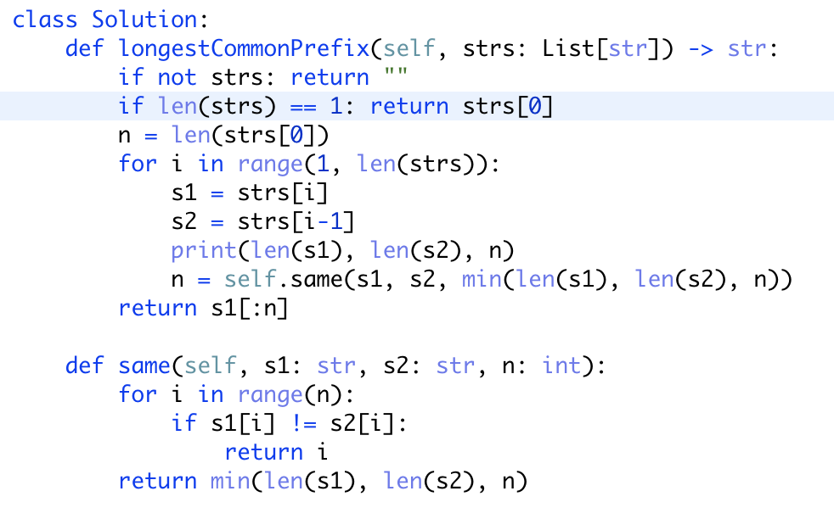

注意：边界情况

改良：取消对数字的记录， 直接记录相同字母

