**182. Duplicate Emails**

Easy

32022FavoriteShare

SQL Schema

Write a SQL query to find all duplicate emails in a table named Person.

+----+---------+

| Id | Email |

+----+---------+

| 1 | a@b.com |

| 2 | c@d.com |

| 3 | a@b.com |

+----+---------+

For example, your query should return the following for the above table:

+---------+

| Email |

+---------+

| a@b.com |

+---------+

**Note**: All emails are in lowercase.

1. 复制，对比相同

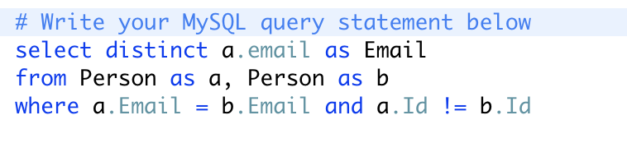

1. Group by

