**204. Count Primes**

Easy

1177426FavoriteShare

Count the number of prime numbers less than a non-negative number, ***n***.

**Example:**

**Input:** 10

**Output:** 4

**Explanation:** There are 4 prime numbers less than 10, they are 2, 3, 5, 7.

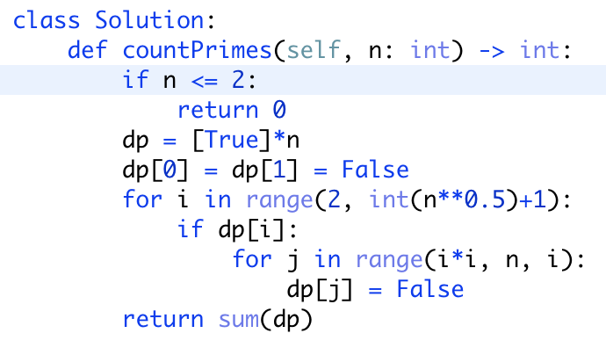

<https://leetcode.com/problems/count-primes/discuss/57595/Fast-Python-Solution>