**205. Isomorphic Strings**

Easy

812235FavoriteShare

Given two strings ***s*** and ***t***, determine if they are isomorphic.

Two strings are isomorphic if the characters in ***s*** can be replaced to get ***t***.

All occurrences of a character must be replaced with another character while preserving the order of characters. No two characters may map to the same character but a character may map to itself.

**Example 1:**

**Input:** ***s*** = "egg", ***t =*** "add"

**Output:** true

**Example 2:**

**Input:** ***s*** = "foo", ***t =*** "bar"

**Output:** false

**Example 3:**

**Input:** ***s*** = "paper", ***t =*** "title"

**Output:** true

**Note:**  
You may assume both ***s***and ***t***have the same length.

1. 用字典记录对应关系

这里的对应关系是相互的，所以不仅需要记录s对t的关系，还要记录t对s的关系

当出现一个字母对应多字母的情况，就肯定不是isomorphic string

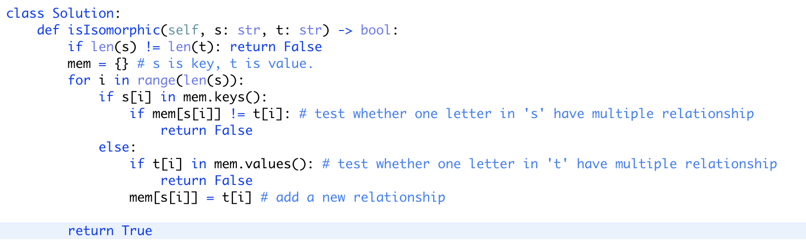

**290. Word Pattern**

Easy

68789FavoriteShare

Given a pattern and a string str, find if str follows the same pattern.

Here **follow** means a full match, such that there is a bijection between a letter in pattern and a **non-empty** word in str.

**Example 1:**

**Input:** pattern = "abba", str = "dog cat cat dog"

**Output:** true

**Example 2:**

**Input:**pattern = "abba", str = "dog cat cat fish"

**Output:** false

**Example 3:**

**Input:** pattern = "aaaa", str = "dog cat cat dog"

**Output:** false

**Example 4:**

**Input:** pattern = "abba", str = "dog dog dog dog"

**Output:** false

**Notes:**  
You may assume pattern contains only lowercase letters, and str contains lowercase letters that may be separated by a single space.

1. 同上

