**21. Merge Two Sorted Lists**

Easy

Merge two sorted linked lists and return it as a new list. The new list should be made by splicing together the nodes of the first two lists.

**Example:**

**Input:** 1->2->4, 1->3->4

**Output:** 1->1->2->3->4->4

思路：递归

为了解决长度不一致的情况：

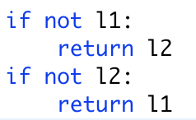

不需要新建list存储答案，直接在l1,l2基础上进行修改

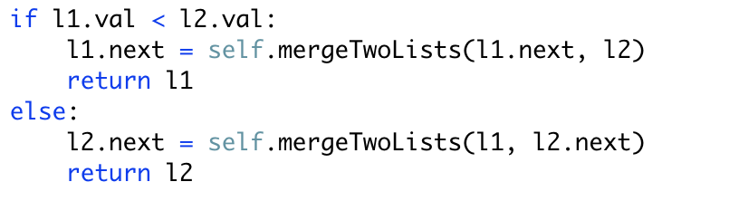

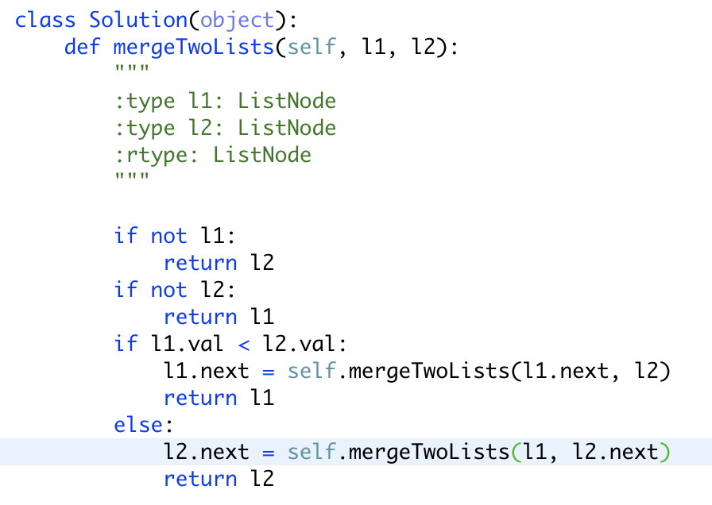

2. 迭代

