**215. Kth Largest Element in an Array**

Medium

2407191FavoriteShare

Find the **k**th largest element in an unsorted array. Note that it is the kth largest element in the sorted order, not the kth distinct element.

**Example 1:**

**Input:** [3,2,1,5,6,4] and k = 2

**Output:** 5

**Example 2:**

**Input:** [3,2,3,1,2,4,5,5,6] and k = 4

**Output:** 4

**Note:**  
You may assume k is always valid, 1 ≤ k ≤ array's length.

1. Priority queue

题目里只要出现 排序，第kth个，都可以用priority queue这种偷懒的办法

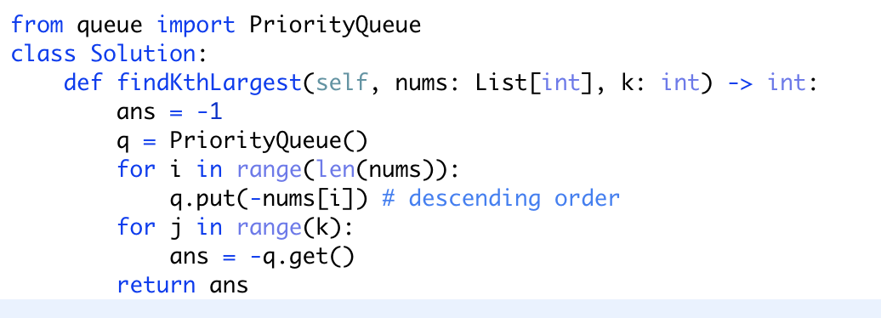

1. Heapq

函数：

<https://docs.python.org/zh-cn/3/library/heapq.html>

heapq的功能和queue.PriorityQueue差不多，区别简单来说堆队列更快更灵活，优先队列更安全

具体区别如下：

<https://codeday.me/bug/20190223/661847.html>

具体解法： <https://leetcode.com/problems/kth-largest-element-in-an-array/discuss/301338/Python-or-tm-215>

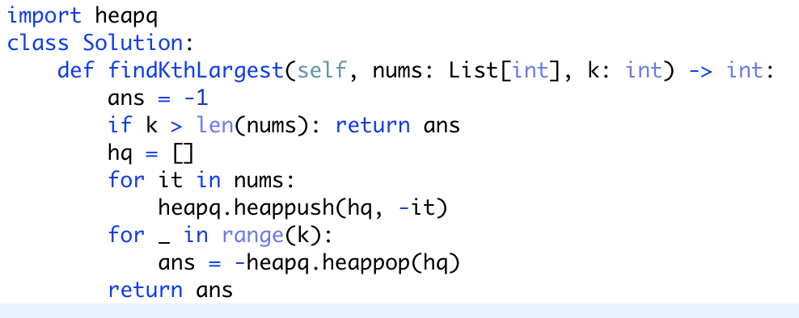

简化版；使用heapify， 原地改变数组，注意将第k大，变为第（n-k+1）小

