**22. Generate Parentheses**

Medium

Given *n* pairs of parentheses, write a function to generate all combinations of well-formed parentheses.

For example, given *n* = 3, a solution set is:

[

"((()))",

"(()())",

"(())()",

"()(())",

"()()()"

]

Python3

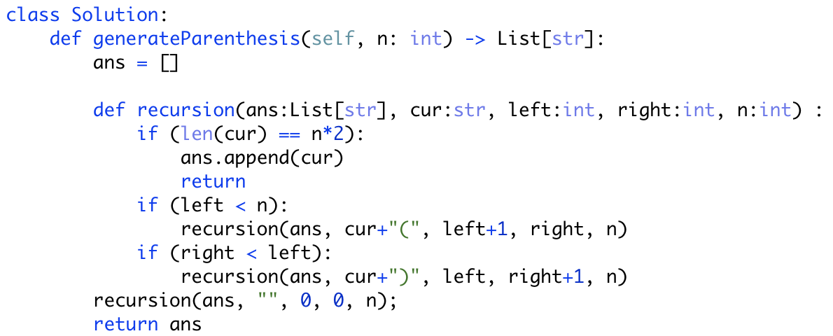

Python2

