**268. Missing Number**

Easy

9781384FavoriteShare

Given an array containing *n* distinct numbers taken from 0, 1, 2, ..., n, find the one that is missing from the array.

**Example 1:**

**Input:** [3,0,1]

**Output:** 2

**Example 2:**

**Input:** [9,6,4,2,3,5,7,0,1]

**Output:** 8

**Note**:  
Your algorithm should run in linear runtime complexity. Could you implement it using only constant extra space complexity?

1. Sorted

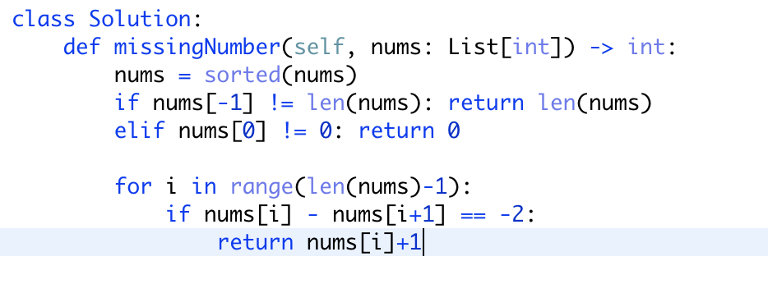

**Time complexity: O(nlogn)**

For loop 是n， sorted是nlogn

**Space complexity: O(1) or O(n):**

In the sample code, we sorted nums in place, allowing us to avoid allocating additional space. If modifying nums is forbidden, we can allocate anO(n) size copy and sort that instead.

1. Set (hashSet)

使用set前：

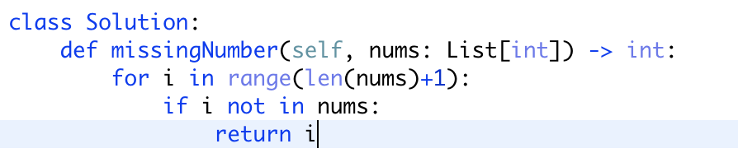



使用set后：

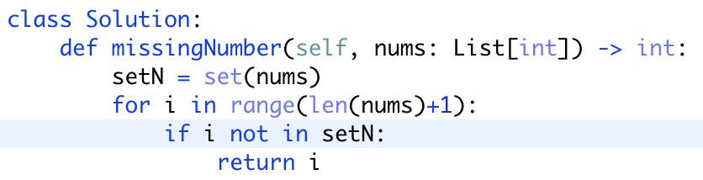

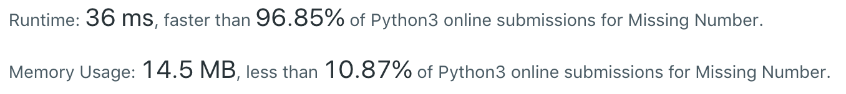

**Time complexity: O(n)**

set allows for O(1) containment queries, the main loop runs in O(n) time.

**Space complexity: O(n):**

注意：当list长为1时，要准确理解题目中对缺失数字的定义，返回适当数字