**28. Implement strStr()**

Easy

9421375FavoriteShare

Implement [strStr()](http://www.cplusplus.com/reference/cstring/strstr/" \t "_blank).

Return the index of the first occurrence of needle in haystack, or **-1** if needle is not part of haystack.

**Example 1:**

**Input:** haystack = "hello", needle = "ll"

**Output:** 2

**Example 2:**

**Input:** haystack = "aaaaa", needle = "bba"

**Output:** -1

**Clarification:**

What should we return when needle is an empty string? This is a great question to ask during an interview.

For the purpose of this problem, we will return 0 when needle is an empty string. This is consistent to C's [strstr()](http://www.cplusplus.com/reference/cstring/strstr/" \t "_blank) and Java's [indexOf()](https://docs.oracle.com/javase/7/docs/api/java/lang/String.html" \l "indexOf(java.lang.String)" \t "_blank).

1. For loop

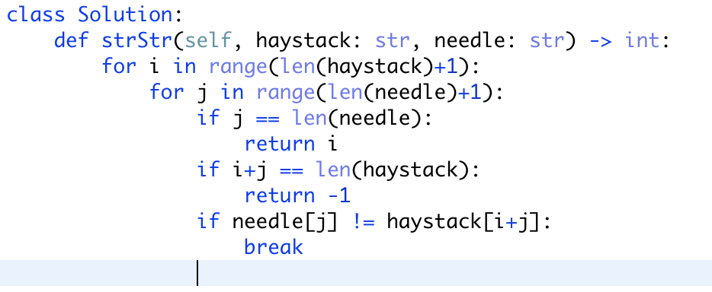

注意： 第二个if和第三个if顺序不能乱