**29. Divide Two Integers**

Medium

7183462FavoriteShare

Given two integers dividend and divisor, divide two integers without using multiplication, division and mod operator.

Return the quotient after dividing dividend by divisor.

The integer division should truncate toward zero.

**Example 1:**

**Input:** dividend = 10, divisor = 3

**Output:** 3

**Example 2:**

**Input:** dividend = 7, divisor = -3

**Output:** -2

**Note:**

* Both dividend and divisor will be 32-bit signed integers.
* The divisor will never be 0.
* Assume we are dealing with an environment which could only store integers within the 32-bit signed integer range: [−231,  231 − 1]. For the purpose of this problem, assume that your function returns 231 − 1 when the division result overflows.

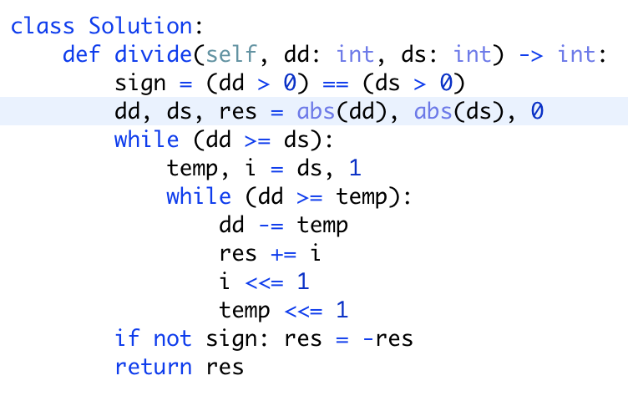

但是因为note3， 即答案的输出范围是（-2147483648，2147483647），负数比正数多一位。所以

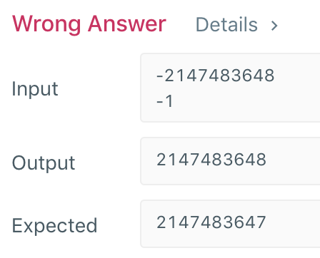

我们需要在return的地方处理一下，规范一下输出范围

