**3. Longest Substring Without Repeating Characters**

Given a string, find the length of the **longest substring** without repeating characters.

**Example 1:**

**Input:** "abcabcbb"

**Output:** 3

**Explanation:** The answer is "abc", with the length of 3.

**Example 2:**

**Input:** "bbbbb"

**Output:** 1

**Explanation:** The answer is "b", with the length of 1.

**Example 3:**

**Input:** "pwwkew"

**Output:** 3

**Explanation:** The answer is "wke", with the length of 3.

Note that the answer must be a **substring**, "pwke" is a *subsequence* and not a substring.

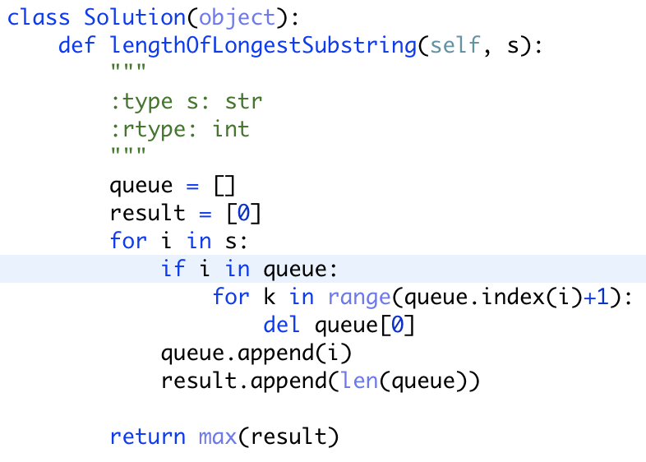

改良：

