**34. Find First and Last Position of Element in Sorted Array**

Medium

Given an array of integers nums sorted in ascending order, find the starting and ending position of a given target value.

Your algorithm's runtime complexity must be in the order of *O*(log *n*).

If the target is not found in the array, return [-1, -1].

**Example 1:**

**Input:** nums = [5,7,7,8,8,10], target = 8

**Output:** [3,4]

**Example 2:**

**Input:** nums = [5,7,7,8,8,10], target = 6

**Output:** [-1,-1]

思路一：头尾两指针遍历

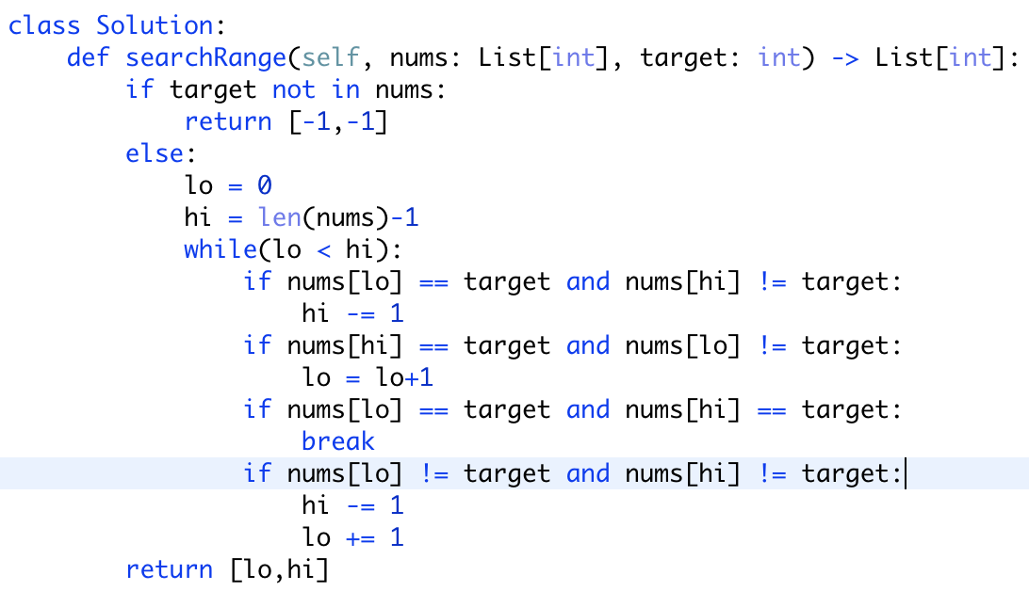

容易想到，但比较慢

时间复杂度：O(n)

空间复杂度：O(1)

改良版：

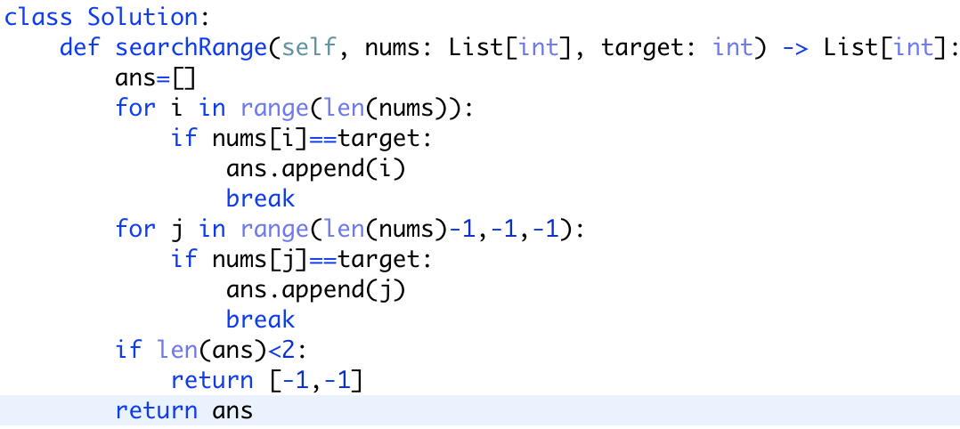

思路二：利用python自带函数（off-the-shelf）

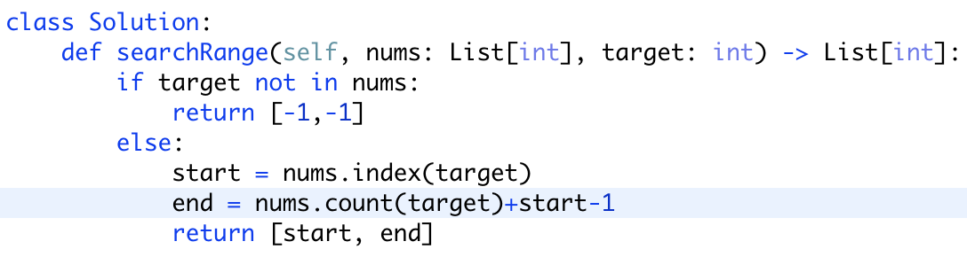

目前速度最快，内存占用最低的方法。

其他思路参考：<https://leetcode.wang/leetCode-34-Find-First-and-Last-Position-of-Element-in-Sorted-Array.html>