**35. Search Insert Position**

Easy

1513198FavoriteShare

Given a sorted array and a target value, return the index if the target is found. If not, return the index where it would be if it were inserted in order.

You may assume no duplicates in the array.

**Example 1:**

**Input:** [1,3,5,6], 5

**Output:** 2

**Example 2:**

**Input:** [1,3,5,6], 2

**Output:** 1

**Example 3:**

**Input:** [1,3,5,6], 7

**Output:** 4

**Example 4:**

**Input:** [1,3,5,6], 0

**Output:** 0

1. O(n)遍历

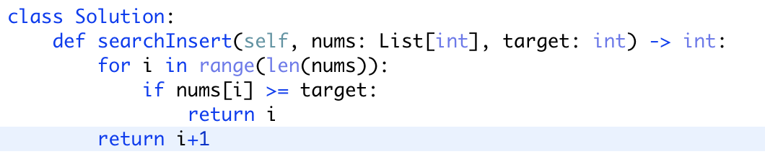

1. O(logn)二分查找

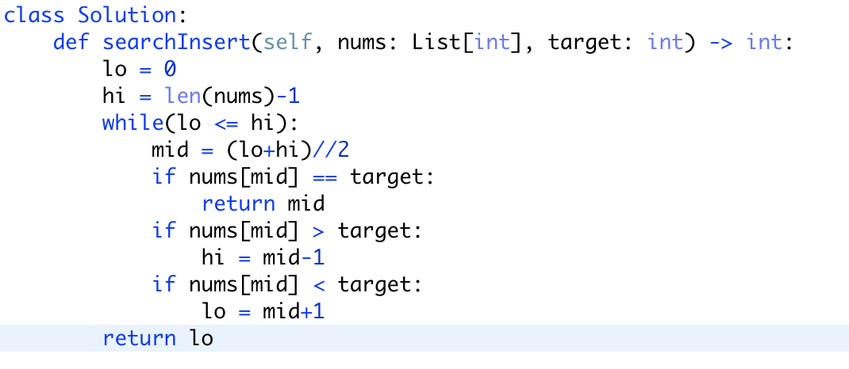

为什么最后要return lo而不是mid，因为当testcase为**[1,3,5,6]， 0时。Lo可以准确返回0而不是1**