**36. Valid Sudoku**

Medium

906335FavoriteShare

Determine if a 9x9 Sudoku board is valid. Only the filled cells need to be validated **according to the following rules**:

1. Each row must contain the digits 1-9 without repetition.
2. Each column must contain the digits 1-9 without repetition.
3. Each of the 9 3x3 sub-boxes of the grid must contain the digits 1-9 without repetition.

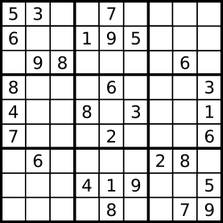  
A partially filled sudoku which is valid.

The Sudoku board could be partially filled, where empty cells are filled with the character '.'.

1. 暴力破解（3次for 循环）

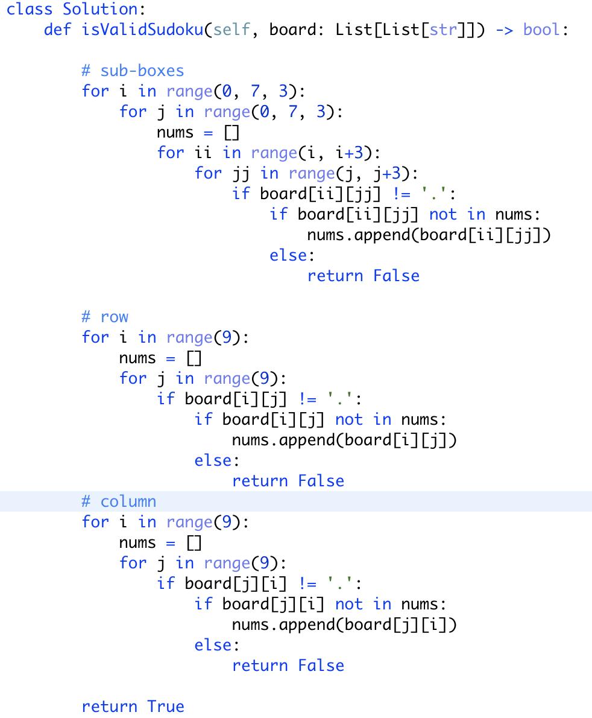

Hashset 版：

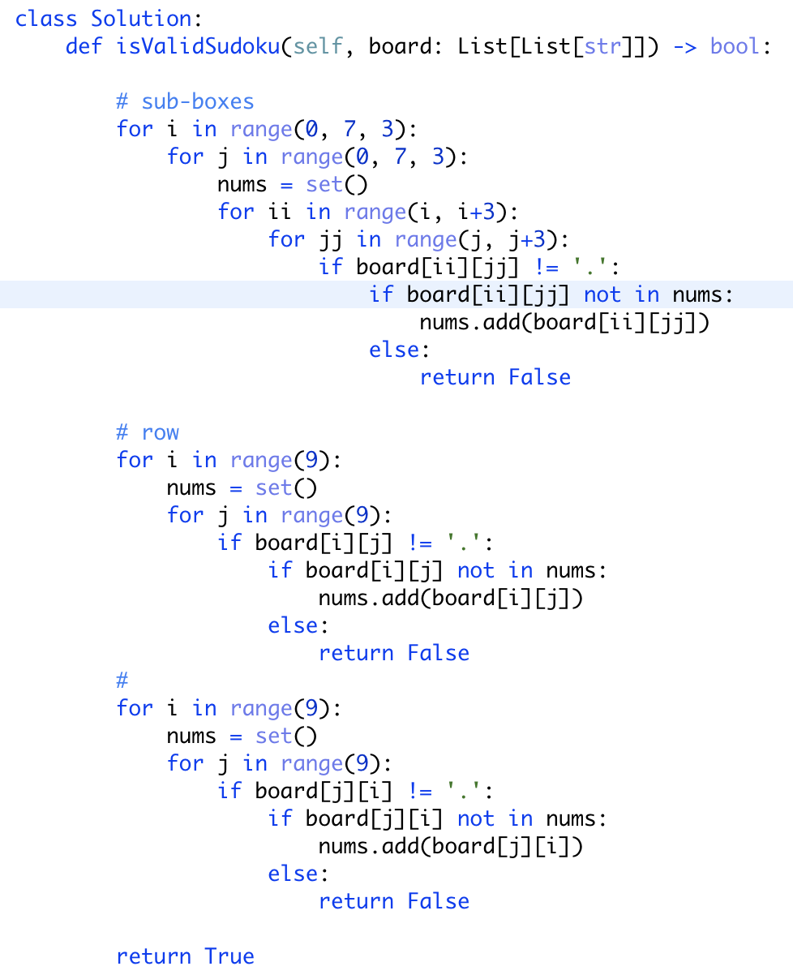



<https://stackoverflow.com/questions/26724002/contains-of-hashsetinteger-in-python>

按道理改用hash set会快一点，因为in的查询时间复杂度是O(1)，但是结果并没有快多少，不知道为什么。

1. 一次for循环版

利用标记， 具体参考<https://leetcode.wang/leetCode-36-Valid-Sudoku.html>

