**38. Count and Say**

Easy

8456549FavoriteShare

The count-and-say sequence is the sequence of integers with the first five terms as following:

1. 1

2. 11

3. 21

4. 1211

5. 111221

1 is read off as "one 1" or 11.  
11 is read off as "two 1s" or 21.  
21 is read off as "one 2, then one 1" or 1211.

Given an integer *n* where 1 ≤ *n* ≤ 30, generate the *n*th term of the count-and-say sequence.

Note: Each term of the sequence of integers will be represented as a string.

**Example 1:**

**Input:** 1

**Output:** "1"

**Example 2:**

**Input:** 4

**Output:** "1211"

Accepted

301,379

Submissions

730,449

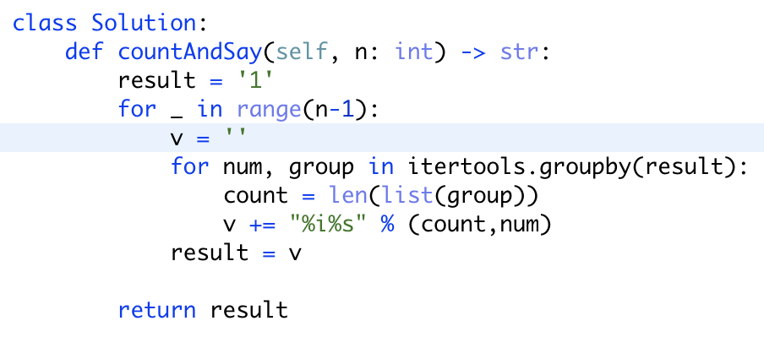

Itertools.groupby用法：

<https://docs.python.org/zh-cn/3/library/itertools.html>

<https://leetcode.com/problems/count-and-say/discuss/15999/4-5-lines-Python-solutions>