**389. Find the Difference**

Easy

536236FavoriteShare

Given two strings ***s*** and ***t*** which consist of only lowercase letters.

String ***t*** is generated by random shuffling string ***s*** and then add one more letter at a random position.

Find the letter that was added in ***t***.

**Example:**

Input:

s = "abcd"

t = "abcde"

Output:

e

Explanation:

'e' is the letter that was added.

1. XOR

使用异或，相同的抵消，留下的是不同的。对于字母要先转换成ASCII码

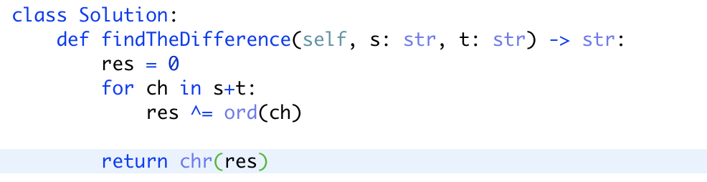

1. Dictionary

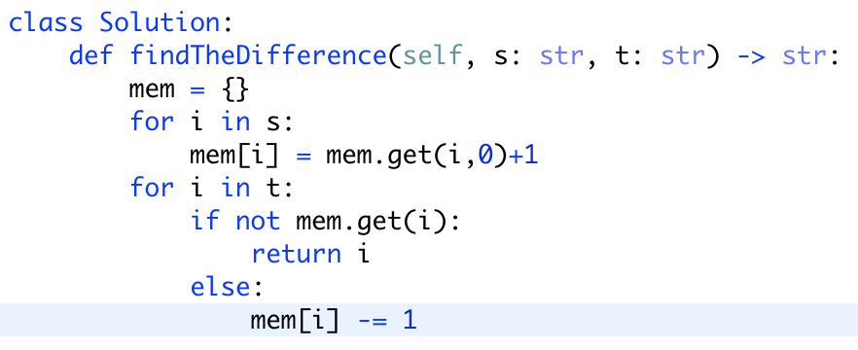

要点： mem.get的使用技巧

<http://www.runoob.com/python/att-dictionary-get.html>