**395. Longest Substring with At Least K Repeating Characters**

Medium

82276FavoriteShare

Find the length of the longest substring ***T*** of a given string (consists of lowercase letters only) such that every character in ***T*** appears no less than *k* times.

**Example 1:**

Input:

s = "aaabb", k = 3

Output:

3

The longest substring is "aaa", as 'a' is repeated 3 times.

**Example 2:**

Input:

s = "ababbc", k = 2

Output:

5

The longest substring is "ababb", as 'a' is repeated 2 times and 'b' is repeated 3 times.

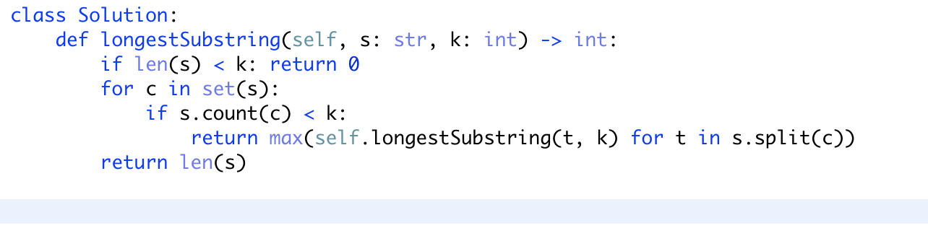

如果字符串s的长度少于k，那么一定不存在满足题意的子字符串，返回0；

如果一个字符在s中出现的次数少于k次，那么所有的包含这个字符的子字符串都不能满足题意。所以，应该去不包含这个字符的子字符串继续寻找。这就是分而治之的思路，返回不同子串的长度最大值。

如果s中的每个字符出现的次数都大于k次，那么s就是我们要求的字符串。