**40. Combination Sum II**

Medium

96950FavoriteShare

Given a collection of candidate numbers (candidates) and a target number (target), find all unique combinations in candidates where the candidate numbers sums to target.

Each number in candidates may only be used **once** in the combination.

**Note:**

* All numbers (including target) will be positive integers.
* The solution set must not contain duplicate combinations.

**Example 1:**

**Input:** candidates = [10,1,2,7,6,1,5], target = 8,

**A solution set is:**

[

[1, 7],

[1, 2, 5],

[2, 6],

[1, 1, 6]

]

**Example 2:**

**Input:** candidates = [2,5,2,1,2], target = 5,

**A solution set is:**

[

  [1,2,2],

  [5]

]

1. Recursion

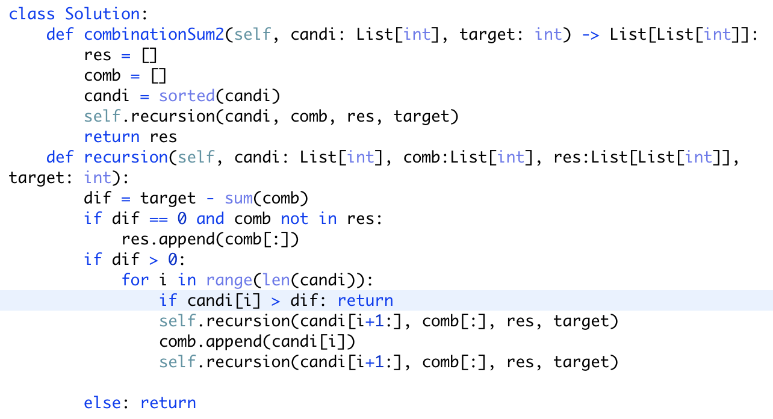

注意： 如何避免加入重复答案（使用sorted），如何避免答案里使用重复数字（for loop）

时间复杂度空间复杂度很大，不建议使用