**414. Third Maximum Number**

Easy

403753FavoriteShare

Given a **non-empty** array of integers, return the **third** maximum number in this array. If it does not exist, return the maximum number. The time complexity must be in O(n).

**Example 1:**

**Input:** [3, 2, 1]

**Output:** 1

**Explanation:** The third maximum is 1.

**Example 2:**

**Input:** [1, 2]

**Output:** 2

**Explanation:** The third maximum does not exist, so the maximum (2) is returned instead.

**Example 3:**

**Input:** [2, 2, 3, 1]

**Output:** 1

**Explanation:** Note that the third maximum here means the third maximum distinct number.

Both numbers with value 2 are both considered as second maximum.

1. Priority queue

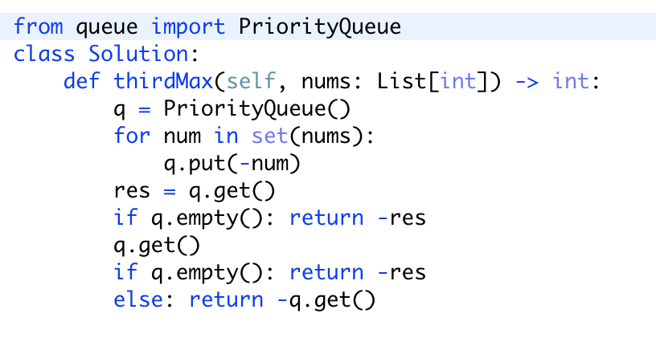

突然想到优先队列就写的。但是时间空间复杂度较高。光是Set的使用，就使空间复杂读大于O(n)了

1. For loop

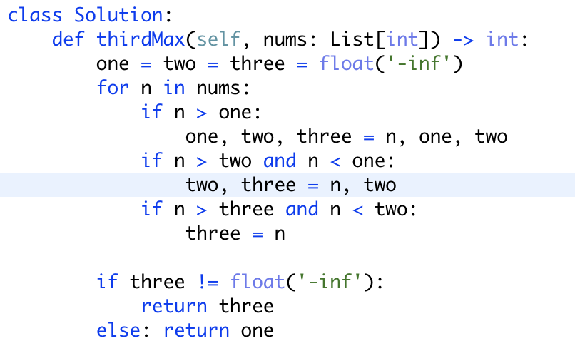

注意：每个if语句的写法，和数据的更替