**5. Longest Palindromic Substring**

Medium

Given a string **s**, find the longest palindromic substring in **s**. You may assume that the maximum length of **s** is 1000.

**Example 1:**

**Input:** "babad"

**Output:** "bab"

**Note:** "aba" is also a valid answer.

**Example 2:**

**Input:** "cbbd"

**Output:** "bb"

思路：中心扩展法，动态规划

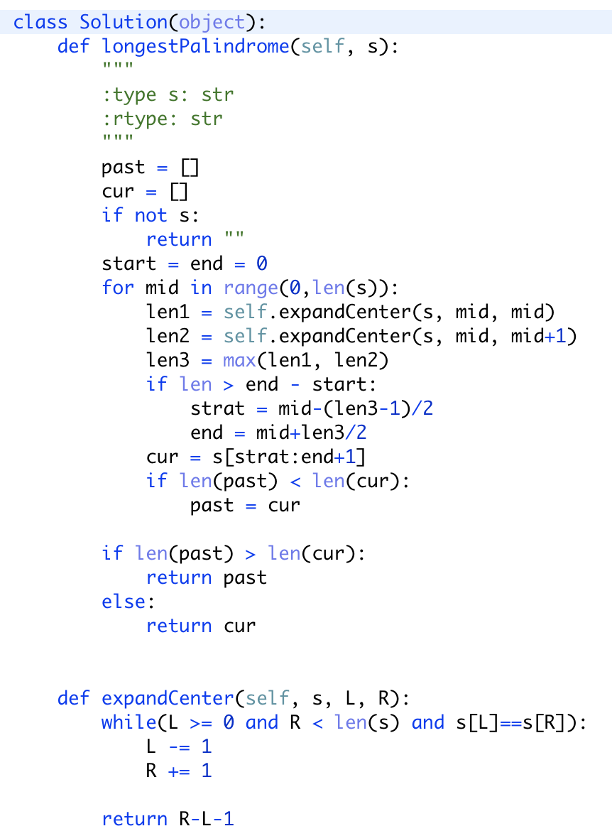

Reference：<https://leetcode.wang/leetCode-5-Longest-Palindromic-Substring.html>