**50. Pow(x, n)**

Medium

9012216FavoriteShare

Implement [pow(*x*, *n*)](http://www.cplusplus.com/reference/valarray/pow/), which calculates *x* raised to the power *n* (xn).

**Example 1:**

**Input:** 2.00000, 10

**Output:** 1024.00000

**Example 2:**

**Input:** 2.10000, 3

**Output:** 9.26100

**Example 3:**

**Input:** 2.00000, -2

**Output:** 0.25000

**Explanation:** 2-2 = 1/22 = 1/4 = 0.25

**Note:**

* -100.0 < *x* < 100.0
* *n* is a 32-bit signed integer, within the range [−231, 231− 1]

1. iteration

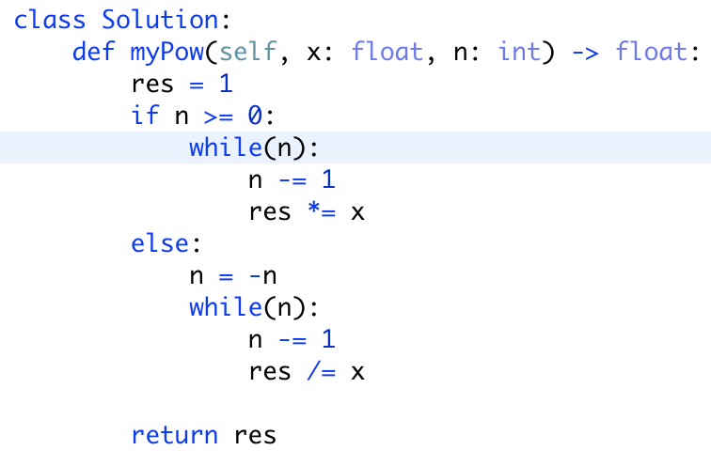

1. recursion

