**53. Maximum Subarray**

Easy

Given an integer array nums, find the contiguous subarray (containing at least one number) which has the largest sum and return its sum.

**Example:**

**Input:** [-2,1,-3,4,-1,2,1,-5,4],

**Output:** 6

**Explanation:** [4,-1,2,1] has the largest sum = 6.

**Follow up:**

If you have figured out the O(*n*) solution, try coding another solution using th

1. 暴力破解：

From the example, we found if we want sum be larger, both start and end of subarray should be positive. So first we need to **Record the positive elements position. Then use two for loops scan each case. But it wasted too much time and the time complexity is O(n2) because of two for loops.**

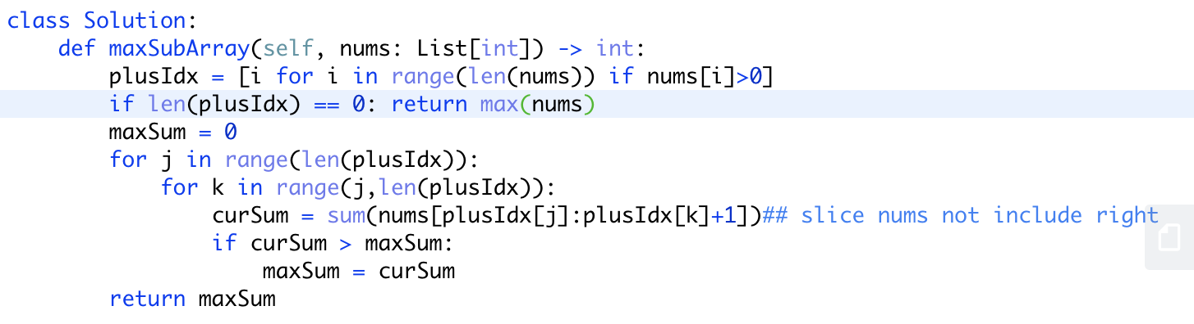

Tips: how to filter sequence elements（List comprehensions）

<https://python3-cookbook.readthedocs.io/zh_CN/latest/c01/p16_filter_sequence_elements.html#id1>

<https://eastlakeside.gitbooks.io/interpy-zh/content/Comprehensions/list-comprehensions.html>

1. 动态规划（DP dynamic programming）

Always using the previous best solution to make the next decision. Using a List (maxSum) to store the maxsum.

