**55. Jump Game**

Medium

2342226FavoriteShare

Given an array of non-negative integers, you are initially positioned at the first index of the array.

Each element in the array represents your maximum jump length at that position.

Determine if you are able to reach the last index.

**Example 1:**

**Input:** [2,3,1,1,4]

**Output:** true

**Explanation:** Jump 1 step from index 0 to 1, then 3 steps to the last index.

**Example 2:**

**Input:** [3,2,1,0,4]

**Output:** false

**Explanation:** You will always arrive at index 3 no matter what. Its maximum

  jump length is 0, which makes it impossible to reach the last index.

1. DP

先判断能否跳到这（是否为true），然后再把能够跳到的范围全部标True

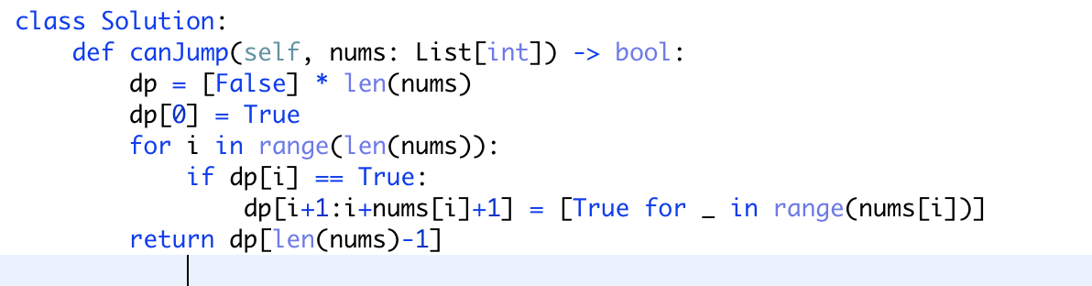

1. 顺藤摸瓜

