**56. Merge Intervals**

Medium

2508194FavoriteShare

Given a collection of intervals, merge all overlapping intervals.

**Example 1:**

**Input:** [[1,3],[2,6],[8,10],[15,18]]

**Output:** [[1,6],[8,10],[15,18]]

**Explanation:** Since intervals [1,3] and [2,6] overlaps, merge them into [1,6].

**Example 2:**

**Input:** [[1,4],[4,5]]

**Output:** [[1,5]]

**Explanation:** Intervals [1,4] and [4,5] are considered overlapping.

**NOTE:** input types have been changed on April 15, 2019. Please reset to default code definition to get new method signature.

1. 暴力

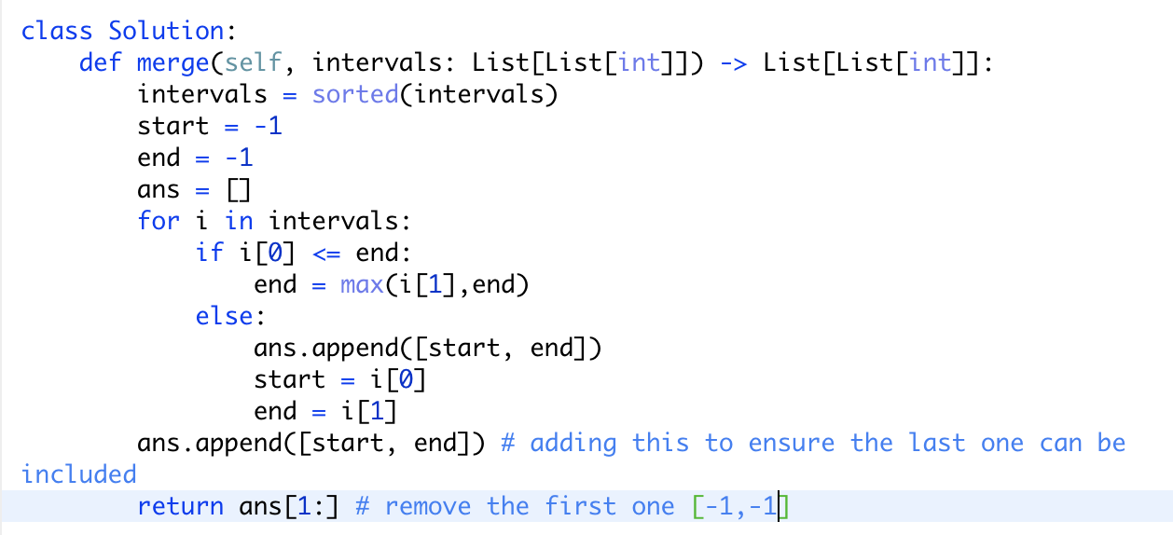

记录interval的start和end，如果遇到下一个start小于end，就merge，直到下一个不需要merge的interval出现再加入。