**67. Add Binary**

Easy

1075202FavoriteShare

Given two binary strings, return their sum (also a binary string).

The input strings are both **non-empty** and contains only characters 1 or 0.

**Example 1:**

**Input:** a = "11", b = "1"

**Output:** "100"

**Example 2:**

**Input:** a = "1010", b = "1011"

**Output:** "10101"

1. 转成十进制运算后再转回二进制

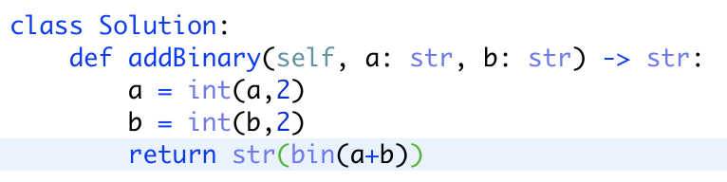

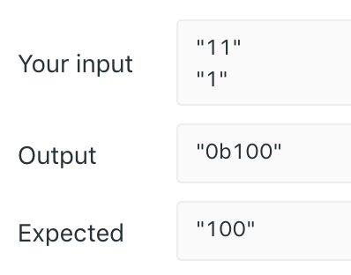此时会有Ob

改进版：

