**75. Sort Colors**

Medium

1761161FavoriteShare

Given an array with *n* objects colored red, white or blue, sort them [**in-place**](https://en.wikipedia.org/wiki/In-place_algorithm)so that objects of the same color are adjacent, with the colors in the order red, white and blue.

Here, we will use the integers 0, 1, and 2 to represent the color red, white, and blue respectively.

**Note:** You are not suppose to use the library's sort function for this problem.

**Example:**

**Input:** [2,0,2,1,1,0]

**Output:** [0,0,1,1,2,2]

**Follow up:**

* A rather straight forward solution is a two-pass algorithm using counting sort.  
  First, iterate the array counting number of 0's, 1's, and 2's, then overwrite array with total number of 0's, then 1's and followed by 2's.
* Could you come up with a one-pass algorithm using only constant space?

1. Bubble sort

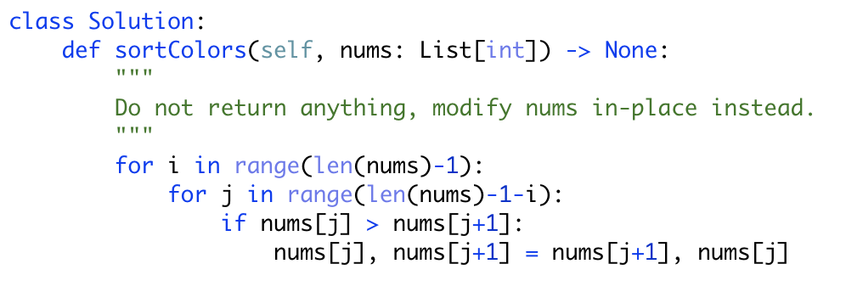

2.

