**811. Subdomain Visit Count**

Easy

301468FavoriteShare

A website domain like "discuss.leetcode.com" consists of various subdomains. At the top level, we have "com", at the next level, we have "leetcode.com", and at the lowest level, "discuss.leetcode.com". When we visit a domain like "discuss.leetcode.com", we will also visit the parent domains "leetcode.com" and "com" implicitly.

Now, call a "count-paired domain" to be a count (representing the number of visits this domain received), followed by a space, followed by the address. An example of a count-paired domain might be "9001 discuss.leetcode.com".

We are given a list cpdomains of count-paired domains. We would like a list of count-paired domains, (in the same format as the input, and in any order), that explicitly counts the number of visits to each subdomain.

**Example 1:**

**Input:**

["9001 discuss.leetcode.com"]

**Output:**

["9001 discuss.leetcode.com", "9001 leetcode.com", "9001 com"]

**Explanation:**

We only have one website domain: "discuss.leetcode.com". As discussed above, the subdomain "leetcode.com" and "com" will also be visited. So they will all be visited 9001 times.

**Example 2:**

**Input:**

["900 google.mail.com", "50 yahoo.com", "1 intel.mail.com", "5 wiki.org"]

**Output:**

["901 mail.com","50 yahoo.com","900 google.mail.com","5 wiki.org","5 org","1 intel.mail.com","951 com"]

**Explanation:**

We will visit "google.mail.com" 900 times, "yahoo.com" 50 times, "intel.mail.com" once and "wiki.org" 5 times. For the subdomains, we will visit "mail.com" 900 + 1 = 901 times, "com" 900 + 50 + 1 = 951 times, and "org" 5 times.

总之，写出subdomain和其总共出现的次数。算法不是难点，难点在于如何拆分string以及组合string。

拆分：str.split(‘ ’), 拆分出来count和domain

组合：’.’.join(list),将list里面的东西用’.’组合起来。<http://www.runoob.com/python/att-string-join.html>

1. Dictionary记录

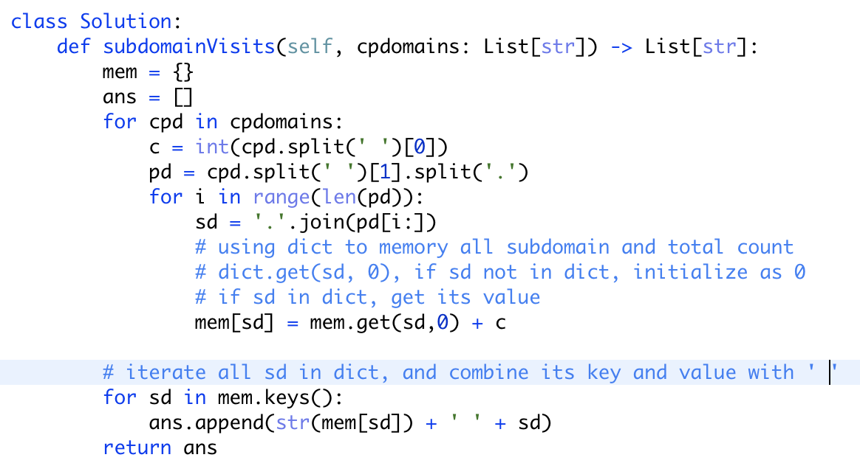

1. * + counter的使用

*：<https://codeyarns.com/2012/04/26/unpack-operator-in-python/>

In Python, the * (asterisk) character is not only used for multiplication and replication, but also for **unpacking**. 把对象变成可迭代

使用前：

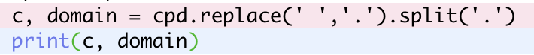



使用后：

