**84. Largest Rectangle in Histogram**

Hard

225560FavoriteShare

Given *n* non-negative integers representing the histogram's bar height where the width of each bar is 1, find the area of largest rectangle in the histogram.

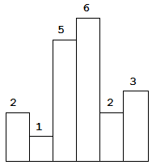  
Above is a histogram where width of each bar is 1, given height = [2,1,5,6,2,3].

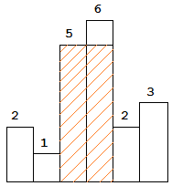  
The largest rectangle is shown in the shaded area, which has area = 10 unit.

**Example:**

**Input:** [2,1,5,6,2,3]

**Output:** 10

1. 遍历高度

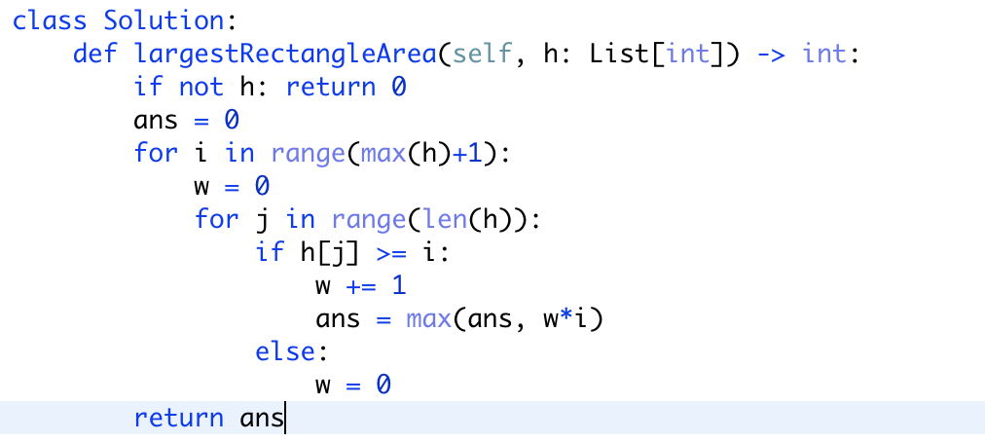

1. 找寻左右两侧低于当前高度柱子的index

类似于42

