Pickpoker

# Overview

PickPoker application simulate this game for running Android Application . The application shows 6 card and allows user to open each poker card.

You will win this game when 6 card is the same card ( 3 type of card: A, 2, 3)

Role: You just only open one card in a turn. To win you have to open cards in 3 rounds.

Line 3 (Bottom ) is round 1, Line 2 is round 2 and Line 1 ( Top) is Round 3

1. Round 1, See line 3, It allows you open the cards in the line number 3. You have to open 3 cards until them be same. , If they are same you will allow to play Round 2.
2. Round 2, See line 2, . You also have to open 2 cards until them be same. If they are same, you will allow to play Round 2. In contrast, you turn back to Round 1 and play again.
3. Round 3, See line 1 . In last Round you have to open the last card that be same type card with Round 2. If it is same, You WIN. In contrast, you turn back to Round 1 and play again.

The application’s functionalities are:

* Show 6 cards
* Allow user to open the cards according rule and reset all card to default.
* Load and show background picture

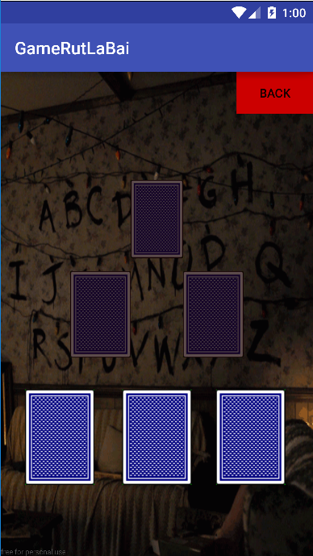

# Usecase Diagram

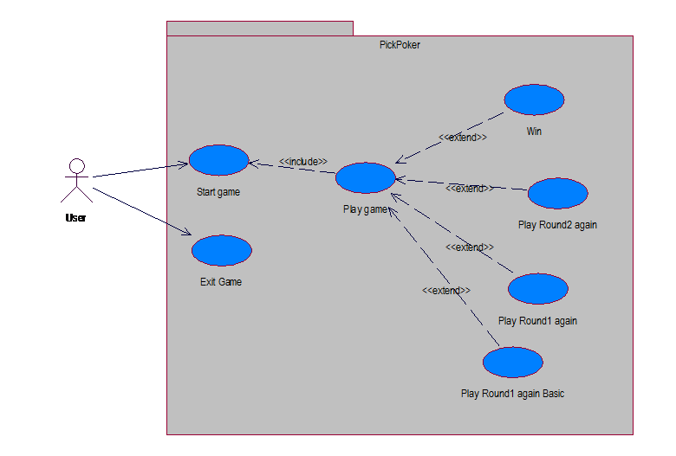

# Usecase Description:

* + - 1. Usecase 1:

|  |  |  |  |
| --- | --- | --- | --- |
| **Use Case ID:** | 1 | | |
| **Name Use case :** | **Win** | | |
| **Creator and updated:** | **Dương Minh Hiếu** | | |
| **Creation date:** | 11/20/2016 | **Date updated:** | 11/20/2016 |
| **Primary actor:** | **User** | | |
| **Brief description:** | **User wins game** | | |
| **Main Success flow:** | 1. **User click on Start Game** 2. **System display main game interface** 3. **In Line 1, User picks 3 Pokers that are same.** 4. **System open 2 Pokers in Line 2 that was disable before** 5. **In Line 2, User picks 2 Pokers that are same** 6. **System open 1 Poker in Line 3 that was disable before** 7. **In Line 3, User picks last Poker that are same with the Pokers in Line 2.** 8. **System notificate “You Win”** 9. **Usecase accomplish.** | | |
| **Sub flows:** | **None** | | |
| **Alternative flows:** | * **Alternative flow 1: While user is playing game, if user click on button “Back” ( to begin main flow 3 or 5 )**  1. **System turn back Start Game interface .** 2. **Usecase accomplish.** | | |
| **Exception flows:** | **Exception flow 1: In Line 1, if user picks 3 pokers that be not same. ( to begin main flow 3 )**   1. **System reset all poker to initial status** 2. **Usecase accomplish.**   **Exception flow 2: In Line 2, if user picks 2 pokers that be not same. ( to begin main flow 5 )**   1. **System reset all poker to initial status** 2. **Usecase accomplish.**   **Exception flow 3: In Line 3, if user picks the last poker that be not same with pokers Line 2. ( to begin main flow 5 )**   1. **System reset poker in Line 3 and 2 to initial status.** 2. **Usecase accomplish.** | | |
| **Trigger:** | **When user click on button Start Game** | | |
| **Relationships:** | **<<extend>> PlayGame** | | |
| **Pre-conditions:** | **User want to play game** | | |
| **Post-conditions:** | * **Successful: User win game** * **Fail: User play again** | | |
| **Priority:** | * **High** | | |
| **Frequency of use:** | **High** | | |
| **Business Rules:** | * **The pokers in each line that user picks must be same** | | |
| **Special Requirement:** | **None** | | |
| **Mockup screen:** |  | | |

Usecase 2:

|  |  |  |  |
| --- | --- | --- | --- |
| **Use Case ID:** | 1 | | |
| **Name Use case :** | **Play again Line 1 basic** | | |
| **Creator and updated:** | **Dương Minh Hiếu** | | |
| **Creation date:** | 11/20/2016 | **Date updated:** | 11/20/2016 |
| **Primary actor:** | **User** | | |
| **Brief description:** | **User fail in to pick 3 same pokers in Line 1 and play again Line 1** | | |
| **Main Success flow:** | 1. **User click on Start Game** 2. **System display main game interface** 3. **In Line 1, User picks 3 Pokers that are not same.** 4. **System reset all poker to initial status** 5. **User play again in Line 1, continutely picks 3 Pokers until they be same** 6. **Usecase accomplish.** | | |
| **Sub flows:** | **None** | | |
| **Alternative flows:** | * **Alternative flow 1: While user is playing game, if user click on button “Back” ( to begin main flow 3 )**  1. **System turn back Start Game interface .** 2. **Usecase accomplish.** | | |
| **Exception flows:** | **Exception flow 1: In Line 1, if user picks 3 pokers that be same. ( to begin main flow 3 )**   1. **System open 2 Pokers in Line 2 that was disable before** 2. **Usecase accomplish.** | | |
| **Trigger:** | **User fail in to pick 3 same pokers in Line 1 and want to play again** | | |
| **Relationships:** | **<<extend>> PlayGame** | | |
| **Pre-conditions:** | **When User picks 3 Pokers that are not same in Line 1** | | |
| **Post-conditions:** | * **Successful: User play again** * **Fail: User is able to play pick pokers in Line 2** | | |
| **Priority:** | * **High** | | |
| **Frequency of use:** | **High** | | |
| **Business Rules:** | * **The pokers in line 1 that user picks must be not same** | | |
| **Special Requirement:** | **None** | | |
| **Mockup screen:** |  | | |

Usecase 3:

|  |  |  |  |
| --- | --- | --- | --- |
| **Use Case ID:** | 1 | | |
| **Name Use case :** | **Play again Line 1** | | |
| **Creator and updated:** | **Dương Minh Hiếu** | | |
| **Creation date:** | 11/20/2016 | **Date updated:** | 11/20/2016 |
| **Primary actor:** | **User** | | |
| **Brief description:** | **User fail in to pick 2 same pokers in Line 2 and must play again Line 1** | | |
| **Main Success flow:** | 1. **User click on Start Game** 2. **System display main game interface** 3. **In Line 1, User picks 3 Pokers that are same.** 4. **System open 2 Pokers in Line 2 that was disable before** 5. **In Line 2, User picks 2 Pokers that are not same.** 6. **System reset all poker to initial status** 7. **User play again in Line 1 and Line 2, continutely picks Pokers until they be same** 8. **Usecase accomplish.** | | |
| **Sub flows:** | **None** | | |
| **Alternative flows:** | * **Alternative flow 1: While user is playing game, if user click on button “Back” ( to begin main flow 3 or 5 or 7 )**  1. **System turn back Start Game interface .** 2. **Usecase accomplish.** | | |
| **Exception flows:** | **Exception flow 1: In Line 2, if user picks 2 pokers that be same. ( to begin main flow 5 )**   1. **System open last Poker in Line 3 that was disable before** 2. **Usecase accomplish.** | | |
| **Trigger:** | **User fail in to pick 2 same pokers in Line 2 and want to play again** | | |
| **Relationships:** | **<<extend>> PlayGame** | | |
| **Pre-conditions:** | **When User picks 2 Pokers that are not same in Line 2** | | |
| **Post-conditions:** | * **Successful: User play Line 1 and Line 2 again** * **Fail: User is able to play pick last poker in Line 3** | | |
| **Priority:** | * **High** | | |
| **Frequency of use:** | **High** | | |
| **Business Rules:** | * **The pokers in line 2 that user picks must be not same** | | |
| **Special Requirement:** | **None** | | |
| **Mockup screen:** |  | | |

Usecase 4

|  |  |  |  |
| --- | --- | --- | --- |
| **Use Case ID:** | 1 | | |
| **Name Use case :** | **Play again Line 2** | | |
| **Creator and updated:** | **Dương Minh Hiếu** | | |
| **Creation date:** | 11/20/2016 | **Date updated:** | 11/20/2016 |
| **Primary actor:** | **User** | | |
| **Brief description:** | **User fail in to pick last Poker in Line 3 be same with the pokers in Line 2 and must play again Line 2** | | |
| **Main Success flow:** | 1. **User click on Start Game** 2. **System display main game interface** 3. **In Line 1, User picks 3 Pokers that are same.** 4. **System open 2 Pokers in Line 2 that was disable before** 5. **In Line 2, User picks 2 Pokers that are same** 6. **System open 1 Poker in Line 3 that was disable before** 7. **In Line 3, User picks last Poker that are not same with the Pokers in Line 2.** 8. **System reset the pokers in Line 2 and 3 to initial status** 9. **User play again in Line 2 , continutely picks 2 Pokers until they be same** 10. **Usecase accomplish.** | | |
| **Sub flows:** | **None** | | |
| **Alternative flows:** | * **Alternative flow 1: While user is playing game, if user click on button “Back” ( to begin main flow 3 or 5 or 7 or 9)**  1. **System turn back Start Game interface .** 2. **Usecase accomplish.** | | |
| **Exception flows:** | **Exception flow 1: In Line 3, if user picks last pokers that be same with the pokers in Line 2. ( to begin main flow 7 )**   1. **System notificate “You Win”** 2. **Usecase accomplish.** | | |
| **Trigger:** | **User fail in to pick same same pokers in Line 3 and Line 2 and want to play again** | | |
| **Relationships:** | **<<extend>> PlayGame** | | |
| **Pre-conditions:** | **When User picks last Pokers that are not same in Line 2** | | |
| **Post-conditions:** | * **Successful: User play Line 2 again** * **Fail: User win** | | |
| **Priority:** | * **High** | | |
| **Frequency of use:** | **High** | | |
| **Business Rules:** | * **The pokers in line 3 that user picks must be not same with the pokers in Line 2** | | |
| **Special Requirement:** | **None** | | |
| **Mockup screen:** |  | | |

# Class Diagram:



# Sequence Diagram:

1. Sequence_PickPoker_Play



1. Sequence_PickPoker_Exit



# Required System.

Device with Android 5.0 upper than API 21

# User Guide

Step1: First, Player run App and it will display main interface:

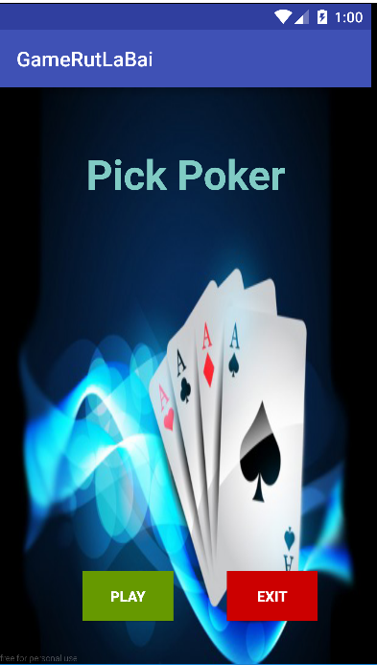

Step 2: Player click on button Play to play game. It will be like this.



Step 3: Now player start to play game, try to pick 3 pokers to be same type. If they are same, The game will enable 2 pocker above. And Try to play until 2 pokers be same.

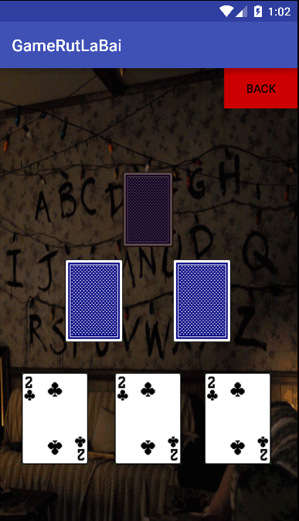

Step 4: If they are same, The game will enable the last pocker above. And Try to play until the last pocker be same with 2 pokers below. Finally we win

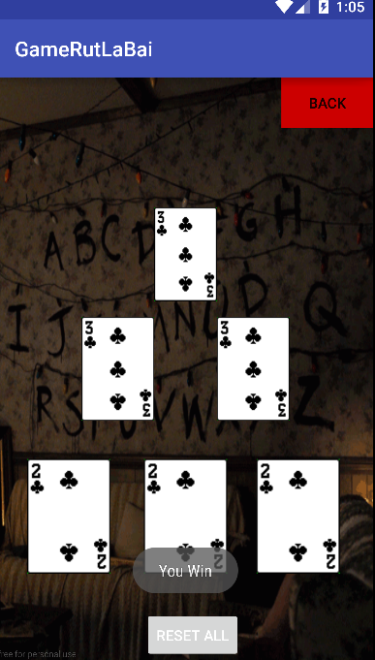

# Source Code

Please see at this link: https://github.com/t146150/PickPokerGame